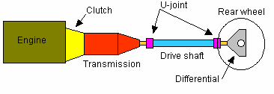
UNIT I
CLUTCH AND GEAR BOX
TRANSMISSION SYSTEM
Chief function of the device is to receive power at one torque and
angular velocity and to deliver it at another torque and the corresponding
angular velocity.
LAYOUT OF AUTOMOBILE POWER TRANSMISSION SYSTEM
REQUIREMENTS OF TRANSMISSION SYSTEM
1. To provide for disconnecting the engine from the driving wheels.
2. When the engine is running, to enable the connection to the driving
wheels to be made smoothly and without shock.
3. To enable the leverage between the engine and driving wheels to be
varied.
4. It must reduce the drive-line speed from that of the engine to that of
the driving wheels in a ratio of somewhere between about 3:1 and 10:1
or more, according to the relative size of engine and weight of vehicle.
5. Turn the drive, if necessary, through 90° or perhaps otherwise re-align
it.
6. Enable the driving wheels to rotate at different speeds.
7. Provide for relative movement between the engine and driving wheels.

AT2301 Automotive Transmission

CLUTCH
The clutch is housed between the engine and transmission where it
provides a mechanical coupling between the engine's flywheel and the
transmission input shaft. The clutch is operated by a linkage that extends
from the passenger compartment to the clutch housing. The purpose of the
clutch is to disconnect the engine from the driven wheels when a vehicle is
changing gears or being started from rest.
Disengaging the clutch separates the flywheel, the clutch plate and the
pressure plate from each other. The flywheel is bolted to the end of the
crankshaft and rotates with it. The clutch plate is splined to the gearbox in
order for both to rotate together and the pressure plate clamps the clutch
plate to the flywheel. When the pressure is released by depressing the clutch
pedal, the crankshaft and gearbox input shaft rotate independently. When
the foot is taken off they rotate as one.
REQUIREMENTS OF A CLUTCH
The clutch must
1. Pick up its load smoothly without grab or clatter.
2. Have a driven disc of low moment of inertia to permit easy shifting.
3. Damp out any vibration of the crankshaft to prevent gear clatter.
4. Require little pedal pressure to operate it.
5. Be easy to adjust and service.
6. Be cheap to manufacture.
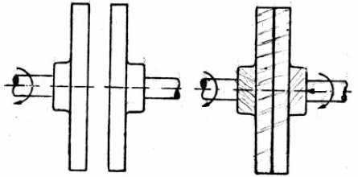
BASIC PRINCIPLE OF THE FRICTION TYPE CLUTCH
To understand the working principle of clutch, let’s take two sanding
discs, first one driven by a power drill corresponds to the flywheel of a car,
driven by the engine. If a second sanding disc is brought into contact with the
first, friction makes it revolve too but more slowly. But when the second disc
pressed against the first disc which is connect to the power drill, as the
pressure increases the two discs revolve as one. This is how a friction clutch
works.
BASIC PRINCIPLE OF THE FRICTION TYPE CLUTCH
TYPES OF CLUTCHES
MULTI COIL SPRING SINGLE PLATE CLUTCH
CONSTRUCTION
A typical clutch actuated by a number of coil springs on a pitch circle
nears the periphery is shown. The driven shaft which normally is a forward
extension of gearbox primary shaft is supported at its front end in ball
bearing in a hole in the centre of flywheel web, which is spigot and bolted on
to a flange at the rear end of the crankshaft.
In this clutch, the coil springs force the pressure plate forwards to
clamp the driven plate between it and the rear face of the flywheel. Three
lugs extend rearwards from periphery of pressure plate both to rotate the
pressure plate and to cause it to rotate with the rest of the assembly. The
driven plate of course is splined onto the shaft.
There are three release levers pressing the coil springs at the outer
end. The inner ends of the levers can be forced forward by means of thrust
bearing made of graphite and slide along the clutch shaft when clutch pedal
is depressed. The driven plate mounted between flywheel and pressure plate
makes the clutch shaft to rotate to transmit power. It has the clutch facing
made of friction materials around the periphery of disc.
WORKING
When the clutch is engaged, the clutch plate is gripped between the
flywheel and pressure plate. The friction linings are on both sides of clutch
plate. Due to friction between flywheel, clutch plate and pressure plate, the
clutch plate revolves with the flywheel. As clutch plate revolves the clutch
shaft also revolves. Thus, engine power is transmitted to the clutch shaft.
When the clutch pedal is pressed the pressure plate moves back
against the spring force and clutch plate becomes free between flywheel and
pressure plate. Thus flywheel remains rotating as long as the clutch pedal is
pressed, the clutch is said to be disengaged and clutch shaft speed reduces
slowly and finally it stops rotating.
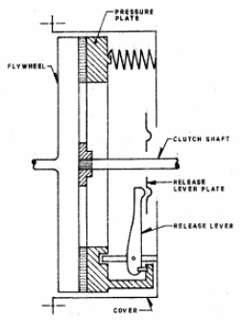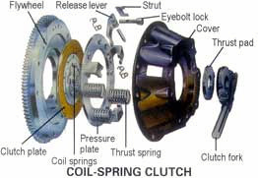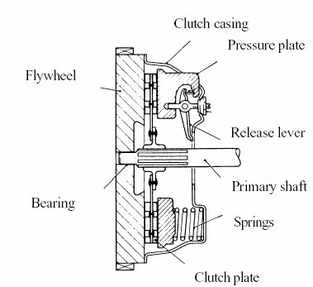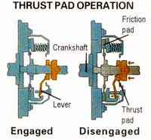
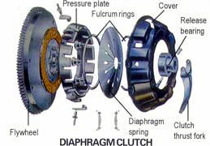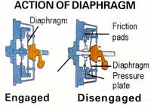
DIAPHRAGM SPRING SINGLE PLATE CLUTCH
Diaphragm spring pressure plate assemblies are widely used in most
modern cars. The diaphragm spring is a single thin sheet of metal which
yields when pressure is applied to it. When pressure is removed the metal
springs back to its original shape. The centre portion of the diaphragm spring
is slit into numerous fingers that act as release levers. During disengagement
of the clutch the fingers are moved forward by the release bearing.
The spring pivots over the fulcrum ring and its outer rim moves away
from the flywheel. The retracting spring pulls the pressure plate away from
the clutch plate thus disengaging the clutch. When engaged the release
bearing and the fingers of the diaphragm spring move towards the
transmission. As the diaphragm pivots over the pivot ring its outer rim forces
the pressure plate against the clutch disc so that the clutch plate is engaged
to the flywheel.
ADVANTAGES OF DIAPHRAGM SPRING CLUTCH
1. It is more compact than other designs.
2. It is easier to balance rotationally and is less subjected to unwanted
effects due to centrifugal force at high rotational speeds.
3. It gives uniformly distributed pressure on pressure plate.
4. It needs no release levers.
5. Minimum effort is sufficient to disengage the clutch.
6. It provides minimum number of moving components and hence
minimum internal friction is experienced.
7. This is very commonly used in cars, light Lorries and mini trucks but
is not much used in heavy vehicles
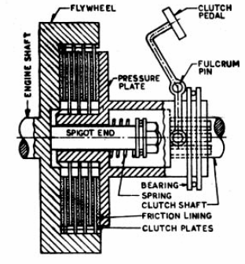
MULTIPLATE CLUTCH
The multi-plate clutch is an extension of single plate type where the
number of frictional and the metal plates are increased. The increase in the
number of friction surfaces obviously increase capacity of the clutch to
transmit torque, the size remaining fixed. Alternatively, the overall diameter
of the clutch is reduced for the same torque transmission as a single plate
clutch. This type of clutch is, used in some heavy transport vehicles, in
epicyclic gearboxes and racing cars where high torque is to be transmitted.
Besides, this finds applications in case of scooters and motorcycles, where
space available is limited.
Extension of flywheel is a drum; which on its inner circumference is
splined to carry a number of thin metal plates. These must consequently
revolve with drum but are able to slide axially. Interleaved with these outer
plates are a number of inner plates that are splined to an inner drum which
is coupled rotationally to the gearbox shaft.
This drum is supported on a spigot extension of crankshaft. Between
the web of inner drum and sleeve in inner drum is a strong coil spring. The
inner drum is thus pressed to left being provided with a flange it squeezes
the inner and outer plates together so that friction between them transmits
driving torque from outer to inner drum.
The clutch is disengaged by pulling inner drum right against spring
force. The plates of multi-plate clutch were at one time made alternately of
steel and phosphor bronze but now are all of steel or one set may be lined
with a friction material. With metal contact lubrication is essential and so
clutch is made oil-tight and partly filled with oil. The oil tends to make the
plates drag when clutch is disengaged and so some mean should be provided
to avoid this drag.
DRY MULTIPLATE CLUTCH
Multi plate clutches are also made to work dry, without any oil. The
driving plates are then lined on each side with a friction fabric. In such
clutches, the driving plates are sometimes carried on a number of studs
screwed into the web of flywheel in the same way as the outer plate of a
Single Plate Clutch is carried. This construction is inconvenient when oil is
used. Several small springs can be used instead of a single spring.
AUTOMATIC CLUTCH
Many attempts have been made to produce motor vehicles that can be
controlled by the accelerator pedal and brakes only. This can be done in
several ways. A centrifugal clutch which automatically disengages itself
when the speed falls below and which re-engages when the speed rises above
some predetermined values may be used. Alternatively, a fluid coupling, fluid
torque converter may be employed.
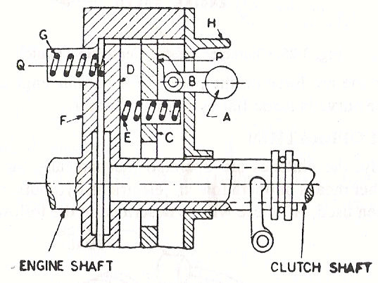
CEN TRIFUGAL CLUTCH
In this type of clutches the springs are eliminated altogether and only
the centrifugal force is used to apply the required pressure for keeping the
clutch in engagement position.
The advantage of the centrifugal clutch is that no separate clutch
pedal is required. The clutch is operated automatically depending upon the
engine speed. This means that car can be stopped in gear without stalling the
engine. Similarly while starting, the driver can first select the gear, put the
car into the gear and simply press the accelerator pedal. This makes the
driving operation very easy.
Figure shows a schematic diagram of a centrifugal clutch. As the speed
increases, the weight A fly off, thereby operating the bell crank lever B that
presses the plate C. This force is transmitted to the plate D by means of
springs E. The plate D containing friction lining is thus pressed against the
flywheel F thereby engages the clutch. Spring G serves to keep the clutch
disengaged at low speed say 500 rpm. The stop H limits the amount of
centrifugal force.
The operating characteristics of this type of clutch will be then as
shown in figure. Force P is proportional to the centrifugal force at a
particular speed, while force Q exerted by spring G is constant at all speeds.
The firm line in the figure shows that net force on the plate D for various
engine speeds. At the upper end the curve is made f lat by means of stop H.
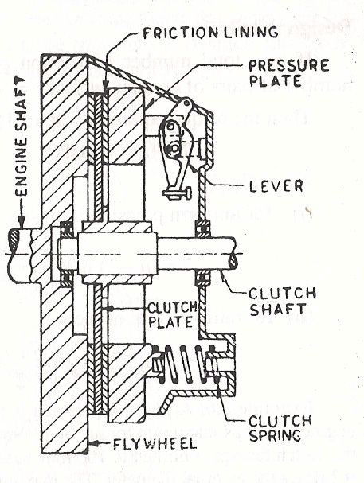
SEMI CENTRIFUGAL CLUTCH
It uses both centrifugal and spring force for keeping it in an engaged
position. The springs are designed to transmit torque at normal speed, while
centrifugal force assists in torque transmission at high speed. This clutch
consists of three hinged and weighted levers and three clutch springs
alternately arranged at equal spaces on the pressure plate. At low speeds the
springs keep the clutch engaged and the weighted levers do not have any
pressure on pressure plate. At high speeds when power transmission is high,
weights fly off and the levers also exert pressure on plate, keeping the clutch
firmly engaged.
When the speed decreases the weights do not exert any pressure on the
pressure plate. Only spring pressure is exerted on pressure plate which keeps
the clutch engaged. An adjusting screw is provided at the end of the lever by
means of which the centrifugal force on pressure plate can be adjusted. At
low speeds pressure on the spring is sufficient to transmit the torque
required.
However at high speeds, the centrifugal force due to weight moves
about the fulcrum thereby pressing the pressure plate. The centrifugal force
is proportional to the square of speed so that adequate pressure level is
attained.
Graph shows the variation of force on the pressure plate as speed
increases. At low speeds spring along applies the force on the pressure plate.
But when speed of the engine raises the centrifugal force also applied by the
weights.
TORQUE CAPACITY OF A SINGLE PLATE CLUTCH
Assume the clutch has a single disc and it may be coil spring clutch or
diaphragm spring clutch.
Area of each friction surface of the disc A = /4 ( Do
– Di
)
2
2
Normal force applied by the pressure springs = /4 ( Do
– Di
) p
2
2
Net axial force applied by pressure springs = /4 ( Do
– Di
) p
Kgf
2
2
mech
Frictional force applied to each frictional face = /4 ( Do
– Di
) µ p
Kgf
2
2
mech
Torque due to both surface = /2 ( Do
– Di
) µ p
R
Kgf-cm-------1
2
2
mech
m
Where
µ = coefficient of friction,
p = permissible unit pressure on friction surfaces
Di = inner outer diameter of disc
Do = outer diameter of disc
R
= mean radius of the friction surface in cm
m
R
= coefficient of reserve (R
value = 1.4)
F
F
= coefficient of mechanical efficiency (
value = 0.85)
mech
mech
Consider a small element at radius ‘r’ and of thickness ‘dr’.
Area of the element a = 2 rdr cm
2
Normal force = 2 rdr p Kgf
Frictional force = 2 rdr p µ Kgf
Torque transmitted by each elemental area = 2 r2 dr p µ Kgf-cm
Torque transmitted by each friction surface =
2 r
dr p µ Kgf-cm
2
= 2 µ p [ r
/ 3 ] Kgf-cm
3
= 2 µ p [ D
D
/ 8x3 ] Kgf-cm
O3_
I3
Torque transmitted
By both friction surfaces = 2x2 µ p [ D
D
/ 8x3 ] Kgf-cm
O3_
I3
= /6 µ p [ D
D
] Kgf-cm -----2
O3_
I3
Comparing equations 1 and 2,
/2 ( Do
– Di
) µ p
R
= /6 µ p [ D
D
]
2
2
m
O3_
I3
R
= 1 / 3 [[ D
D
/ Do
– Di
]
2
2
m
O3_
I3
Now substitute Value of R
in equation----- 1.
m
Torque transmitted
By both friction surfaces = /2 µ p
R
( Do
– Di
)
Kgf-cm
2
2
mech
m
= /6 µ p
[ D
D
]
Kgf-cm
mech
O3_
I3
Torque capacity of clutch T = /600 µ p
[ D
D
]
Kgf-m
mech
O3_
I3
Rated torque capacity of a clutch= T / R
F
Then Rated torque capacity = /600 µ p
[ D
D
] / R
Kgf-m
mech
O3_
I3
F
DESIGN ASPECTS OF CLUTCH
In passenger cars, pedal eff ort should be in the range of 10-12 kgf and
in commercial vehicles the range should be 20-24 kgf.
Let
E1 be energy required to compress the clutch for disengagement
E2 be energy required to overcome friction of clutch components
E3 be elastic deformation of clutch disengaging components
Then E2 + E3 = 0.6E1
Thus total energy required = E1+E2+E3= 1.6 E1
CLUTCH GRAB
Grab is the sudden jerky motion of the vehicle when clutch pedal is
released.
CLUTCH CLATTER
Clatter is the alternative movement of the clutch disc between flywheel
and pressure plate. (Or) A shaking or shuddering of the vehicle as the clutch
is operated.
CLUTCH DRAG
A problem in which the clutch disc does not come to a complete stop
after the clutch pedal is depressed.
CUSHION SPRINGS
The clutch clatter is avoided by providing cushion spring between
friction facings. Cushioning device consists of waved cushion springs to which
the facings are riveted. These springs compress slightly as the clutch engages
producing a cushioning effect.
DAMPER SPRINGS
Torsional vibration damper hub is provided in steel disc to prevent the
torsional vibration of the engine from being transmitted through clutch which
would result in gear and driveline noises. Coil springs are generally used to
provide torque build up as hub is rotated with respect to the clutch plate. The
pressure of the coil spring is designed to produce a counter torque as high as
the torque transmitted by the engine.
FRICTION MATERIALS
Mill board type
1. Woven type- a) laminated b) solid woven
2. Moulded or composition type
MOULDED TYPE
This type of lining is composed of asbestos fibers in their natural state
mixed with a bonding material and then moulded in dies under pressure and
at elevated temperature. Metallic wires are sometimes included only to
increase the wear qualities and to eliminate scoring of metal faces against
which the lining rubs.
CLUTCH COMPONENTS MATERIALS
Components Material Components Material
Cover plate Mild steel Damper spring Spring steel
Diaphragm spring Spring steel Clutch hub Mild steel
Coil spring Spring steel Bolts to fasten flywheel and cover plate Steel
Pressure plate Cast iron Rivets on cushion spring Brass
Clutch disc Mild steel Retainer spring Spring steel
Friction facing Asbestos base Damper spring retainer plate Mild steel
Rivets on facing Aluminum brass Cushion spring Mild steel
PROBLEMS ON CLUTCH D ESIGN
Torque transmitting capacity of clutch
According to Uniform pressure theory
Torque transmitted by clutch = T = 2 x x W x n x ( r
³-r
³) N-m
2
1
3 ( r
²-r
²)
2
1
According to Uniform wear theory
Torque transmitted by clutch = T = x W x n x ( r
+r
) N-m
2
1
2
C = pr = Constant = ____W____
2 (r
-r
)
2
1
Where,
W = Axial load exerted by actuating spring in N
µ = coefficient of friction between the contact surf aces.
P = normal pressure in Pa
r
and r
= internal and external radii of contact surface in m
1
2
n = No. of contact surfaces
n = n
+ n
–1
1
2
n
and n
are no. of driving plates and no. of driven plates respectively
1
2
A motorcar engine develops 5.9 b.k W at 2100rpm. Find the suitable size
1.
of clutch plate having friction linings riveted on both sides, to transmit
the power, under the following conditions:
(i) Intensity of pressure on the surface not to exceed 6.87x10 pa.
(ii) Slip torque and losses due to wear etc. is35% of engine torque.
(iii) Coefficient of friction on contact surface is 0.3.
(iv) Inside diameter of the friction plate is 0.55 times the outside diameter.
T = P
x 60000 = 60000 x 5.9 = 26.84 N-m
w
2 N 2 x 2100
Taking account of the losses, the total torque is
T = 26.84 x 1.35 = 36.23 N-m
We, have
T = 2 µC (r
-r
)
22
12
36.23 = 3.14 x 0.3 x 6.87 x 10
x r
[(r
/0.55)
– r
] x 2
4
2
1
1
12
= 3.14 x 4.122x10
[(1/0.303) –1] r
4
13
= 36.23 x 0.303 = 1.22 m
r13
3
3.14 x 4.122 x 10
x 0.697 10
4
4
r
= 49.5 mm r
= 90 mm
1
2
Hence,
Inside diameter = 99 mm
Outside diameter = 180 mm
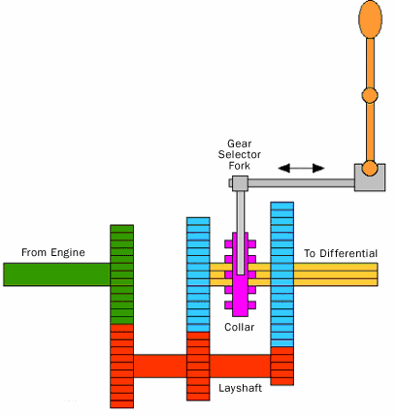
NECESSITY OF GEAR BOX IN AN AUTOMOBILE
The gear box is necessary in the transmission system to
maintain engine speed at the most economical value under all conditions of
vehicle mo vement. An ideal gear box would provide an infinite range of gear
ratios, so that the engine speed should be kept at or near that the maximum
power is developed what ever the speed of the vehicle.
FUNCTION OF A GEAR BOX
1. Torque ratio between the engine and wheels to be varied for
rapid acceleration and for climbing gradients.
2. It provides means of reversal of vehicle motion.
3. Transmission can be disconnected from engine by neutral
position of gear box.
TYPES OF GEAR BOX
PROGRESSIVE TYPE GEAR BOX
Usually this gear boxes are used in motor cycles. In this gear boxes the
gears pass through the intervening speeds while shifting from one speed to
another. There is a neutral position between two positions. These gear boxes
are a combination of sliding and constant mesh gear boxes. The various gear
speeds are obtained by sliding the dog clutch or gear to the required position.
EPICYCLIC (OR) PLANETARY TYPE GEAR BOX
The epicylic or planetary type transmission uses no sliding dogs or
gears to engage but different gear speeds are obtained by merely tightening
brake-bands on the gear drums, which simplify gear changing. A planetary
gear set consists of ring gear or annular wheel, sun gear and planet gears
with carrier. In order to obtain different speeds any one of these three units
can be held from rotation by means of brake bands.
SELECTIVE TYPE GEAR BOX
It is the transmission in which any speed may be selected from the
neutral position. In this type of transmission neutral position has to be
obtained before selecting any forward or reverse gear. Some selective type
gear boxes are,
1. Constant mesh gear box with positive dog clutch.
2. Constant mesh gear box with synchromesh device.
3. Sliding mesh gear box.
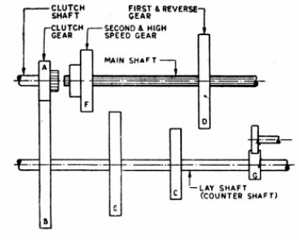
SLIDING MESH GEAR BOX
It is the simplest and oldest type of gear box.
1. The clutch gear is rigidly fixed to the clutch shaft.
2. The clutch gear always remains connected to the drive gear of
countershaft.
3. The other lay shaft gears are also rigidly fixed with it.
4. Two gears are mounted on the main shaft and can be sliding by shifter
yoke when shifter is operated.
5. One gear is second speed gear and the other is the first and reverse
speed gears. All gears used are spur gears.
6. A reverse idler gear is mounted on another shaft and always remains
connected to reverse gear of counter shaft.
FIRST GEAR
By operating gearshift lever, the larger gear on main shaft is made to
slide and mesh with first gear of countershaft. The main shaft turns in the
same direction as clutch shaft in the ratio of 3:1.
SECOND GEAR
By operating gear shaft lever, the smaller gear on the main shaft is
made to slide and mesh with second gear of counter shaft. A gear reduction of
approximately 2:1 is obtained.
TOP GEAR
By operating gearshift lever, the combined second speed gear and top
speed gear is forced axially against clutch shaft gear. External teeth on clutch
gear mesh with internal teeth on top gear and the gear ratio is 1:1.
REVERSE GEAR
By operating gearshift lever, the larger gear of main shaft is meshed
with reverse idler gear. The reverse idler gear is always on the mesh with
counter shaft reverse gear. Interposing the idler gear, between reverse and
main shaft gear, the main shaft turns in a direction opposite to clutch shaft.
NEUTRAL GEAR
When engine is running and the clutch is engaged, clutch shaft gear
drives the drive gear of the lay shaft and thus lay shaft also rotates. But the
main shaft remains stationary as no gears in main shaft are engaged with lay
shaft gears.
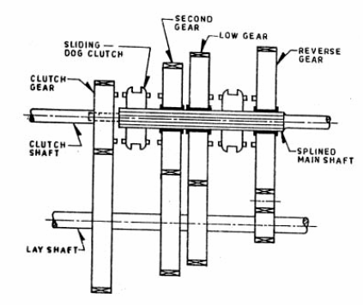
CONSTANT MESH GEARBOX
In this type of gearbox, all the gears of the main shaft are in constant
mesh with corresponding gears of the countershaft. The gears on the main
shaft which are bushed are free to rotate. The dog clutches are provided on
main shaft. The gears on the lay shaft are, however, fixed.
When the left Dog clutch is slid to the left by means of the selector
mechanism, its teeth are engaged with those on the clutch gear and we get
the direct gear. The same dog clutch, however, when slid to right makes
contact with the second gear and second gear is obtained.
Similarly movement of the right dog clutch to the left results in low
gear and towards right in reverse gear. Usually the helical gears are used in
constant mesh gearbox for smooth and noiseless operation.
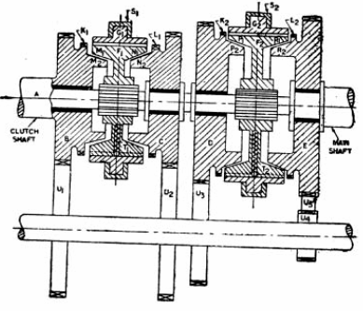
SYNCHROMESH GEARBOX
This type of gearbox is similar to the constant mesh type gearbox.
Instead of using dog clutches here synchronizers are used. The modern cars
use helical gears and synchromesh devices in gearboxes, that synchronize the
rotation of gears that are about to be meshed.
SYNCHRONIZERS
This type of gearbox is similar to the constant mesh type in that all the
gears on the main shaft are in constant mesh with the corresponding gears
on the lay shaft. The gears on the lay shaft are fixed to it while those on the
main shaft are free to rotate on the same. Its working is also similar to the
constant mesh type, but in the f ormer there is one definite improvement over
the latter. This is the provision of synchromesh device which avoids the
necessity of double-declutching. The parts that ultimately are to be engaged
are first brought into frictional contact, which equalizes their speed, after
which these may be engaged smoothly.
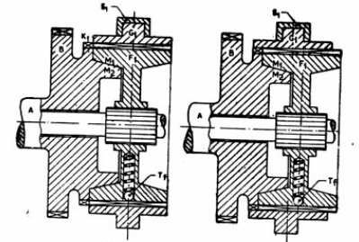
Figure shows the construction and working of a synchromesh gearbox.
In most of the cars, however, the synchromesh devices are not fitted to all the
gears as is shown in this figure. They are fitted only on the high gears and on
the low and reverse gears ordinary dog clutches are only provided. This is
done to reduce the cost.
In figure A is the engine is the engine shaft, Gears B, C, D, E are free
on the main shaf t and are always in mesh with corresponding gears on the
lay shaft. Thus all the gears on main shaft as well as on lay shaft continue to
rotate so long as shaft A is rotating. Members F1 and F2 are free to slide on
splines on the main shaft. G1 and G2 are ring shaped members having
internal teeth fit onto the external teeth members F1 and F2 respectively. K1
and K2 are dogteeth on B and D respectively and these also fit onto the teeth
of G1 and G2. S1 and S2 are the forks. T1 and T2 are the balls supported by
spring. These tend to prevent the sliding of members G1 (G2) on F1 (F2).
However when the force applied on G1 (G2) slides over F1 (F2). These are
usually six of these balls symmetrically placed circumferentially in one
synchromesh device. M1, M2, N1, N2, P1, P2, R1, R2 are the frictional
surfaces.
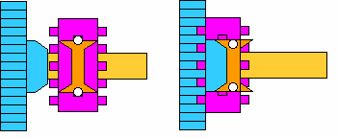
To understand the working of this gearbox, consider figure which
shows in steps how the gears are engaged. For direct gear, member G1 and
hence member F1 (through spring- loaded balls) is slid towards left till cones
M1 and M2 rub and friction makes their speed equal. Further pushing the
member G1 to left causes it to overdrive the balls and get engaged with dogs
K1. Now the drive to the main shaft is direct from B via F1 and the splines.
However, if member G1 is pushed too quickly so that there is not sufficient
time for synchronization of speeds, a clash may result. Likewise defect will
arise in case springs supporting the balls T1 have become weak.
Similarly for second gear the members F1 and G1 are slid to the right
so that finally the internal teeth on G1 are engaged with L1. Then the drive
to main shaft will be from B via U1, U2, C, F1 and splines. For first gear, G2
and F2 are moved towards left. The drive will be from B via U1, U2, D, F2
and splines to the main shaft. For reverse gear, G2 and F2 are slid towards
right. In this case the drive will be from B via U1, U2, U5, E, F2 and splines
to the main shaft.
A synchro's purpose is to allow the collar and the gear to make
frictional contact before the dog teeth make contact. This lets the collar and
the gear synchronizes their speeds before the teeth need to engage, like this:
The cone on the blue gear fits into the cone-shaped area in the collar, and
friction between the cone and the collar synchronize the collar and the gear.
The outer portion of the collar then slides so that the dog teeth can engage
the gear.
DETERMINATION OF GEAR RATIOS
From one point of view, the ideal type of transmission is the so called
indefinitely variable gear, in which torque ratio can be varied continuously
within wide limits, because it permits of operating the engine at all times
under optimum conditions with respect to both fuel consumption and wear
and tear. However in an ordinary transmission only a small number of gear
ratios can be provided to cut down expenses and weight. The most desirable
number of gear changes depends in part on the use to which the transmission
is to be put, and each field of application must be considered separately.
The most desirable number of gear ratios depends on the difference
between highest and lowest gear ratios. The larger the ratio between
corresponding gear ratios, the more difficult it is to make the change from
one gear to another, it must be done by either shifting gears into mesh
laterally or securing a gear to its shaft by means of a jaw clutch. A ratio of 2:1
is about the limit and is frequently used in trucks although a ratio of 1.5:1 is
considered better from a standpoint of ease shifting.
Formerly a ratio of 1:8 was used in passenger cars and high speed was
a direct drive with a ratio of 1:1, the intermediate speed a reduction gear
with a1:8 ratio and the low speed a reduction gear with a ratio of (1.8 x 1.8): 1
or 3.24:1. When gear ratios are arranged in such an order they form a
geometrical series which offers certain advantages from the standpoint of
operation. In most automotive transmission the ratios of the different gears
come fairly close to forming a geometric series. A slight deviation from the
series is made at high speed end. There are certain limitations on the number
of gear tee th which can be provided, and it is therefore not always possible to
obtain an exact geometrical series of ratios, even if that should be desired.
GEAR RATIO CALCULATION FOR SMALL CARS
HIGH GEAR RATIO (TOP GEAR RATIO)
Power required to propel the vehicle HP = R
V / 270
t
t
R
= Ra
+ R
+ R
t
r
g
Where
V = vehicle speed in kmph
= transmission efficiency
t
R
= total resistance in N
t
In top gear R
= 0 R
= R
+ R
g
t
a
r
Maximum speed V = N R
/ 2.65 G
r
w
Where
N = Engine speed in rpm
R
= Wheel Radius
w
G = gear ratio in top gear 1:1
r = permanent reduction in the final drive.
LOW GEAR RATIO (FIRST GEAR RATIO)
Assume that gradient resistance is high.
R
= Ra
+ R
+ R
t
r
g
Tractive force available at the driving wheel
F
T
G
r / R
w =
e t
w
T
= 4500 * P / 2 N
e
T
= Engine torque
e
From this G
can be calculated.
1
INTERMEDIATE GEAR RATIOS
To calculate intermediate gear ratios the decisions to be taken for
1. Number of intermediate gear ratios
2. Step between two successive gear ratios. It should not exceed 1.5 for
small cars, 1.8 for truck, and 1.9 for tractor.
In first gear, the vehicle speed V
= N
R
/ 2.65 G
r-------1
1
1
w
1
Gear ratio is in geometrical progression ratio
During gear shifting V
= N
R
/ 2.65 G
r
1
2
w
2
= x (N
/ G
) ------2
2
2
Where x =
R
/ 2.65
r = constant.
w
Equate 1 and 2 x (N
/ G
)
= x (N
/ G
)
1
1
2
2
G
= ( N
/ N
) G
2
2
1
1
In second gear, the vehicle speed V
= N
R
/ 2.65 G
r-------3
2
1
w
2
Gear ratio is in geometrical progression ratio
During gear shifting V
= N
R
/ 2.65 G
r
2
2
w
3
= x (N
/ G
) ------4
2
3
Where x =
R
/ 2.65
r = constant.
w
Equate 1 and 2 x (N
/ G
)
= x (N
/ G
)--------4
1
2
2
3
G
= ( N
/ N
) G
3
2
1
2
Substitute G
value in G
2
3
G
= ( N
/ N
)
G
2
3
2
1
2
Similarly
G
= ( N
/ N
)
G
3
4
2
1
1
Practically the gear shifting operation from top to next is frequent one.
Hence this shifting operation should be smoother. In order to achieve the
easier operation the step between these two gears is reduced.
ADVANTAGES OF GEOMETRICAL SERIES
The advantage of gear ratios following a geometrical series is
explained with reference to figure. The figure shown applies to a four speed
truck transmission, the truck being so geared that when in direct drive it
attains a speed of 48 mph with the engine running at 2800 rpm. The four
ratios in the transmission are 6.64, 3.53, 1.88 and 1.00.
The vehicle is accelerated to a speed of 6 miles/hour in first gear with
engine speed 2400 rpm. It is indicated by the first slope line. For further
acceleration the driver shifts to second gear which reduces the engine speed
proportional to 1.88:1 if the engine is directly coupled to drive wheels, but
since the clutch is allowed to slip for some time, The vehicle accelerates in
second gear with the clutch slipping, and by the time the drive has become
positive, it will move ahead at higher speed. It is indicated by the dotted
lines, connecting the first gear and the second gear acceleration lines.
In second gear, the truck is allowed to accelerate until engine reaches
2400 rpm. Then the gear is shifted to third and again the vehicle is brought
up to a speed of 2400 rpm. After this the transmission is shifted to high,
which once more slows down and tries to achieve maximum speed. The entire
process of vehicle acceleration therefore consists of engine acceleration and
deceleration and if gear ratios are in geometric order, the engine can be
accelerated through the same speed range in each gear.
It is advisable not to accelerate to too high an engine speed, as high
speeds are injurious, and it is also advisable not to slow the engine down too
much, as at very low speeds it operates jerkily, which also is injurious. If the
engine is accelerated through the same speed range in each gear, the
conditions would seem to be the best, except f or one fact-that the torque load
is greater in high gear than in any of the lower ones, and the engine is more
likely to be rough in high gear if its speed is reduced too much.
This is one of the reasons why it is a general practice in transmission
design to make the step between the highest and the next gear smaller than
the step between any other two gears. Another reason is that the shift from
one gear to another is easier to make the smaller the step between the two
gear ratios, and in traffic driving the change from high gear into the next and
back again had to be made quite frequently than any other.
PERFORMANCE CHARACTERISTICS
The above graph gives the relation between car speed and total
resistance, tractive effort at the different gear ratios and different gradients.
From the figure, the curves A to F are curves of total resistance for a road
with uniform surface but of varying gradient, curve A being level and the
curve F the steepest gradient. Curves RS, TU, VW are curves of tractive
effort for three different types of gear ratios.
Suppose the vehicle is traveling on the level at a speed represented by
OX. Then resistance to be overcome is XY and XZ is the tractive effort
available. The tractive effort available is therefore greater than the
resistance to be overcome and the excess tractive effort YZ will go to increase
the speed of the vehicle.
Thus during acceleration, the resistance increases and extra effort for
acceleration reduces. When the speed is OM, the total tractive effort is equal
to total resistance. Thus speed cannot be increased further.
If the vehicle now comes to a gradient to which the curve B applies. At
the speed OM on gradient B, the resistance is MN. But tractive effort
available is only MH. Thus excessive resistance MN will reduce speed of the
vehicle to the point I where tractive effort is equal to the resistance.
Now suppose the gradient becomes steeper and steeper, so we pass in
succession from curve B to C and so on. Then speed maintained lowers down
to the points J, K etc. It is seen that we can traverse the gradient at any
speed, since tractive effort at III gear lies everywhere below resistance curve.
In such cases, the gear has to be shifted to second and the speed can be
maintained at the point G.
GEAR BOX DESIGN
Power required to for propelling the vehicle (P
)
v
P
= RV kw
v
3600
Where
V = speed of the vehicle in km / hr
= transmission or drive line ef ficiency
t
R = total resistance in N
R
= air resistance in N
a
R
= rolling resistance in N
r
R
= grade resistance in N
g
R = (R
+R
) when vehicle moves along a level road.
a
r
R = (R
+R
+R
) when vehicle moves up a gradient.
a
r
g
Engine power required (P
)
req
P
P
= RV KW
req =
v
3600
t
t
Air resistance
R
= K
AV
2
a
a
Where
A = projected frontal area, m
2
V = speed of the vehicle, Km/hr
K
= coefficient of air resistance
a
= 0.023 for best streamlined cars
= 0.031 for average cars
= 0.045 for trucks and Lorries
Rolling resistance
R
= KW
r
W = total weight of the vehicle, N
K = constant or rolling resistance and depends on the nature of road surface
and types of tyres
= 0.0059 for good surface
= 0.18 for loose sand roads
= 0.015, a representative value
Grade resistance
R
= Wsin
g
W = total weight of the vehicle, N
= inclination of the slope of the horizontal.
Traction and tractive effort
The force available at the contact between the rear wheel tyres and
road is known as tractive effort. The ability of the rear wheels to transmit
this effort without slipping is known as traction. Hence usable tractive effort
will never exceed traction.
Engine torque, T
= 60000P
N-m
e
e
2pN
Torque at rear wheels,
T
= (g.r.*a.r.) T
G
T
w
e =
t
e
Tractive effort, F = T
= T
G
N
W
e
t
r r
P
= engine b.p., KW
e
T
= mean engine torque in N-m
E
= overall transmission efficiency
t
g.r. = gear box gear ratio
a.r. = back axle ratio
G = overall gear ratio = (g.r. * a.r.)
R = radius of tyre in metre
N = r.p.m. of crank shaft
When the tractive effort F>R, the total resistance on level road, the surplus
tractive effort is utilized for acceleration, hill climbing and draw-bar pull.
Relation between engine revolutions, N and Vehicle speed, V
N/V ratio depends upon the overall gear ratio. A vehicle having four different
gears will have four different values of N/V ratio. V is km/hour and r is in
metre.
2 rN = 1000V
G 60
N = 1000 G = 2.65 G
V 2 r x 60 r
PROBLEMS ON GEAR BOX
1. Find out the axial force required to synchronize the speeds. Given
coefficient of friction = 0.04, cone angle is 10 degree, angular
acceleration is 50 rad/sec², moment of inertia 254 kg cm² and the mean
radius of the cone surface 4.13 cm.
Torque = Moment of Inertia in kg-cm² x Angular Acceleration in rad/sec²
Acceleration due to gravity in cm/sec²
T = I x a
g
T = 254 x 50 = 12.95 kg-cm
981
Torque = Mean Radius of cone x Axial Force in N x Coefficient of friction
Cone Angle
T = r x W x
Sin
12.95 = 4.13 x W x 0.04
Sin 10°
W = 13.31 kg
Axial force required W = 130.64 N
2. In a gear box the clutch shaft pinion has 14 teeth and low gear main
shaft pinion 32 teeth. The corresponding lay shaft pinions have 36 teeth
and 18 teeth. The axle ratio is 3.7:1 and effective radius of the rear type is
35.5 cm. calculate the car speed in the above arrangement at an engine
speed of 2500rpm.
Determination of gear ratio:
CLUTCH SHAFT GEAR
MAIN SHAFT GEAR
LAY SHAFT GEAR A LAY SHAFT GEAR B
Gear Ratio = Speed of the clutch shaft x Speed of the Lay shaft
Speed of the Lay shaft x Speed of the main shaft
Gear Ratio =
No. of teeth on the lay shaft Gear A x No. of teeth on the main shaft Gear A
No. of teeth on the clutch shaft Gear A x No. of teeth on the lay shaft Gear B
= 36 x 32 = 4.57:1
14 x 18
The rear axle ratio is 3.7:1
Hence the overall gear ratio,
G= 4.57 x 3.7:1 = 16.92:1
Speed of the car, V = 2 N r = 2 x 0.355 x 60 m/min
G 16.92
= 2 x 2500 x 0.355 x 60 km/hr
16.92 x 1000
= 19.8 km /hr
3. A truck has a gross vehicle weight of 89026 N. engine displacement is
10m
, power 77.3kW at governed speed, of 2400 r.p.m. maximum torque,
3
345.8 Nm at 1400r.p.m. Rear axle ratio 6.166: 1. fourth speed reduction ratio
in transmission,1.605 :1, drive line losses amount to 10.7kW at 2400r.p.m
and 6.3 kW at 1400 r.p.m. tyre size 0.4572 m x 1.016 m (effective wheel
diameter 0.950 m),f rontal area of truck 6.95mcalculate the grades which the
vehicle can climb in fourth gear in still air conditions.
(i) At governed engine speed; and
(ii) At speed of maximum torque, in the equation
R = KW +Ka A V²
Ka= 0.0462 where V in km/hr
Overall gear ratio G= 6.166x1.605:1=9.9:1
(a) At governed speed,
We have, V =2 Nr
G
=2 x 2400 x .575 = 724 m/min
9.9
= 724x60 = 43.44 km/hr
1000
Total resistance in climbing the grade, inclination to the horizontal at
the above speed
R=KW + K
AV
+ W sin
2
a
= 0.014 x 89026 + 0 .0462 x 6.95 x (43.44)
+ W sin
2
= 1246.4 + 606 + 89026 sin
Power available at the road wheels = 77.3-10.7 = 66.6 KW
Tractive effort, F=66.6x 3600 = 5519.3 N
43.44
Since the car is moving at uniform speed, then
5519.3 = 1852.4 + 89026 sin
Therefore sin = 3666.9 = 1
89026 24.3
As sin is very small; sin - tan .
Hence grade is 1 in 24.3.
(b) At speed of maximum torque
V= 2 x 1400 x 0.475 = 422 m/min = 25.32 km/hr
9.9
Total resistance in the grade when going up at 25.32 km/hr
R = 0.014 x 89026 + 0.0462 x6.95 x 25.32
+ 89026 sin
2
= 1246.4 + 205.9 + 89026 sin
= 1452.3 + 89026 sin
Power available on the wheels = 2 NT - 6.3
60000
= 2 x 1400 x 345.8 – 6.3
60000
= 50.7 – 6.3 = 44.4 KW
Tractive effort, F= 44.4 x 3600 = 6312.8N
25.32
As the car is moving with uniform speed, then
F=R
Or 6312.8 = 1452.3 + 89026 sin
Therefore, sin = 4860.5 = 1
89026 18.3
Since sin - tan for small value of , grade is 1 in 18.3.
7. 4. The coefficient of rolling resistance for a truck weighing 62293.5 N is
0.018 and the coefficient of air resistance is 0.0276 in the formula
R=KW+KaAV², N, where A is m² of frontal area and V the speed in km/hr.
the transmission efficiency in top gear of 6.2:1 is 90% and that in the second
gear of 15:1 is 88%. The frontal area is 5.574 m². If the truck has to have
maximum speed of88km/hr. in top gear calculate.
8. (i) the engine b.p required;
9. (ii) the engine speed if the driving wheels have an effective
diameter of 0.8125m;
(iii) The maximum grade the truck can negotiate at the above engine
speed in second gear
(i) R = 0.018 W + 0.0276 AV
2
= 0.018 x 62293.5 + 0.0276 x 50574 (88)
2
= 1121.3 + 1191.4 = 2312.7 N
Engine b.p = RV = 2312.7 x 88
1000
1000 x 0.9 3.6
t
= 62.8 b.p.
(ii) V = 2 rN m/min
G
N = VG = 88 x 1000 x 6.2
2 r 60 2 x 3.14 x 0.40625
= 88 x1000 x 6.2
60 x 2 x 3.14 x 0.40625
= 3564 rpm
(iii)In second gear
V = 88 x 6.2 = 36.4 km/hr = 36.4 m/s
15 3.6
R = 0.018 x 62293.5 + 0.0276 x 5.574 x 36.4
2
= 1121.3 + 203.8 = 1325.1 N
If it can climb the maximum grade of 1 in X, then
R = [1325.1 + (622293.5/x)]
We have
F = b.p x
x1000
t
V
= 62.8 x 0.8 x1000 x 3.6 = 4968.8 N
36.4
Hence,
1325.1 + 622293.5 = 4968.8
X
Therefore,
X = 62293.5 = 17.1
3643.7
Hence maximum grade is 1 in 17.1
(iv)Maximum drawbar pulls on level road
= Tractive effort available – Tractive effort for resistance on level road
= 4968.8 – 1325.1 = 3643.7 N
UNIT II
HYDRODYNAMIC DRIVE
FLUID COUPLING
Fluid coupling is a device which is used to transmit torque from engine
to gear box with fluid as working medium. The purpose of fluid coupling is to
act as flexible power transmitting coupling.
CONSTRUCTION DETAILS AND PRINCIPLE OF OPERATION
The function of the FC is to act as an automatic clutch between engine
and gearbox. It allows the engine to idle when the car is stationary but takes
up the drive smoothly and progressively when the driver speeds up the
engine by depressing the accelerator pedal.
T I
T I
There are two main rotating parts; an impeller driven by the engine
and a turbine which drives gearbox. Each is bowl shaped and contains a
number of partitions called vanes. The two bowls are placed face to face in a
casing filled with oil, and they are separated by a small clearance so that no
rubbing contact between them.
The basic form of the fluid drive known as fluid flywheel or fluid
coupling is used in place of friction clutch in cars with pre-selector gearboxes.
It generally consists of an impeller and a turbine with oil continuously
circulated between the two when engine is running. When the engine is
idling, the oil is flung from the impeller by centrifugal force. Directed forward
by the vanes, it enters turbine which remains stationary because the force of
oil is not yet sufficient to turn it.
When the driver depresses the accelerator pedal, impeller speed
increases and turning ef fect derived from fast moving oil becomes great
enough to overcome the resistance of the turbine, which begins to rotate so
setting the car in motion. After giving up the energy to turbine, oil reenters
the impeller and is circulated back to the impeller again. If the speed of
engine continues to increase, the difference between the rotational speeds of
impeller and turbine gradually diminishes until the slip between then is
reduced to as little as 2%. The limitations of FC is that torque applied to
turbine can never be greater that that delivered by impeller.
IDLING
The driving part of FC is attached to the engine and faces the driven
part from which it is separated by small clearances. At idling speed, there is
insufficient centrifugal force for the oil to turn turbine and to move the car.
LOW TO MEDIUM REVOLUTIONS
As the engine speeds up, centrifugal force pushes oil into turbine and
some turning effort is transmitted. But there is still a large degree of slip in
the unit. The output shaft is thus rotating more slowly than input shaft.
MEDIUM TO HIGH REVOLUTIONS
Once the engine reaches a preset speed, the oil forces is sufficient to
transmit full power. This gives in effect a direct drive with output shaft
rotating at about 98%of speed of input shaft.
ADVANTAGES OF FLUID COUPLING
1. It provides acceleration pedal control to effect automatic
disengagement of drive to gearbox at a predetermined speed.
2. Vibrations from engine side are not transmitted to wheels and
similarly shock loads from transmission side will not be transmitted to
engine.
3. The engine will not stall if it is overloaded.
4. No wear on moving parts and no adjustments to be made.
5. No jerk on transmission when gear engages. It damps all shocks and
strains incident with connecting a revolving engine to transmission.
6. Vehicle can be stopped in gear and move off by pre ssing acceleration
only.
7. There is no direct firm connection between engines and wheels. So
when engine is overloaded, it will not stop. But it results in slip within
coupling.
8. Unlike friction clutch, slip within coupling does not cause damage
within working components.
9. In case of FC, engine is not f orced to operate at very low speeds when it
is overloaded.
10. No wear is experienced on impeller or turbine blades.
TORQUE CAPACITY OF FLUID COUPLING
B
C
X
Y
R
A D
When slip is below 3%
The change is KE depends on,
1. weight of fluid particles
2. speed of impeller
3. outer radius of coupling
i.e., change in KE Proportional to W
Proportional to N
2
Proportional to R
2
Centrifugal force acting on impeller F
is proportional to N
2
1
Centrifugal force acting in turbine F
is proportional to n
2
2
When slip is constant,
n is proportional to N
i.e., F
is proportional to N
2
2
Resultant centrif ugal force F
-F
is proportional to N
,
2
1
2
But resistance to flow = F
-F
1
2
i.e., Resistance to flow is proportional to v
.
f2
N
is proportional to v
2
f2
Therefore, N is proportional to v
f
Number of flow circuits per unit time is proportional to v
f
Is also proportional to N
Power transferred =Energy per cycle x Number of cycles per unit time.
Energy per cycle is proportional to N
and W
2
Number of cycles per unit time is proportional to N and R
2
Case 1
Power transferred is proportional to N
and N
2
Power transferred is proportional to N
3
Torque transmitted = P/N,
i.e., T is proportional to N
2
Case 2
Power transferred is proportional to W x R
2
Wt of particle = volume x density i.e., W is proportional to D
3
Power transferred per cycle is proportional to D
x D
3
2
Total power transferred in a number of cycles is proportional to D
x N
5
Torque transmitted is proportional to D
5
From (1) and (2); T is proportional to N
and D
2
5
Thus, T = CN
D
2
5
Where, N= Impeller speed in hundreds of rpm
D= Outer diameter of coupling in m
C= coupling constant = 5.25
When Slip is upto10%
K.E. = ½ x W/g (2x3.14xN)(R
-r
)
2
2
Power transferred = Energy per cycle x Number of cycles per unit time
P is proportional to WN
(R
-r
) N
2
2
2
P=f(T,N) <=WN
(R
-r
)N
2
2
2
i.e., Torque T is proportional to WN
(R
-r
)
2
2
2
Up to 10% of slip,
Torque is directly proportional to slip
i.e., T is proportional to S
Therefore, T is proportional to SWN
(R
-r
)
2
2
2
Torque capacity T = C
SWN
(R
-r
) Kgf-m
2
2
2
1
Where, c1= 0.241 and S is in decimal.
If slip is 10%, then S= 0.1
R = (0.5(R
+R
))
m
1/2
12
22
r = (0.5(r
+r
))
m
1/2
12
22
DISADVANTAGE OF FULID COUPLING
Even whe n the engine is idling, runner shaft rotates i.e., some torque
is transmitted during the engine is in idling condition. Due to this the gear
shifting is some what difficult and the vehicle will tend to move when it is
parked in gear.
DRAG TORQUE
The torque transmitted when the engine is in idling condition is known
as drag torque. Even when %slip is 100% there is a drag on GB shafts, which
renders gear changing with ordinary type of gearbox very difficult and vehicle
will tend to move when it is parked.
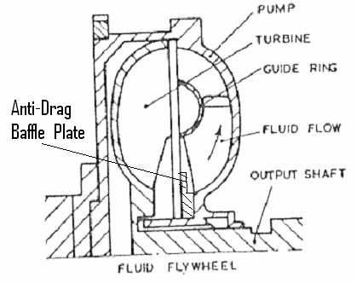
To reduce the drag torque, following methods are used,
1) Using anti drag torque baffle.
2) Using fluid reservoir.
3) Using combination of both.
4) Fluid coupling is used on combination with epicyclic gear box.
5) Fluid coupling with conventional synchromesh gearbox
ANTI-DRAG BAFFLE
It is a circular plate secured to either the impeller or the runner at the
inner circumference of the torus, and projecting into latter, thus obstructing
the path of fluid flow. At normal operating speeds the liquid is carried toward
the circumference of coupling by centrifugal force, and it is found that under
these conditions the baffle does not affect circulation.
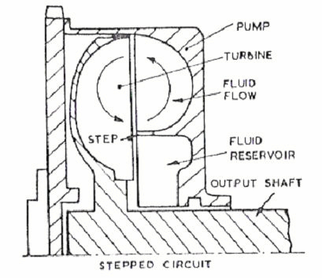
Under idling and starting conditions, however, the velocity of the
runner is low and the liquid then is forced by the centrifugal force of the
vertex motion, so that its flow is greatly affected by the plate. As the speed of
the runner increases, the centrifugal force due to runner rotation increases,
while that due to vertex motion decreases, and the effect of baffle then
gradually vanishes or reduced.
FLUID RESERVOIR
At high speeds, when the liquid is forced toward the other
circumference of the coupling by centrifugal force, the fluid coupling will be
completely filled with oil and the fluid coupling will transmit maximum
possible torque in the reservoir.
The chief purpose of the reservoir is to reduce the drag while the
engine is idling, by partly empty in the torus by returning the oil to the torus
automatically with an increases in speed. It ensures allow slip and relatively
high efficiency of the coupling at crossing speeds. Here we can safely e nsure
100% filling of coupling. Hence the maximum torque and efficiency is
increased. But the fluid reservoir increases the overall axial length of
coupling.
COMBINING ANTI-DRAG BAFFLE AND RESERVOIR
Using both the anti-drag baffle and the reservoir in the same vehicle
we can reduce the drag torque by about 85 to 90%.
FLUID COUPLING WITH EPICYCLIC GEARBOX
The fluid flywheel is generally used in combination with epicyclic
gearboxes which eliminates the drag torque.
FLUID COUPLING WITH CONVENTIONAL SYNCHROMESH
GEARBOXES
Auxiliary clutches are used during gear shift operation. This type of
transmission was used in Dodge fluid drive in 1950.
CHARACTERISTICS OF THE FLUID COUPLING
The characteristic which is of chief importance is the way in which
percentage slip varies with speed of rotation. The percentage slip is defined
as the quantity ((N-n)/N)*100 and is a measure of the difference in speed of
two rotors. If ‘n’ were equal to ‘N’, then % slip would be zero and if n=0 then
% slip would be 100.
When percentage slip is plotted against engine speed (N), the resulting
graph is the form as shown. At any speed less than about 600 rpm (this speed
can be made to have any desired value by suitably modifying the design), the
% slip is 100, i.e., the GB shaft is stationary and we have equivalent of
completely disengaged clutch.
100
80
60
40
20
0
500 1000 1500 2000 2500 3000
IMPELLER SPEED (rpm)
As the engine speed increases from 600 to 1000 rpm, the % slip falls
rapidly to about 12%. This corresponds to the period of actual engagement of
an ordinary clutch, the speed of GB shaft being rapidly brought up to roughly
the same value as engine speed. From 1000 rpm up to maximum speed, the %
slip decreases comparatively slowly from 12 down to possibly as little as 2.
The % slip at any engine speed depends however on the torque being
transmitted. The curve being based on assumption that engine exerts full
torque at every speed. If the engine torque is reduced below the full torque
(open throttle) value, the % slip will be reduced.
Thus % slip may be less than 1%. The chain dotted curve indicates the
variation of % slip with the speed f or such condition, i.e., level road and no
head wind. Whatever the value of % slip, however it represents a direct loss
of energy and thus an increase in fuel consumption. Thus, it is an abuse of
fluid flywheel to allow the engine speed to fall to region between 100 to 600
rpm, full throttle when %slip becomes ordinary clutch which also increases
fuel consumption, the difference being that whereas an ordinary friction
clutch would be damaged by prolonged slipping but FC will not suffer any
damage although it may become so hot as to burn ones hand if he touches it.
100
98%
80
60
40
20
0
0.1 0.2 0.3 0.4 0.5 0.6 0.7 0.8 0.9 1.0
SPEED RATIO
Figure shows that when speed ratio (n / N) is 0.9, the efficiency is maximum.
12
100
10
80
8
60
6
40
4
20
2
Full Load
0
0
10 20 30 40 50 60 70 80 90 100
SLIP - PER CENT
Figure shows Up to 10% of slip the torque is directly proportional to % slip.
PROBLEM ON FLUID COUPLING
1. A petrol engine develops 10 N-m torque at maximum BHP speed of
4000rpm. Determine the diameter of the impeller required to transmit
the torque for a slip of 3%.
Torque transmitting capacity of the fluid coupling with in 3% slip
T = C D
N
5
2
Where
C = A coefficient = 5.25
D = Diameter of impeller in m
N = Maximum speed of the impeller in hundreds of rpm.
T = 10 N-m = 5.25 x D
x 40
5
2
The diameter of the impeller D = 0.26 m
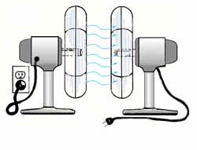
TORQUE CONVERTER
BASIC PRINCIPLE OF TO RQUE CONVERTER
On automatic transmissions, the torque converter takes the place of
the clutch found on standard shift vehicles. It is there to allow the engine to
continue running when the vehicle comes to a stop. The principle behind a
torque converter is like taking a fan that is plugged into the wall and blowing
air into another fan which is unplugged. If you grab the blade on the
unplugged fan, you are able to hold it from turning but as soon as you let go,
it will begin to speed up until it comes close to the speed of the powered fan.
The difference with a torque converter is that instead of using air, it uses oil
or transmission fluid, to be more precise.
TORQUE CONVERTER
Most cars with automatic transmission use a form of fluid drive known
as toque converter as the name implies, it converts the torque or tuning effort
of engine into higher torque needed by cars at low road speed. An increase in
torque has same effect as changing to a lower gear; so a TC is also a gear
reducer, acting like an extra set of gears before engine drive reaches gear box.
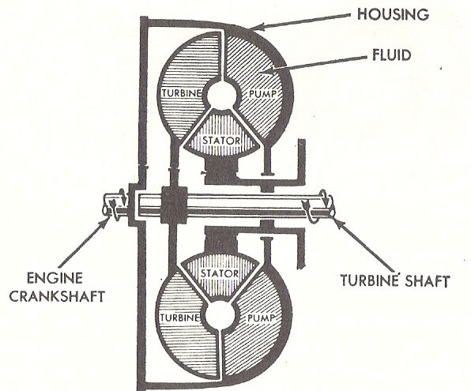
Like fluid flywheel, TC has an engine driven impeller and a turbine
connected to GB input shaft. It is also able to deliver a higher torque than
that engine produces, because it is also able to deliver a higher torque and a
small vane wheel known as reactor (stator). A one way clutch (ORC) lock
reactor to gear box casing at lower engine speed.
In a f luid flywheel, oil returning from turbine tends to curb the speed
of impeller. But in TC, the vanes of locked reactor direct oil along a torque
favorable path back to the centre of impeller enabling it to give extra thrust
to turbine blades.
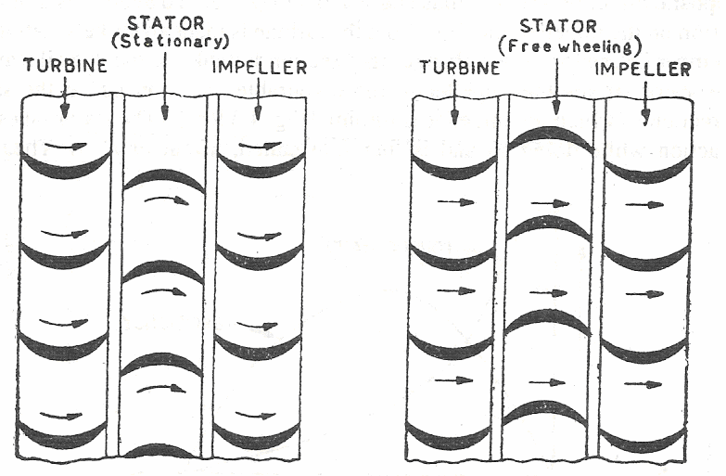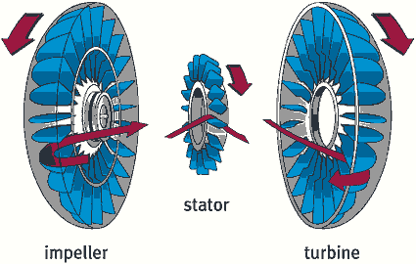
At pull away speeds, Torque Converter double the effort produced by
engine. As engine picks up speed, this 2:1 increase in torque is reduced until
at cruising speed, there is no torque increase at all. The reactor is spun round
by oil at some rate as turbine. TC now acts like a fluid flywheel with reactor
‘free wheeling’ and having no torque increasing effort. Neither FC nor TC can
be epicycle transmission which aloe gear changing without disconnecting.
An alternative used on few models, is to provide a friction clutch in
addition to TC. This enables a synchromesh gear box to be used, as friction
clutch disconnects engine when gears are being changed.
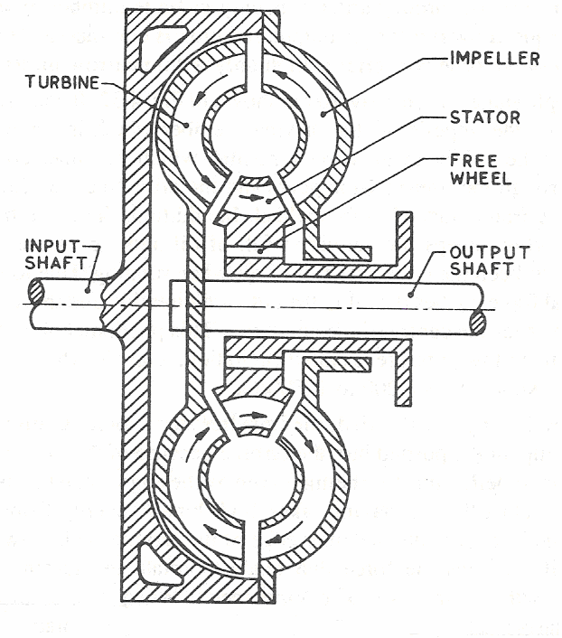
CONVERTER COUPLING
The converter coupling is a next type of fluid drive to consider. This
type represents an attempt to combine the best part of converter performance
with those of Fluid Coupling. Most forms of converter can be employed as
coupling by means of small changes to the reactors.
The converter is made to operate as a coupling by releasing the
reactors from external constraint at the time when the applied torque on this
member reverses direction. The reactor then rotates slowly so as to give least
resistance to the fluid flow. As a result, any torque applied to the pump alters
flow conditions in a way that induces an equal torque on turbine member.
Various methods of controlling the reactor have been utilized but most
convenient is the use of “f ree wheel” or “over running clutch” unit into reactor
so that it is free to rotate in some direction as the turbine but is locked
against rotation in opposite direction.
Conditions of equilibrium, ensures that torque on reactor changes
direction when o/p torque has fallen to value of i/p, so that introduction of free
wheel unit provides an automatic method of changing fro m converter to
coupling operation at correct time. This change over point is normally
referred to as “coupling point”. The resultant characteristics is shown where
it is seen that best parts of converter and coupling efficiency curves have been
successfully combined.
5
100
CONVERTER
COUPLING
OPERATION
OPERATION
4
80
EFFICIENCY
3
60
2
40
1
20
CONSTANT INPUT TORQUE
0
0 0.2 0.4 0.6 0.8 0
1.0
OUTPUT
INPUT SPEED RATIO
It is noted that there is a slip in efficiency curve around coupling point
and effort to remove this efficiency resulted in some interesting innovations.
One very simple improvement involves a change in design point which is
shifted to a higher speed ratio, when it will be seen that a much improved
efficiency curve is obtained for the higher speed ratio at the expense of
performance at lower speed ratio. More important, however is the rather
serious reduction in torque conversion which detracts from the usefulness of
design if larger o/p torque ratios are required. It is fair to say, however that
several American automobiles manufacturers appears to be concentrating on
this type of converter-coupling, used in conjunction with a number of gear
ratios to amplify o/p torque. One feature of converter coupling which is
not relived by graphs plotted to a speed ratio base is the fact that transition
from converter to coupling after reaching the coupling point is a drawn out
process which usually to be accelerated by increased input speed.
The reason for this sluggish coupling operation is that the curved blade
which is required, in turbine for converter operation is not so suitable when
operating as a coupling. Moreover, the free-wheeling reactor introduces some
additional friction in fluid circuit so that it is very difficult to obtain a curve
on a basis of turbine o/p speed revolves more accurately the most of the
transition from converter to coupling and performance of converter coupling
as been redrawn to new abscissa. That graph illustrates conditions which
apply for full throttle acceleration. Normal occurring conditions where engine
runs at reduced o/p torque will take place at or near coupling point. At this
point i/p and o/p torque are equal but o/p speed will be about 10% less than
i/p speed, depending on converter design.
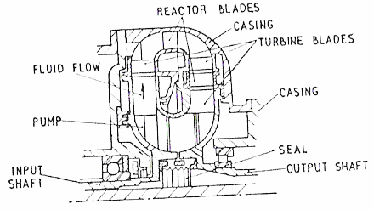
MULTISTAGE TORQUE CONVERTERS
For the highest torque ratios, it is necessary to employ multi-stage
converter. The M.S converter is one in which, the circulating fluid impinges
two or more turbine members separated by reactors. First stage of conversion
is reached when the fuel has traveled through the impeller, turbine and
reactors and extra stages are sometimes added to obtain a particular type of
performance.
The provision of an additional turbine is referred to as an extra stage
and thus conforms to steam turbine practice. It is necessary to emphasize
that additional turbine member must be separated by a reactor from a
previous turbine to create an extra stage, and should not be confuse with
practice of dividing the reactor member for instance into several parts, so as
to carry out operation of reactor in a number of phases.
The reason for using an increased number of stages is usually to
increase torque conversion ratio but certain other advantages are obtainable.
A multistage converter having a turbine immediately preceding impeller has
advantage that as the vehicle accelerates, fluid can be delivered at greater
velocity head to turbine which is enabled to rotate at faster speed. This fact
extends useful range of converter and increases it power rating. The
increased number of stages may increase f luid friction on account of longer
circulation path, and efficiency of multistage converter tends to fall of rather
sharply and racing usually occurs at lower speed ratios than for a single-
stage converter.
5
100
4
80
EFFICIENCY
3
60
2
40
1
20
CONSTANT INPUT TORQUE
0
0
0
0.2
0.4
0.6
0.8
1.0
OUTPUT
SPEED RATIO
INPUT
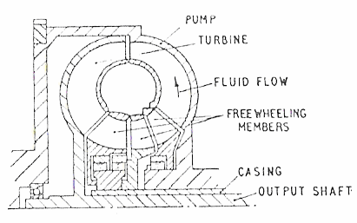
Thus, although increased torque ratios are obtained with multistage
converter, it is noticed that all the forms of converter discussed so for exhibit
a similar o/p characteristic which is roughly parabolic in shape. Variations in
blade design or number of stages has the effect of moving the peak of curve
towards low ratio (stall) end of o/p speed range or towards the higher ratios
(racing).consequently a typical Multi Stage converter will develop an o/p
torque equal to about 2 ½ times the value of i/p torque at its maximum
efficiency point. But as the turbine accelerates, the falls rapidly and o/p
torque soon falls to zero. This type of converters thus would give a good initial
acceleration of vehicle from rest but would be inefficient for a normal cruising
which is mainly carried out at unity torque ratio (direct drive). For this
reason, most MS or high torque ratio converters are used in conjunction with
a friction clutch are some other way of obtaining an efficient direct drive.
POLY PHASE CONVERTER-COUPLING
The next type of fluid drive represents an attempt to combine the best
operating characteristics of two or more different designs of converters into a
single converter. These ideas are usually incorporated into converter
couplings, but it is converter operation it takes place in several phases.
A poly phase converter coupling is a variation of a normal 3-element
machine in which at least one of the 3 basic members is divided into further
elements. The reactor has to deal with fluid flow from widely changing
entrance direction and this member can be divided into a number of elements
which adjusts them selves to the changing flow. The practice of dividing a
rotating member into several elements is widely used at the present time and
it is usual to have 2&3 phases, each of which is represented by a bladed ring
element which is also rotate freely when the fluid flow has changed the
direction by a given amount. In this way, the elements of reactor enables the
operation of redirecting the flow to be carried out in a number of distinct
phases, giving rise to the use of the term poly phase converter, or poly phase
converter coupling.
5
100
EFFICIENCY
3
4
80
1 2
3
60
2
40
1
20
CONSTANT INPUT TORQUE
0
0
0 0.2 0.4 0.6 0.8
1.0
OUTPUT
INPUT SPEED RATIO
This method is not confined to reaction member, and impeller or
turbine member may also be divided into a number of these elements which
may rotate at different speed by the introduction of free-wheel units. Such
free-wheeling blade elements detach themselves from parent member and
rotate at speeds that least resistance to fluid flow occurs. At this point, the
detached members can be considered as turbines at raising speed. From
figure, it is seen that efficiency curve combines the most useful parts of
curves of three different converter designs as the fluid drive effects a three
phase transition from converter to coupling. Each peak is related to a
particular design point which is referred to as one of the three separate
phases of particular design. The poly phase converter coupling represents
modern practice in which entrance losses are almost completely removed for
a useful range of speed ratios. There still remains a need to extend this useful
range of ratio and most transmission use and auxiliary gear box to give
increased o/p torque for improved acceleration and for climbing steeped
gradient.
Although there are a few transmission which include a certain features
not covered by foregoing 5 basic types, all known design can be properly
classified into one of three categories.
CHARACTERISTICS OF TORQUE CONVERTER
The graph (a) shows the manner in which torque-increases and
efficiency vary when rotor speed varies from zero to maximum value (2700
rpm) the impeller speed being constant at 300 rpm. When the rotor speed is
zero (because the resistance opposing its motion is large enough to hold it
fixed), the torque tending to rotate will be yearly 6 ½ times the torque
developed by engine at its speed of 3000 rpm.
7
6
TORQUE RATIO
100
5
4
80
EFFICIENCY
60
3
2
40
20
1
0
500
1000
1500
2000
2500
3000
OUTPUT SPEED REV / MIN
INPUT SPEED 3000 REV / MIN
If the resistance to the motion of rotor now decreases, so that rotor
starts to rotate, then as it gathers speed so the driving torque driving action
on it falls off, At a rotor speed of 1000, f or eg: the driving torque would have
fallen off to about 3 times the engine torque, at 1900 rpm. The driving torque
would be just equal to engine torque, while at 2700 rpm, then driving torque
would have f allen to zero.
The efficiency on the other hand starts at zero, when the rotor speed is
zero, because although torque acting on the rotor is then larger, no rotation
occurs and torque does not work, thus no work is being got out of converter
but a lot of work being put in by the engine and so the efficiency is zero, as
the rotor speed increases, so does the efficiency and a peak efficiency of 86-
90% is reached at a rotor speed of about 1000 rpm.
As the rotor speed continuous to increase, the efficiency falls off again
and at 2700 rpm becomes zero one more, this time because although rotor is
revolving rapidly, the driving torque on it is zero, and no work can be out of
it.
100
5
TORQUE RATIO
4
80
EFFICIENCY
60
3
2
40
20
1
0 500 1000 1500 2000
OUTPUT SPEED REV / MIN
INPUT SPEED 2000 REV / MIN
The graph (b) shows the same things but for on impeller speed of 2000
rpm instead of 3000 rpm. It will be seen that the driving torque acting on the
rotor when it is stalled, i.e., held at rest, is now only 4 1/3 times of engine
torque and it falls of to zero at a rotor speed of 1800 rpm. The efficiency
reaches a maximum value of only about 80% instead of 85-90%.It is thus that
only a rather range of rotor speeds, if the efficiency resonantly good and it
must be borne in mind that if efficiency is (say)60%, then 40% of power
developed by engine is wasted, being converted into heat which raises the
temperature of TC fluid and which has to dissipate by some means,
commonly a radiator.
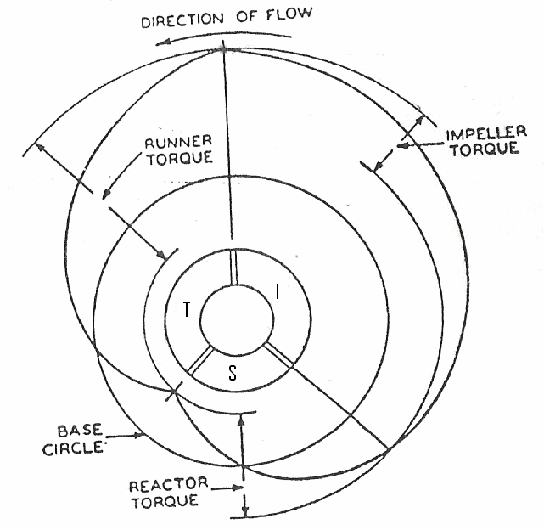
The falling off of the efficiency at low speed end of range can be treated
because these speeds are normally used only for short period when starting
and climbing several hill, but the fall off at higher speeds cannot be tolerated
and must be circumvented.
There are two principle ways in which this can be done
a) By substituting a direct drive for TC at high speeds.
b) By making the TC function as a fluid flywheel at the higher speeds.
PRINCIPLE OF HYDRODYNAMIC TORQUE CONVERSION
The phenomenon of torque conversion by hydrodynamic means is
illustrated graphically by polar diagram, where distance radially outward
from the base circle represent forward or positive moments of momentum of
the spinning fluid and distance inward from that circle negative moments.
The spinning velocity of fluid and its moment momentum both are maximum
at the runner entrance at the top of diagram. When the runner is at rest or
nearly so the spinning velocity and moment of momentum of the fluid are
quickly reduced to zero, and owing curvature of the running blades a reverse
or negative spinning motion is imparted to the fluid. The torque imposed on
the runner is proportional to the sum of the forward moment of momentum at
the entrance and reverse moment of momentum at the exit as shown. But
while fluid undergoes a great change of motion in runner and as a result
subjects the latter to heavy torque it gives up little energy to the runner
because latter is either standstill or turning at a very low speed. On leaving
the runner the fluid therefore still possesses most of the kinetic energy with
which it entered the member.
In reaction member the spinning motion is reversed and
the fluid leaves that member with a positive moment of momentum nearly
equal to the negative moment of momentum with which it entered. The
reaction member is subjected to a torque opposite in direction to that on the
runner and proportional to the difference between the negative moment of
momentum at entrance and positive moment of momentum at exit, of course
it is proportional to the sum of the two. The fluid now enters the impeller
already possessed of a certain forward spinning velocity and the impeller
needs to add only enough to bring the total velocity up to that at which the
fluid entered the runner. In the case represented by the diagram, if the
moment of momentum added to the fluid in the impeller is represented by1,
the change of moment of momentum in the reactor is about 1.4, and the
change of moment of momentum in the runner is 2.4.There fore torque ratio
in this particular case is 2.4.
UNIT III
AUTOMATIC TRANSMISSION
AUTOMATIC TRANSMISSION
It is the transmission which automatically provides varying gear ratios
to suit operating conditions. In this case gear changes are effected
automatically without manual assistant.
MAIN COMPONENTS OF AUTOMATIC TRANSMISSIO N SYSTEM
1. Torque converter.
2. Gearbox of planetary type with friction brake bands and multiple
disc clutch operated by hydraulic system.
3. Hydraulic Control System. This system has a source of hydraulic
pressure servo units and control valves.
BLOCK DIAGRAM OF AUTOMATIC TRANSMISSION
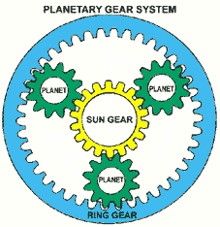
ADVANTAGES OF AUTOMATIC TRANSMISSION SYSTEM
1. Smooth operation.
2. Ease of control, i.e. it relieves the driver from fatigue due to the
elimination of clutch and gear controls.
3. Numerous numbers of gear ratios are available.
4. Quick change of gear ratios effected automatically.
5. Minimum interruption of power during gear shifts.
DISADVANTAGES OF AUTOMATIC TRANSMISSION SYSTEM
1. High cost.
2. Complicated design.
3. Possibility for oil leakage.
EPICYCLIC GEAR TRAIN
Sun gear (S) = 30 teeth (A)
Annulus (or) Ring gear (A) = 75 teeth (B)
SUN = DRIVER
FOR
CARRIER = DRIVEN
HIGH REDUCTION
ANNULUS = FIXED
GEAR RATIO A / (A+B) = 30 / (30 + 75)
GEAR RATIO = 3.5 : 1
SUN = DRIVEN
FOR
CARRIER = DRIVER
LOW REDUCTION
ANNULUS = FIXED
GEAR RATIO (A+B) / A = (30 + 75) / 30
GEAR RATIO = 1.4 : 1
SUN = DRIVER
FOR
CARRIER AND
DIRECT DRIVE
ANNULUS ARE
INTER LOCKED
WITH EACH OTHER
GEAR RATIO
GEAR RATIO = 1 : 1
SUN = FIXED
FOR
CARRIER = DRIVER
OVER DRIVE
ANNULUS = DRIVEN
GEAR RATIO (A+B) / A = (30 + 75) / 30
GEAR RATIO = 1 : 1.4
SUN = DRIVER
FOR
CARRIER = FIXED
REVERSE DRIVE
ANNULUS = DRIVEN
GEAR RATIO A / B = 30 / 75
GEAR RATIO = 2.5 : 1
SUN = DRIVER
FOR
CARRIER = FREE
NEUTRAL
ANNULUS = DRIVEN
GEAR RATIO
GEAR RATIO = --
PRINCIPLE OF THE ALL-SPUR TYPE
One form of the “all-spur” type of planetary transmission is illustrated
in diagram. It comprises three adjacent independent gears A, B, D,
Concentric with the driving and driven shafts S and S’, which are telescoped,
and three corresponding pinions A’, B’, D’, forming a rigid planetary unit.
There are usually three such units, spaced uniformly around the gears
mounted on the driving and driven shafts. Gear A is the driving and gear D
the driven member.
Low forward speed is obtained in a simple manner by holding the
planet carrier from rotation, by means of a brake drum provided on it for the
purpose. Power then enters at gear A and is transmitted through the pairs of
back gears A’, D’, to gear D, hence no planetary motion is involved in the low
speed forward drive. The low-speed reduction ratio is a’d / ad’. For high
forward speed the driving shafts is coupled to the driven shaft by means of a
friction clutch incorporated in the assembly, which gives a direct drive.
For the reverse motion gear B, which is free on the driving shaft, is
held from rotation. Assume that the planet carrier rotates left-handedly,
causing pinion B’ to roll on B. For one left-handed revolution of the planet
carrier, the gear cluster A’, B’, D’, makes b/b’ left-hand revolutions around its
own axis. The reduction ratio then is d (b-a) / a (d-b). It will be seen at once
that this reduction is positive if b > a and d > b.
FORD T-MODEL
An example of the “all-spur” type of planetary transmission is the ford
model T, with which millions of cars have been equipped. A sectional view of
this transmission is shown in figure. Here, instead of power being applied
through one of the sun pinions, it is applied to the planet carrier.
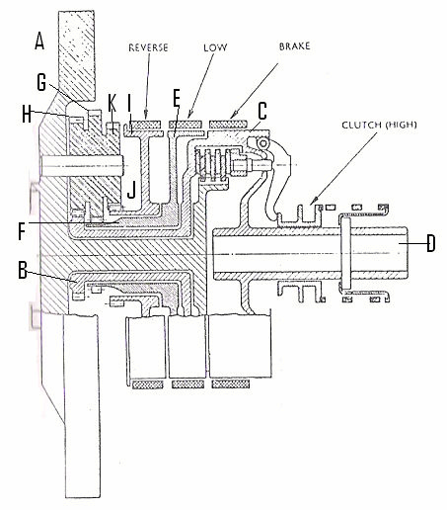
The flywheel rim A serves as planet carrier and driving member,
having lateral studs secured into it which carry triple planetary pinions. Gear
B is the driven member, being keyed to the hub of clutch drum C, which in
turn is secured to driven shaft D. By applying a brake band to drum E, gear F
is held stationary, pinion G rolls on it, and the smaller pinion H causes gear
B to turn slowly in the same direction as pinion carrier A. By applying a
brake band to drum I, gear J is held stationary; pinion H turns gear B slo wly
in the reverse direction. For the high gear or direct drive, the friction clutch
locks clutch drum C to the engine crankshaft, and the gear rotates as a unit.
The three pedals control the transmission and brakes. When the left
pedal is push down all the way, the car is low gear. To remain in low gear,
you must continue pushing on the left pedal. (It’s been said that you push a
Model T up a hill in low gear with your left foot!). If the left pedal is pushed
to the halfway position, the car is in neutral. When the left pedal is
completely released (not depressed at all) , the car is in high gear. If the car is
in neutral (either by depressing the left pedal halfway or by moving the
leaver to the left of the pedals to an upright position) the middle pedal can be
pushed to engage reverse gear. The right pedal is a brake that acts on the
transmission when pushed. Operating the brake and transmission sounds
more difficult than it really is. After some practice, most drivers don’t give it
a second thought.
Interestingly, the Model T has a planetary transmission that’s the
forerunner of the transmission. It’s very similar to an automatic transmission
expect you use foot pedal pressure to operate the bands rather then hydraulic
pressure and it doesn’t have a torque converter. The leaver at the right and
under the steering wheel is the hand throttle. It controls the speed, much like
the control found on the tractor or riding mower.
Model T’s were made from 1908 until 1927. Over 15 million Model T’s
were produced. Far more were produced than any other car until the
Volkswagen Beetle overtook its production in the 1970’s, at a time when two-
car families become the norm. The impact of the Model T’s in its day is hard
far us to imagine, but in the early 1920s, half of all cars on the road
worldwide were Model T’s.A Model T in good mechanical condition will cruise
all day at 30 to 35 mph. Most can go 45 to 50 mph but the engine is working
pretty hard at these speeds, so most drivers go this fast only briefly. These
figures also depend upon the body style and weight of the car, with roadsters
and sedans and depot hacks the heaviest.
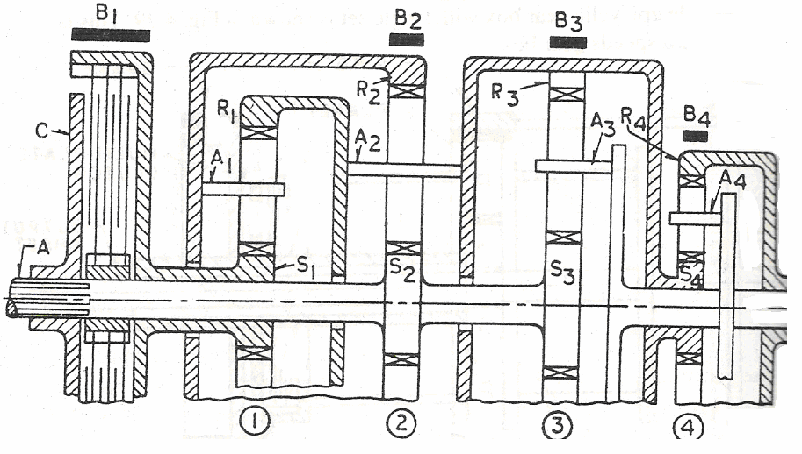
WILSON GEAR BOX
CONSTRUCTION
The gearbox comprises of three subassemblies, the running gear, the
brake harness and the control mechanism housed in an oil tight container.
This consists of a four epicyclic trains of gear inter connected, so that
different ratios and a reverse can be obtained. The direct drive is achieved by
engaging the clutch.
One train of epicyclic gearing is used for all the various ratios, its sun
S1 being secured to a shaft D coupled permanently to the engine and its arm
R1 to the shaft E which is coupled permanently to the driving road wheels
and the various ratios are obtained by driving the annulus A1 at different
speeds in relation to the engine speed.
OPERATION
FIRST GEAR
First gear is obtained by applying a brake to the first gear train
annulus A1. So that it is held stationary. The engine will then, be turning the
sun gear S1. So that the planet gears will be rolling round inside the annulus
A1 carrying their arm R1 round with them. As this arm R1 fixed to the
output shaft its motion is imported to it.
First Gear ratio:
Engine speed = 1000 rpm = sun S1 speed
Arm R1 speed = wheel speed = 1000 x s/ (a +s)
= 1000 x 25 / (100 + 25)
= 200
Where s = 25 = sun wheel teeth
a = 100 = annulus teeth
Gear ratio:
1000: 200
5: 1
SECOND GEAR
Second gear is obtained by holding the second gear train annulus A2
stationary by its brake. The main sun gear S2 still turned by the engine
cause the planet gear to revolve and their arm R2. But this arm R2 is
connected to the first gear train annulus A1 which therefore turns, speeding
up the rotation of the planet gear and arm R1 and it turning the output shaft
faster than was the case in first gear, i.e. less reduction.
Second Gear ratio:
Engine speed = 1000 rpm = sun gear S1
Annulus speed = 100 rpm
Gear ratio:
1000 : 280
3.57 : 1
THIRD GEAR
Third gear is obtained by holding the third gear sun wheel S3 by brake
drum holding. Which is interconnected further the annulus A3 is an integral
part of the second gear planet arm R2 which is in turn connected to the first
gear annulus A1. The third gear arm R3 is connected to the second gear
annulus A2 so driving it in same direction as the engine. i.e. increasing its
speed so the drive is taken back through the second gear planets and arm R2
and the first gear train annulus A1 both of which are speeded up. The result
is to speed up the first gear train arm R1 which are connected to output
shaft. In other words by interconnecting the second and third arms, an
increase of speed is obtained at the first gear train annulus, which increases
the speed of the arm R1.
Third Gear ratio:
Sun wheel S1 speed = 1000 rpm
Arm R1 speed = 360 rpm
Gear ratio: 1000 : 360
2.78 : 1
TOP GEAR
In the top gear all the gear trains are locked together and revolve as a
solid block driving the output shaft at engine speed. This is brought about by
the engagement of this driving member to the clutch which is the drum and
sun gear S3 gear train. So that locking the third gear sun to the driving
shaft.
Those are all the sun gear will be revolving at the same speed. Since the first
and second gear train sun wheel are fixed to the shaft (output) and their will
not be any individual action of the various gear train. All the brake bands
being loose their annulus.
Gear ratio:
1000 : 1000
1 : 1
REVERSE GEAR
The first gear annulus A1 is connected to the sun gear S4 of the reverse gear train
and hence drive output shaft opposite to engine rotation. When the brake is applied to the
reverse gear annulus A4 the reverse gear planet wheels turned by the reverse sun gear
connected to the first gear annulus and therefore turning opposite to the engine speed
output shaft. As the arm A4 connected to the output shaft the direction of rotation of the
propeller shaft reversed.
Reverse Gear ratio:
Sun wheel S1 = 25
Annulus A1 = 100
Sun wheel S4 = 40
Annulus A4 = 80
Gear ratio: 7 :1
COTAL EPICYCLIC GEAR BOX
CONSTRUCTION
The wheel A is integral with the engine shaft and meshes with pinions
carried by a spider A which is free to slide along the outside of the engine
shaft. When the spider B is slid to the left, its teeth E mesh with teeth F of an
annulus which is fixed to the gearbox casing. The pins of the spider then form
fixed bearings for the pinions, and so the annulus C with which the latter
mesh is driven in the opposite direction to the wheel A. This gives the reverse
drives. When the spider B is slid to the right its teeth E engage the teeth of
the annulus C and then the wheel A, pinions, spider B and annulus C revolve
‘solid’. This gives the forward drives.
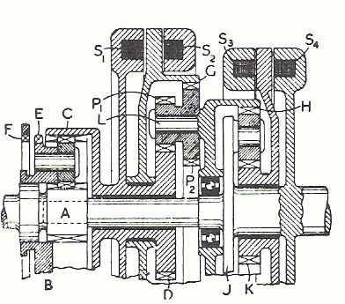
The four forward ratios are obtained by means of two epicyclic trains
arranged in tandem. One consists of the sun D (fixed to the annulus C), the
compound planets P1, P2 (carried on the pins L of the arm which is integral
with the annulus H of the second train) and the annulus G which can be held
fixed.
When this is done the annulus H is driven in the same direction as the
sun D but at a lower speed. The second train consists of the annulus H, the
sun K and the arm J which is fixed on the output shaft. The sun K can be
held at rest so that the train gives a reduction between the annulus H and
the arm J and it can also be locked to the output shaft so that the train must
revolve solid. The annulus G can also be locked to the sun D so that the first
train must revolve solid.
WORKING
The fixing and locking of the members is done by electromagnets
whose windings S1 S2 S3 S4 are energized as may be required. For first gear
S2 and S3 are energized and both epicyclic trains provide a reduction since
both annulus G and sun K are fixed. For second gear, S2 and S4 are
energized and the second train revolves solid, the only reduction being in the
first train. For third gear, S1 and S3 are energized, the first train is locked
solid and the only reduction occurs in the second train. For f ourth gear S1
and S4 are energized and both trains revolves solid so that a direct drive is
obtained.
The windings S1and S4 are carried by parts that sometimes rotate and
so these windings are connected to slip rings on which brushes bear. The
current for energizing the windings is supplied by the battery or generator of
the car and is between two and three amperes.
The control is extremely simple consisting merely of a switch which
connects the appropriate winding to the battery. This switch is usually
mounted at the center of the steering wheel.
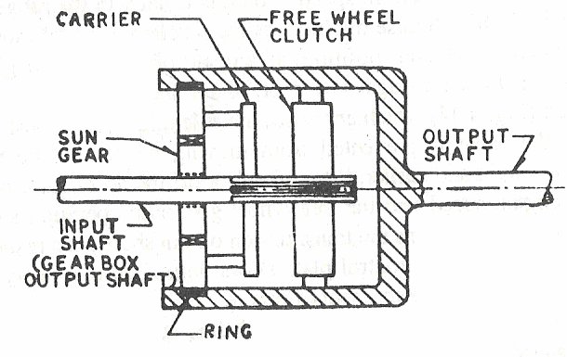
AUTOMATIC OVER DRIVE
PRINCIPLE OF THE OVER DRIVE
The principle of the overdrive is illustrated in figure, which shows a
simple epicyclic gear train. In this the gear box output shaft is connected to
the planet carrier ring while the annulus or ring gear is attached to the outer
race of the free-wheel unit and from this to the output shaft; the latter drives
the propeller shaft through the front universal coupling. The sun wheel is the
reaction member of the gear train and when it is locked to the gear box
output -or overdrive input-shaft the planet carrier which is driven by the gear
bow shaft rotates about the sun wheel carrying with it the pinion wheels
which in turn, drive the annulus gear and with it the output shaft to the
propeller shaft. The annulus rotates more slowly than the planet carrier thus
giving a lower gear ratio than for direct drive. The position in which the sun
wheel is locked to the gear box shaft, which has just been described, gives the
overdrive requirements.
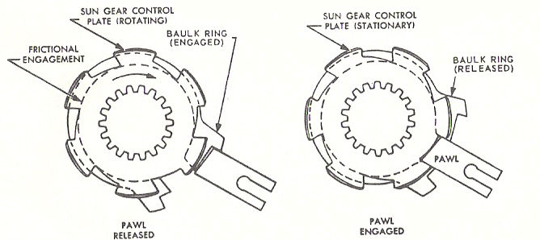
OVER DRIVE OPERATIONS
DIRECT DRIVE CONDITIONS
To obtain direct drive the overdrive gear must be locked in some
manner so as to rotate as one solid unit. This is done by connecting the sun
gear solidly with the planet carrier. The drive from the gear box shaft is then
taken through the locked epicyclic gear train and thence through the free-
wheel to the overdrive output shaft. Therefore, when in direct drive the
propeller shaft side can rotate faster than the gear box shaft. Since, however,
the direct drive is only used at speeds below about 28 to 30 m.p.h, this
advantage is only realized at these at these lower speeds.
COMPLETE OVERDRIVE
Having explained the principle of this overdrive, the purposes of the
various components should be better understood by reference to the
illustration of a complete overdrive, as used on cars fitted with three-speed
gear boxes. The annulus or ring gear and the outer race of the free-wheel are
splined to the overdrive main shaft.
The overdrive unit includes a device to lock the sun gear and hold of
stationary. To do this a centrifugal go vernor, driven by the o verdrive output
shaft is used to close the contacts of an electrical circuit which contains the
windings of the solenoid. When the road speed of the car increases to about
28 to 30 m.p.h., the governor closes the contacts and thus energizes the
solenoid which forces its plunger outwards and therefore pushes the pawl
member towards a notched ring around the overdrive input shaft; this pawl is
shown as the gear plate. Since if would not be advisable for the pawl to
engage with one of the notches in the gear plate during the rotation of the
plate the pawl of not allowed, initially, to enter a notch, being prevented from
doing so by a baulk ring which is a friction fit to the gear plate.
To obtain a smooth engage ment of the pawl it is necessary to
decelerate the overdrive input shaft, momentarily, by releasing the
accelerator pedal, so that the engine begins to slow down. Since the
momentum of the car will cause the ring gear still to rotate, the ring gear will
rotate the pinions, driving the sun gear and baulk ring in a reverse direction.
This movement of the baulk ring allows the pawl to move from the step and
engage one of the gear plate notches, thus bringing the overdrive into
operation. The engagement, after the accelerator pedal release, is so quick
that the gear plate rotates only about one-third of a turn before full
engageme nt of the pawl with a notch. This method of engagement depends
upon synchronizing the pawl movement with the momentary stopping of the
gear plate.
To release the overdrive the accelerator should be released so that the
road speed falls by 2 to 4 m.p.h below the cut-in speed; so that the governor’s
contacts open and the solenoid actuated pawl is released; the direct drive is
then re-engaged, automatically.
LOCKING THE OVERDRIVE
As mentioned earlier, in order to obtain normal top gear as given by
the gear box, it is necessary to lock the epicylic gear so that it will rotate as a
solid unit. The sun gear which is integral with the pinion shaft is therefore
locked to the planet carrier and the while unit revolves solidly.
THE KICK-DOWN CONTROL SWITCH
When the car is running in overdrive, due to the fact that the gear
ratio is then lower than for direct top gear there is, at any given speed, below
maximum, less engine power available for the overdrive than for direct drive
at the same speed. Therefore, should the driver wish to accelerate, for traffic
passing purposes, it is possible for him to do so, simply by depressing the
accelerator pedal quickly and to its full extent. The result is to release the
solenoid current but owing to the torque reaction the pawl does not leave its
notch in the gear plate and cannot do so until the torque is released
momentarily. This is done with the kick-down switch which is operated when
the accelerator pedal is depressed fully, thus switching off the ignition so that
the pawl readily leaver its notch and also the gear plate; the direct drive is
then in operation through the over running clutch.
When the driver wished to return to the overdrive he lifts his foot from the
accelerator pedal for a few seconds, when the over drive engages
automatically, unless the car speed falls below about 28 to 30 m.p.h.For
convenience the overdrive switch is of ten mounted on the carburettor, so that
it can be actuated by the accelerator pedal rod connection at the throttle
lever.
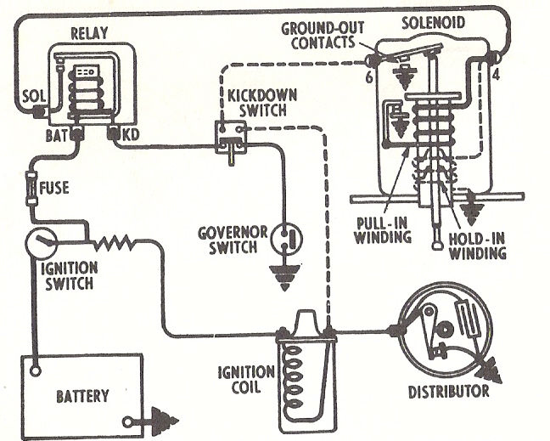
SOLENOID UNIT
The solenoid comprises (i) a heavy traction type of winding which is
provided to mo move the plunger outwards until the pawl is almost engaged
with the gear ring; (2) a hold-in winding taking much less current than (i)
which holds the plunger in its outward position; (3) relay contacts.
One set of contacts operates when the governor switch closes at 28 to
30 m.p.h., the other contacts in series with the windings (i) opens and cuts
out these windings. Since the solenoid remains energized during the whole
period of over drive engagement the current consumption is reduced
appreciably since it flows through the holding winding, only.
ELECTRICAL CIRCUITS
There are three circuits associated with the operation of the overdrive,
the circuits are shown diagrammatically.
THE CONTROL CIRCUIT
This circuit includes the solenoid relay and the electrical contacts in the kick-
down and governor switches. These two contacts must be closed for the
solenoid to operate. The relay is a type of switch operated
electromagnetically, such that when current flows through a relay winding
the relay contacts are closed. If either of the other two set of contacts are
opened, the relay contacts will be broken.
THE SOLENOID CIRCUIT
This circuit includes the solenoid winding and also the relay contacts.
When the contacts are closed the solenoid pull–in winding is energized, and
the pawl is moved towards the notched ge ar ring as explained earlier. As the
solenoid plunger completes its outward movement it opens a set of contact in
series with the pull-in winding. The current in the pull-in winding is thus
switched off and at the same time currents is switched on to the holding
winding to keep the solenoid plunger in its outward position.
THE KICK-DOWN OR IGNITION CIRCUIT
This circuit, which is indicated by the dotted lines in figure, is
connected in parallel with the ignition distributor’s contact breaker points.
Its also includes the normally open solenoid contacts which close when the
overdrive is engaged. When the kick down switch is operated the ignition coil
primary winding is earthed through these two sets of contacts thus cutting off
the ignition H.T current to the sparking plugs and thus stopping the engine
momentarily. The control circuit is opened at the same time, to allow the
overdrive to be cut out of action as explained previously.
ADVANTAGES OF OVER DRIVE
1. This device permits the engine to operate at only about 70% of the
propeller shaft speed when the car is operating in the higher speed
ranges. i.e., over drive engine speed about 30%.
2. Because the engine is not required to turn over fast at high car
speed, the use of over drive reduces engine wear and vibration and
saves gasoline.
3. Usually a slightly higher rear –axle gear ratio is employed with an
over –drive then without one.
DRAWBACKS OF OVER DRIVE
1. In descending long steep hills where the braking effect of the engine
would be lost due to slip in ORC. To avoid over drive should be
locked.
2. The driving force available at the wheels is less in case of vehicles
with over-drive.
REVERSE LOCK-UP
Since the free-wheel unit cannot power in reverse, provision is made in
the Gear-shift linkage to shift the rail and fork assembly into the lock-up
position whenever the conventional transmission is shifted take reverse gear.
OVER-DRIVE LUBRICATION
The over-drive unit is connected to the transmission and uses the same
type of lubricant, SAE 80 (or) 90 gear oil (or) SAE Engine Oil.
OVER-DRIVE GEAR RATIO
Driving member - Planet Carrier (A)
Driven member - Ring Gear (R)
Fixed member - Sun Gear (S)
RING GEAR SUN ARM
S/R -1 0
1 1 1
(R+S) / R 0 1
Over-Drive gear ratio = Driving / Driven
= 1 / ( ( R+S ) / R )
= R / ( R+S )
If number of teeth in ring gear is 140 and sun gear are 60.
Then,
The Over-Drive gear ratio =140 / ( 140 + 60 ) = 0.7.
= 0.7 : 1
HYDRAULIC CONTRO L SYSTEM
The hydraulic control system of the automatic transmission is shown
in figure. Which is a simplified diagram illustrating the basic principles.
Hydraulic fluid is drawn from input and ensures that pressure is available as
soon as the engine starts. The rear pump is driven from the output shaft so
that pressure is generated in this pump as soon as the vehicle moves, and
this feature provides a means of preventing the reverse and park
mechanisms being engaged whilst the vehicle is in motion. Non-return valves
ensure that hydraulic pressure can be available from either pump and the
joint delivery is regulated to a suitable pressure by a pressure relief valve.
The fluid at regulated pressure is fed to the converter which is kept full of
fluid and a small flow from the converter is used for lubrication of the
gearbox.
The main fluid supply is fed to the manual selector valve which is
controlled by a steering-column selector lever, and this may be moved to any
of five positions. This valve may direct fluid under pressure to the reverse
brake when a reverse ratio is obtained. In the low selection, fluid is applied to
both the forward and low brakes and maintains the transmission in low gear.
Neutral selection is obtained by removal of pressure from all friction
elements, and the park position engages a mechanical lock preventing
rotation of the output shaft.
When the Drive selection is made the manual selector applies fluid
under pressure to the Forward and Low brakes and also to the governor
valve. The governor valve is moved by the combination of an accelerator
pedal movement together with the position of a centrifugal governor. At low
road speeds the governor valve is blocked and the transmission is retained in
low gear. At a higher road speed the governor valve moves to apply fluid at
pressure to the multi-plate clutch so as to engage Intermediate gear. As the
multi-plate clutch begins to take up the drive the pressure in the clutch rises
and becomes sufficient to operate the relay valve and cut off the fluid supply
to the low friction brake band. This relay valve carries out the transition from
Low to Intermediate clutch. This relay valve corresponds to the more usual
shift although in this case the valve is moved by spring force in opposition to
hydraulic pressure.
The change into direct drive is effected by the application of fluid
pressure to the single-plate clutch by the governor valve. The other friction
elements remain in the same condition as for the Intermediate gear so that
no transition from one element to another is needed. No smoothing device is
incorporated for the take-up of this clutch, which relies on the capacity of the
clutch piston to give a steady build-up of pressure. Gear changes to lower
ratios operate in the reverse sequence.
The complete hydraulic circuit diagram is only slightly different from
the simplified block diagram and a typical system. It will be noted that a
hydraulic accumulator is included to give a rapid initial flow of fluid when
the selector or governor valves operate, and a converter shuffle valve adjusts
the converter pressure to a higher valve in low gear. A small hydraulic detent
applies a slight bias to the governor valve so that hunting, or repeated gear
changes between two ratios, is avoided. Interlocks are provided to prevent
engageme nt of the mechanical Park interlock mechanism when the rear
pump is generating pressure, indicating movement of the output shaft. A
similar interlock piston prevents Reverse gear being engaged when rear
pump pressure is available. This piston operates so as to block the control
line which supplies pressure to the Reverse servo pistons. The relay valve is
restored by hydraulic pressure to ensure a rapid operation of the piston
return spring when a manual selection of low is made
HYDRAULIC COMPONENTS
A summary of the functions of the various hydraulic components is
given in an abbreviated manner.
Front Pump: Driven from input shaft and provides the main hydraulic
supply.
Rear Pump: Driven by output shaft and acts as an auxiliary supply in case
of front pump failure, and also to detect forward movement of the vehicle.
Pressure Relief Valve: Regulates hydraulic supply pressure from both
pumps to predetermined values. Initially, the relief valve springs ensure that
20 lb. /sq. in. pressure is admitted to the back of the relief valve raising the
system to 80 lb. /sq. in. which is the normal pressure. When Reverse is
selected, hydraulic pressure is applied to another piston so as to raise the
pressure to 200 lb. /sq. in
Ball valves: Two balls inserted in the main supply line prevent a failure of
either pump causing a complete loss of pressure. The system is arranged so
that either pump will supply the control system as soon as the vehicle is
moving.
Hydraulic Accumulator: Spring deflects when pressure is applied and the
accumulator piston retracts in the cylinder to store a small volume of fluid at
pressure. At a given deflection of the piston, fluid is admitted to the back of
the pressure relief valve to increase the regulated pressure.
“Park” Interlock: A small spring loaded piston deflects due to pressure
from the rear pump to prevent engagement of the Park lock.
Reserve Interlock Valve: A spring loaded piston deflects due to pressure
from the rear pump to prevent pressure being applied to the Reverse band
brake.
Manual Selector Valve: operated by the selector lever for the five positions:
park, netural, drive, low and reverse.
“Park,” “Neutral” positions: All pressure is cut off from the friction
clutches and bands. The park mechanism is operated from the selector lever
but will not engage if the vehicle is moving forwards.
“Drive” position: Pressure is applied to the forward and low band brakes
and also to the governor valve.
“Low” position: Pressure is maintained on the forward and low bands but is
removed from the governor valve and applied to the back of the relay valve.
Governor valve: Operated by a combination of road speed (as measured
from the output shaft), together with the accelerator pedal position. The
valve initiates the gear changes between low and intermediate ratios and
between intermediate ratio and direct drive at predetermined speeds when
the manual selector valve has been moved to drive.
Converter shuttle valve: Regulates the flow of fluid into the hydraulic
converter-coupling. Fluid is supplied from the main supply line to the valve
and flows through a conical shaped valve seat. When reverse is selected, or
when intermediate or direct gear is operative the pressure applied to the
converter by inserting a conical plug into the valve seat so that an orifice of
reduced size is presented to the flow. An increased pressure, and hence, flow
is permitted for the low selection.
“Reverse” Position: Pressure is applied to the Reverse band brake, via the
interlock valve. Pressure is also applied to the converter shuttle valve and
the main relief valve.
Lubrication valve: The fluid drive is maintained at pressure by a spring
loaded ball valve. When the pressure exceeds the set value the balls lifts and
permits a flow of fluid through the converter. The escaping fluid is used for
lubrication of the gearing.
Clutch Pistons: The single plate friction clutch and the multi-plate
Intermediate clutch are both operated by annular pistons which fit in
appropriate housings and apply the necessary load to the friction plates when
fluid pressure is available.
Brake Pistons: The friction band brakes are applied by servo pistons which
develop the necessary loads to hold the brake drums stationary. The servo
cylinders each contain two pistons which act in tandem. A small restriction is
placed between the two pistons as a means of smoothing the application and
release of the bands.
UNIT – IV
HYDROSTATIC DRIVE AND ELECTRIC DRIVE
HYD ROSTATIC DRIVE
In this type of drives a hydrostatic pump and a motor
is used. The engine drives the pump and it generates hydrostatic pressure on
the fluid. The pressurized fluid then fed to the motor and the motor drives
the wheel. In these transmissions mechanical power is generated in the
motor as a result of displacement under hydraulic pressure. The fluid, of
course, also carries kinetic energy, but since it leaves the motor at the same
velocity as that at which it enters, there is no change in its kinetic- energy
content, and kinetic energy plays no part in the transmission of power.
PRINCIPLE OF HYDROSTATIC DRIVE SYSTEM
LAYOUT OF HYDROSTATIC DRIVE SYSTEM
It consists of a pump, which converts torque and rotation of
mechanical shaft into flow of pressurized f luid combined with a hydraulic
motor, which converts fluid flow under pressure into rotating torque on the
output shaft. The pump and motor are identical in construction but they may
vary in size and displacement, particularly when torque multiplication is
needed. By employing variable delivery of hydraulic units, it is possible to
obtain a wide range of output ratios.
VARIOUS TYPES OF HYDROSTATIC SYSTEMS
1. CONSTANT DISPLACEMENT PUMP AND CONSTANT
DISPLACEMENT MOTOR
Here both of the pump and motor are constant displacement type.
Hence, variation of output torque or speed is not possible. So, this system is
not used. This system suffers loss of power due to the provision of
intermediate relief valves. Such a transmission is similar to a very flexible
mechanical drive shaft except for slight speed loss as load increases due to
slip both in the pump and in the motor.
2. VARIABLE DISPLACEMENT PUMP AND CONSTANT
DISPLACEMENT MOTOR
With a variable displacement pump and fixed displacement motor, it is
possible to obtain variable output speed from motor, which can be smoothly
controlled from the designed maximum value to zero. This system provides a
constant output torque throughout the speed range.
It can be used to drive one or more hydraulic motor, and it gives equal
performance in both forward and reverse speeds. Power output varies in
direct proportion with output speed. This system can be advantageous in
tractors and construction equipments. With the pump at zero output an
idling condition is produced which is analogous to a disengaged clutch. The
transmission can be reversible without the need for a directional control
valve simply by reversing the pump.
Pump displacement
Motor displacement
Speed
in cc
in cc
ratio
0 0 0
75 375 5
375 375 1
3. CONSTANT D ISPLACEMENT PUMP AND VARIABLE
DISPLACEMENT MOTOR
Fixed displacement pump and variable speed motor, capable
of giving constant power output, which is independent of output speed.
Output torque and speed can be continuously varied. This transmission can
be used with advantages along with a governed engine to ensure the
application of constant input power to transmission.
Crank radius of pump is fixed. So, displacement 375 cc is governed at
maximum BHP level. If power is more important than torque this system is
applied in such situations.
4. VARIABLE DISPLACEMENT PUMP AND VARIABLE
DISPLACEMENT MOTOR
This combination can give either a constant power or a constant torque
drive. A wide range of speed variation may be obtained, the maximum motor
speed being with the pump at full output and the motor at minimum
displacement per revolution and vice-versa for minimum speed.
The torque capacity is in inverse proportion. Since both are variable
type, the torque ratio can be varied widely. When both the pump and motor
are of variable displacement type, possibilities of infinite variation of output
speed and output torque are available.
ADVANTAGES OF HYDROSTATIC DRIVE
1. Hydrostatic drive eliminates the need for mechanical transmission
components like clutch and gearbox as well as allied controls.
2. It provides for smooth and precise control of vehicle speed and travel.
3. This system ensures faster acceleration and deceleration of vehicle
4. It offers better flexibility in vehicle installation because of wide range
in choice of pumps and motors of different capacities and of fixed or
variable displacement type. Besides hydraulic fluid pipes lines replace
mechanical transmission drive line components
5. The ease with which the reverse drive can be obtained makes the
hydrostatic drive more attractive. This drive is fully reversible from
maximum speed in one direction to zero speed and to maximum speed in
the reverse direction.
LIMITATIONS OF HYDROSTATIC DRIVE
1. Noisy in operation
2. Heavier in weight and larger in bulk
3. Costlier when compared to other types of transmission
4. Manufacturing of pump and motor requires high precision
machining of components and skilled workmanship
5. In view of high pressure employed in system, the working
components are heavier. It also possesses problem of oil
leakage through oil seals.
APPLICATIONS OF HYDROSTATIC DRIVE
1. It is used to move the machine tools accurately.
2. Used in steering gears of ship.
3. Used in war ships to operate gun turrets.
4. Used in road rollers, tractors, earth movers, heavy duty trucks.
COMPARISON OF HYDROSTATIC DRIVE WITH HYDRODYNAMIC
DRIVES
1. Torque ratio is lesser in hydrostatic drives for different speed ratios
2. Hydrostatic offers high efficiency over a wide range of speeds when
compared to hydrodynamic drives.
3. Vehicle with hydrostatic drive has no tendency to creep unlike
hydrodynamic drive during idling.
4. Dynamic braking of vehicle is an inherent feature of hydrostatic drive.
This feature helps to eliminate conventional shoe or disc type of
brakes. Creep is caused to drag torque, movement of vehicle during
idling
5. Throughout the operating torque range, the vehicle operates at almost
constant speed, whether the vehicle is moving uphill or downhill or
when the load is suddenly removed.
6. Pressure relief valve as a basic part of any hydrostatic transmission
and this provides complete overload protection to the engine as well as
hydraulic system.
JANNEY HYDROSTATIC D RIVE
CONSTRUCTION AND WORKING
A hydraulic transmission known as the Janny has long been built by
the Waterbury Tool Co. of Waterbury, Conn., for various industrial uses, and
it has been applied also to motor trucks, rails and diesel locomotives.
PUMP: Nine cylinders, axially disposed, variable stroke, swash plate type.
MOTOR: Nine cylinders, axially disposed, swash plate type, constant stroke.
A longitudinal section through the whole assembly is shown in figure.
Practically the only difference between pump and motor is in former inclination of
swash plate is adjustable while in latter it is not. Referring to the drawing Both the
pump and the motor unit have central shafts which project at one end only, each
shaft is supported by plain bearing in housing and a roller bearing in valve plate. To
the inner end of shaft is keyed, a cylinder block in which there are 9 bores forming
the working cylinder. The bores are parallel with the axis of rotation and equally
spaced around it.
When the cylinder block revolves, cylinder head slide against the valve
plate. A port in each of cylinder head registers alternatively with two annular
ports in valve plate for admission and delivery of oil, respectively. Each port
extends over approximately 125º, and since there is port opening from the
time the cylinder port begins to register with the valve plate port to the time
it passes out of registry therewith port opening extends over nearly 180º.
The spring surrounding the shaft, serve to press the cylinder block
against valve plate when no load is transmitted. During transmission of
power, the fluid pressure keeps all parts in close contact. The cylinder block
is so mounted on the shaft that it can slide thereon, and also it can rock
slightly. This enables the block to seat correctly on valve plate even if there
should be slight misalignment, or if wear should have occurred.
The plunger is lapped into bores to a clearance of 0.001”. Each plunger is
connected to socket ring by a connecting rod with spherical heads. The rods have
drill holes extending through their shanks, and there is a small drill hole also in the
head of the piston, hence the bearings of the connecting rod are lubricated with the
oil in the power transmission circuit, and the pressure under which lubricant is
supplied to the bearing surfaces is proportional to the load.
Each socket ring is connected to shaft by means of universal joint, so that
while it revolves with the shaft, its plane of rotation may bear any angle with the
axis of the shaft. In case of pump unit, angle of socket ring can be varied between
0deg and 20deg in either direction by means of control lever connected to roller
bearing tilting box. In motor unit, the angle box is secured to housing and has a
fixed inclination of 20deg.
PUMP
If the angle box is set of right angles to the shaft, there will be no
reciprocation of plungers in cylinder when cylinder block is revolving, and,
consequently, no oil will be moved. When the angle box is set to make an
angle with the shaft, the plungers begins to reciprocate in the cylinders as
they revolve around with the block. Each cylinder draws oil through the port
in valve plate during one half of the revolution and delivers oil through
delivering port in valve plate during next half of revolution.

MOTOR
The motor unit is merely an inversion of the principle of the pump
unit, oil entering the cylinder under pressure forcing the plunger outward
and the reaction between socket ring and swash plate causing cylinder block
and its shaft to revolve. If the angle plate of pump unit is set to the same
angle as that of motor unit, then the motor will turn the same speed as pump
unit and any speed lower than this can be obtained on motor shaft by merely
reducing the angularity of auto angle box.
HYDROSTATIC TRANSMISSION
INTRODUCTION
Hydrostatic transmissions are hydraulic systems specifically designed
to have a pump to drive a hydraulic motor. Thus, a hydrostatic transmission
simply transforms mechanical power into fluid power and then reconverts the
fluid power back into shaft power. The advantages of hydrostatic
transmissions include power transmission to remote areas, infinitely variable
speed control, self-overload protection, reverse rotation capability, dynamic
braking, and a high horsepower-to-weight ratio. They are used in
applications where lifting, lowering, opening, closing, and indexing are
required. Specific applications include materials handling equipment, farm
tractors, railway locomotives, buses, automobiles, and machine tools.
A system consists of a hydraulic motor, and appropriate valves and
pipes can be used to provide adjustable-speed drives for many practical
applications. Such a system is called a “Hydrostatic Transmission.” There
must, of course, be a prime mover such as an electric motor or gasoline
engine. Applications in existence include tractors, rollers, front-end loaders,
hoes, and lift trucks. Some of the advantages of hydrostatic transmissions are
the following:
1. Infinitely variable speed and torque in direction and over the full
speed and torque ranges.
2. Extremely high horsepower-to-weight ratio.
3. Ability to be stalled without damage.
4. Low inertia of rotating members permits fast starting and stopping
with smoothness and precision.
5. Flexibility and simplicity of design.
The internal features of a variable displacement piston pump and
affixed piston motor used in a heavy–duty hydrostatic transmission. Both
pump and motor are of the swash plate in-line piston design. This type of
hydrostatic transmission is expressly designed for application in the
agricultural, construction, materials-handling, garden tractor, recreational
vehicle and industrial markets.
The operator has complete control of the system, with one lever for
starting, forward motion, or reserve motion. Control of the variable
displacement pump is the key to controlling the vehicles. Prime mover horse
power is transmitted to the pump. When the operator moves the control
lever, the swash plate in the pump is tilted from neutral. When the pump
swash plate is tilted, a positive stroke of the pistons occurs. This, in turn, at
any given input speed, produces a certain flow from the pump. This flow is
transferred through high pressure lines to the motor. The ratio of the volume
of flow from the pump to the displacement of the motor determines the speed
at which the motor will run. Moving the control lever to the opposite side of
neutral causes the flow through the pump to reverse its direction. This
reverses the direction of rotation of the motor. Speed of the output shaft is
controlled by adjusting the displacement (flow) of the pump.
Load (working Pressure) is determined by the external condition
(grade, ground conditions, etc.), and this establishes the demand on the
system. The shutoff valve is included to facilitate a filter change without a
large loss of fluid from the reservoir. The heat exchange ensures that the
maximum continuous oil temperature will not exceed 180°F.
OPEN TYPE ONE WAY HYDROSTATIC TRANSMISSION
There are two types of hydrostatic transmission system. They are
closed and open circuit drives. In open circuit drive the pump draws its fluid
from the reservoir. Its output is then directed to a hydraulic motor and
discharge from the motor back into the reservoir. In a closed circuit drive,
exhaust oil from the motor is returned directly to the pump inlet. The figure
gives a circuit of a closed circuit drive that allows foe only one direction of
motor rotation. The motor speed is varied by changing the pump
displacement. The torque capacity of the motor can be adjusted by the
pressure setting of the relief valve. Makeup oil to replenish leakage from the
closed loop flows into the low-pressure side of the circuit through a line from
the reservoir.
CLOSED TYPE REVERSIBLE HYDROSTATIC TRANSMISSION
Many hydrostatic transmissions are reversible closed circuit drives
that use a variable displacement reversible pump. This allows the motor to be
driven in either direction and at infinitely variable speeds depending on the
position of the pump displacement control. The Figure shows circuit of such a
system using a fixed displacement hydraulic motor. Internal leakage losses
are made up by a replenishing pump, which keeps a positive pressure on the
low-pressure side of the system. There are two check and two relief valves to
accommodate the two directions of flow and motor rotation.
ELECTRIC DRIVE
Electric drive equipment for transportation units consists of a
generator driven by the prime mover, a motor or motors in direct connection
with the driving wheels of the unit and supplied with current from the
generator and the necessary control apparatus. In locomotives the generator
is separately excited, as a rule, and the equipment then includes a small
additional generator, the exciter.
PRINCIPLE OF ELECTRIC TORQUE CONVERSION
With electric drive, speed control of the vehicle can be done either
electrically or by varying the speed of prime mover. In the first the engine
and direct connected generator operate at constant speed under the control of
a governor. This system was in favor during pioneer days, when gasoline
engines had very little flexibility. The other system, in which practically all
speed control of the vehicle is effected by means of the engine throttle or fuel
control rack was used exclusively during the later days of bus electric drive.
EARLY WARD LEONARD CONTROL SYSTEM
An early method of obtaining a variable speed drive electrically from a
constant speed prime mover is known as the Ward Leonard system. It
comprises a generator whose field current is obtained from a separate exciter.
Generator terminals are directly connected to the terminals of the motor,
whose field is also separately excited, from the same source as the generator
field. But whereas the field of the motor is at all times excited to the point of
saturation, the field current of the generator is controlled by means of a
rheostat.
With the generator driven at constant speed, its voltage and output
will vary with the field strength, which in turn varies with the exciting
current, and with the motor field maintained at constant strength by the
exciter, the speed of the motor will vary almost in direct proportion to the
generator voltage, and the motor torque in direct proportion to the current
passing from the generator to the motor. With this system, the reversal of
drive is effected by reversing the direction of current flow through the
generator field.
MODIFIED WARD LEO NARD CONTROL SYSTEM
For application in the traction or transportation field, certain
modifications have been made in the original Ward Leonard system. In the
first place, the field polarity of the generator is not changed, and reverse is
achieved by reversing the direction of current flow through the field coils of
the motor.
The motor moreover is a series motor, as generally employed for
traction purposes. Generator speed being constant, the torque load on the
engine varies with the excitation of the generator field and the current output
of the generator.
In some cases, the separately excited field coil is supplemented by a
differential series field coil, that is, a coil through which the main current
from the generator flows, but in such a direction that it tends to demagnetize
the filed. This differential series field is so proportioned with the engine
running at its normal speed, and the throttle wide open, the generator
supplies its f ull load current at the normal emf to the motor.
Vehicle speed can be controlled manually by means of a rheostat in the
exciter circuit, and the differential series field automatically takes care of any
change in traction resistance. For instance, if the vehicle encounters a grade,
it will slow down, and so will the motor, which is geared to it directly. An
increased current then flows from generator to motor, but this increased
current, passing through the differential series field coil, weakens the field of
the generator, thereby reducing the voltage of the generator and limiting it
output. As the generator field is weakened, the engine speeds up, and at
higher speeds the engine generates more power, which takes care of the
increased load due to the grade.
In the design of such drives, the aim is so to proportion the two source
of the field excitation that as the current output of the generato r increases in
a certain proportion, the generator voltage drops in the inverse proportion, so
that the output remains constant. If this object is attained, then the electric
drive can absorb the maximum engine power under all driving conditions, if
necessary. Engine output and vehicle speed can always be controlled by
means of rheostat in generator field.
ELECTRIC DRIVE FOR BUSES
Electric drive systems generally consist of shunt wound generators and
series wound motors. However, the generator field may be provided also with
a so-called teaser winding, through which current from the car battery flows
for a short time, while the engine is being accelerated. A differential series
wounding may also be used, but it is generally omitted.
The generators and the motors are always provided with commutating
poles, to make possible sparkles commutation. The reason for the teaser
winding is that a conventional shunt wounding generator, when speeded up,
picks up voltage gradually, and with such a generator there is a tendency for
the engine to “race” when the accelerator pedal is depressed.
With the teaser winding, the full voltage of the car battery is applied
as soon as the accelerator is depressed beyond the idling position; hence
generator field strength and voltage build up rapidly. As the engine gains
speed, the teaser circuit is interrupted automatically by a switch actuated by
a relay connected across the generator mains.
ADVANTAGES OF ELECTRIC DRIVE
1. In the bus field the electric drive replaced a conventional geared
transmission, over which it had certain operating advantages.
2. It afforded continuous acceleration throughout the entire speed range,
and the shocks sometimes experienced in a bus with mechanical drive
when resuming after a gear change were eliminated. Such shocks were
particularly annoying to passengers who had just entered and not yet
seated. Passengers, generally, therefore preferred the electric drive.
3. Another advantage was greater ease of operation. In city operation the
driver of a bus had to make several thousands gear changes a day,
each shift preceded by disengagement of the clutch against a spring
pressure of the order of 50 lb. With electric drive there were no such
tiring operations, consequently the driver was less fatigued, and
accident hazards were said to be reduced.
4. As all of the engine power was absorbed by the generator, which was
connected directly to the engine, there was no torque reaction on the
frame, and the power plant could have a very flexible mounting, which
reduced noise and vibration in the bus.
5. Electric drive also eliminated both the exhaust fumes, which
frequently annoyed passengers when a gasoline bus was brought to a
stop and the smoky exhaust of the diesel engine when operating at low
speed under heavy torque load. The fumes were due to incomplete
combustion occurring when the throttle was closed and the engine
driven by the vehicle, and diesel exhaust smoke was eliminated or
least reduced because with electric drive the engine speed is not
reduced in direct proportion to bus speed.
LIMITATIONS OF ELECTRIC DRIVE
1. Excessive weight of the equipment, high production cost, and relatively
low efficiency over the greater part of the speed range.
2. With the introduction of hydraulic torque converter drives, which were
much lighter, less expensive to produce, and more efficient, electric
drive disappeared from bus field.
PERFORMANCE CHARACTERISTICS OF ELECTRIC DRIVE
When the vehicle encounters increased resistance to motion, the motor
is pulled down in speed, develops less counter-electromotive force, and draws
more current. Since the current can come only from the generator, the output
of the latter will be similarly increased. In fact, the current received by the
motor is exactly the same as that delivered by the generator, except for the
small amount required for the generator shunt field.
If the field strength were constant, generator voltage would be
directly proportional to armature speed, and generator current to torque
impressed on the generator armature in excess of that necessary to overcome
bearing and brush friction. But the field strength is not constant in either the
generator or the motor.
The motor has a series field winding, and if its armature current
increases, the current through its field coils increases equally. Therefore,
since more torque is proportional to both armature current and strength of
magnetic field, it always increases faster than armature current, and a curve
of motor torque with respect to current flow is convex toward the current axis
over the range of currents corresponding to normal loads.
The exact opposite holds in the case of generator. Field
excitation of the generator is derived from the shunt winding connected
across the generator means. When the current delivered by the generator
increases there is an increase in potential drop in armature windings, and
consequently a decrease in terminal voltage and in field excitations due to
shunt coils.
Hence even if the generator speed remained absolutely constant, the
field strength would decrease with an increase in armature current.
However, with increased torque load on the engine due to the greater
armature current, the engine speed will drop, which results in a further
decrease in terminal voltage and in field strength.
Thus there is an inherent tendency for the field strength of the
generator to decrease with an increase in armature current. The horsepower
output of the generator is proportional to the product of voltage and current,
and if the generator voltage drops while the current increases, there is a
tendency for the engine load to remain constant regardless of rear axle
torque. If this tendency is not sufficiently pronounced it can be strengthened
by providing the generator with the small reverse series winding which tends
to demagnetize the field.
CURVES OF GENERATOR INPUT TORQUE AND MOTOR TORQUE
vs. ARMATURE CURRENT
This automatic change in the ratio of torque conversion by the
electrical system is well illustrated in figure, which represents torque curves
of generator input (engine torque) and of motor output. It will be noticed that
with a current flow of 120 amps the generator torque is about 220 lb-ft, and
that there is only little variation in the generator torque from this point on,
the maximum value being a little more than 250 lb-ft. on the other hand, the
motor torque, which is about 85 lb-ft with a current flow of 120 amps,
becomes 410 lb-ft with a current flow of 400 amps. Thus at 120 amps, the
torque is decreased as it would be with a mechanical overdrive having a ratio
of 0.385:1.00, while at 400 amps, when the generator torque is 230 lb-ft, the
torque is multiplied the same as with a mechanical reduction gear with a
ratio of 1.78:1.00. At 400 amps, therefore, the torque conversion ratio is about
4.6 times as great as at 120 amps.
CURVES OF GENRATOR SPEED AND MOTOR SPEED vs.
ARMATURE CURRENT
The variation of the generator and motor speeds with current flow is
shown in figure. It will be seen that generator speed is nearly constant over a
wide range of current flow, from which it follows that with electric drive the
engine runs at nearly constant speed.
Moreover, with both the speed and the torque of the engine output is
practically constant under all operating conditions. The motor speed, on the
other hand, varies inversely as the motor torque, high motor speed,
corresponding to a small current and a low motor torque, and low motor
speed to high motor torque.
SEPARATE EXCITATION
When it was first attempted to connect a vehicle motor directly to a
generator driven by a combustion engine without having a battery floating on
the line, one difficulty that was experienced was that when the driver opened
the throttle quickly for a rapid get-away, engine would be momentarily
without adequate load and would “race” which not only injurious to its
mechanism, but resulted in unpleasant vibration. This difficulty was
overcome by providing a certain amount of separate excitation, the current
for which, must come from a battery. The teaser current from the battery is
kept flowing for a short time only, until the voltage across the generator
mains has built up sufficiently, and thereafter the generator is self-excited.
Interruption of the teaser current is brought about by a cut-out are teaser
relays. If the teaser cut-out is provided with a shunt coil and a series coil, the
time the teaser coil continues to carry current depends not only on the rate at
which the generator is accelerated, but also on the load it carries.
ELECTRIC BRAKES
When there is no direct mechanical connection between the engine and
the driving wheels, the engine cannot be used as a brake. The electric motor,
however, lends itself to the same purpose. It can be used either as a mild
brake, to prevent the bus from attaining too high a speed in descending
grades, or as a severe brake, for emergence. In the first case the motor is
merely disconnected form the generator and its circuit is closed through a
resistance. The braking power of an engine can be varied by means of the
throttle. Ordinarily however, only one step is provided. Emergency braking is
effected by connecting the motor to the generator in reverse, with a resistance
in circuit. The braking effect then depends on the throttle position, and can
be controlled by means of the throttle.
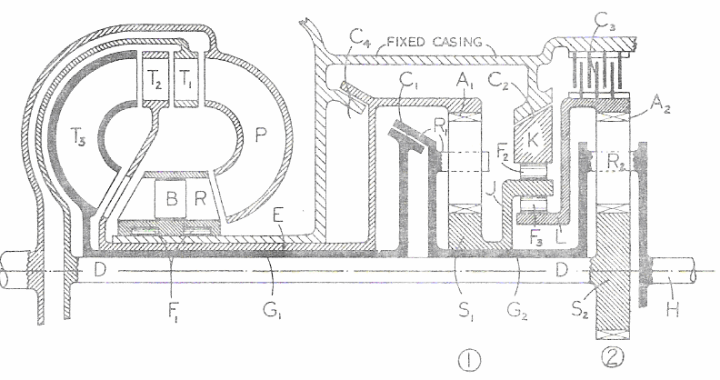
UNIT V
AUTOMATIC TRANSMISSION APPLICATIONS
CHERVROLET TURBOGLIDE TRANSMISSION
This is a combination of a converter and an epicyclic gear and is shown
in figure. The converter has five elements, the pump P, three turbines or
driven elements T1, T2 and T3, and a reaction member R. The latter is free to
rotate in the forward direction on the freewheel F1 and is provided with a set
of blades B, whose angles are adjustable; the mechanism for making the
adjustment is not indicated.
The first turbine element T1 is coupled by the shaft D to the sun S2 of
the second epicyclic train; the second turbine T2 is coupled through the sleeve
E to the annulus A1 of the first epicyclic train and the third turbine T3 is
coupled to the output shaft H by the sleeve G1, the clutch C1 (which is
always engaged except when neutral and reverse are selected), the sleeve G2
and the planet carrier R2.
The sun S1 is normally prevented from rotating backwards by the free
wheel F2, since usually the clutch C2 is engaged and the member K is fixed
so that the sleeve J cannot rotate backwards. The annulus A2 is also
prevented from rotating backwards by the freewheel F3 which locks it for
such rotation to the sleeve J. Engagement of the clutch C3 fixes the annulus
A2 against forwards or backwards rotation, and this is done when ‘low’ is
selected so as to reduce the load on the freewheel F3, when the engine is
pulling hard under adverse road conditions, and to allow the engine to be
used effectively as a brake on down gradients.
At low forward speeds of the output shaft H relative to the engine
speed, the sun S1, and annulus A2 will be stationary because the torques on
them will tend to make them rotate backwards and this motion is prevented
by the freewheels F2 and F3. Both epicyclic trains then provide speed
reductions and torque increases, and all three turbines will be driving.
As the output speed rises, the torque passing through the sun S2 will
fall and at some point will tend to become negative, and then the annulus A2
will start to rotate forwards and the turbine T1 will be effectively out of
action. At a higher output shaft speed, the sun S1 will start to rotate
forwards and the turbine T2 will go out of action. The drive will then be
through T3 direct to the output shaft, the only torque magnification then
being that due to the torque converter itself.
Finally, the reaction member R will start to rotate forwards and the
torque converter will run as a fluid coupling. The speeds and torques at
which these events occur will depend on the angle at which the blades B are
set.
Reverse is obtained by engaging the clutch C4 and disengaging C1, C2
and C3. The trains 1 and 2 are then compounded and give a reverse ratio, the
whole of the driving torque being transmitted by the turbine T1 and sun S2.
Forward motion of S2 tends to drive R2 forwards and A2 backwards;
backward motion of A2, however, results in backward motion of S1 (through
the free wheel F3 and the sleeve J) and so in train 1, whose annulus is fixed,
the sun tends to rotate the planet carrier R1 backwards. The backward
torque on R1 is greater than the forward torque on R2 (from S2), and so R1
and R2 will move backwards.
CHEVROLET POWERGLIDE TRANSMISSION
Chevrolet power glide transmission comprises of a three-element
hydraulic torque converter and a two-speed and reverse planetary unit.
CONSTRUCTION
TORQUE CONVERTER
The impeller and runner are of fabricated construction, and have 31
and 33 vanes, respectively. Their pressed-steel vanes have tabs that fit into
slots in the shells, and after assembly the tabs are spun flat to hold the parts
together. The cast aluminum reactor has 12 vanes of hydrofoil section cast
integral with the hub, and a wide ring of concave section welded to the ends
of the vanes. The reactor is mounted on an over running clutch of the roller
type. The torque ratio of the converter at stall is 2.10:1
PLANETARY GEARBOX
By providing intermediate gears between the sun gear and planetary
gears meshing with a ring gear, it is possible to use the same sun gear and
the same planetary gears for both the low forward speed and the reverse, and
this arrangement is used in automatic transmissions incorporating a
hydrodynamic torque converter.
Reverse
Band 2
R
Band 1
Low
Reverse
Gear
C
Planet
High
Carrier
P
1
S
1
S
2
Sun
OUTPUT
INPUT
Gear
SHAFT
SHAFT
Reaction
Gear
Pc
Intermediate
Gear
Band 1
Band 2
Two small adjacent gears are carried on the driving shaft-a driving sun
gear splined thereon. The reaction gear can be held from rotation by means of
a friction band. Three planetary gears mesh with both the ring gear and the
reaction gear, and three intermediate gears of slightly more than the
combined face width of sun gear and reaction gear mesh with both the sun
gear and planetary gears.
OPERATION
For low speed the reaction gear is held from rotation by means of its
friction band. The sun gear, which is supposed to turn left-handedly as
indicated by the arrow, will turn the intermediate gears right-handedly and
the planetary (or reverse) gears left-handedly around their respective axes.
The planetary gears then roll on the reaction gear and carry the planet
carrier--the driven member–along with them; hence the driven member turns
in the same direction as the driving shaf t, but at a reduced speed. While the
assembly is being used as a low-speed forward gear the ring gear turns idly
in the same direction in which the sun gear and planet carrier are turning.
For direct drive the reaction gear is locked to the driving shaft by
means of a multiple-disc friction clutch. As the two central gears are then
locked together, it is impossible for the planetary gears to turn on their studs,
and the whole assembly rotates as a unit.
For reverse motion the ring gear is held from rotation by its friction
band. The sun gear, turning left-handedly, rotates the intermediate gears
right handedly and the planetary or reverse gears left-handedly, and the
later, rolling on the ring gear, carry the planet carrier along with them in the
right-hand direction, or in the direction opposite to that of the sun gear. At
the same time the reaction gear, which is now released by its friction band,
idles in the direction in which the planet carrier turns.
When the driver sets the selector lever in Drive and depresses the
accelerator pedal, the car will start in low gear, and at a speed determined by
the movement of the accelerator pedal will automatically shift into High gear.
The selector lever has five positions: Park, Neutral, Drive, Low, and Reverse.
To get the lever into the park position, it must be lifted above its normal
level, and to get into Reverse it must be lifted over a stop.
GEAR RATIOS
First Gear : 1.82 : 1
High Gear : 1 : 1
Reverse Gear : 1.82 : 1
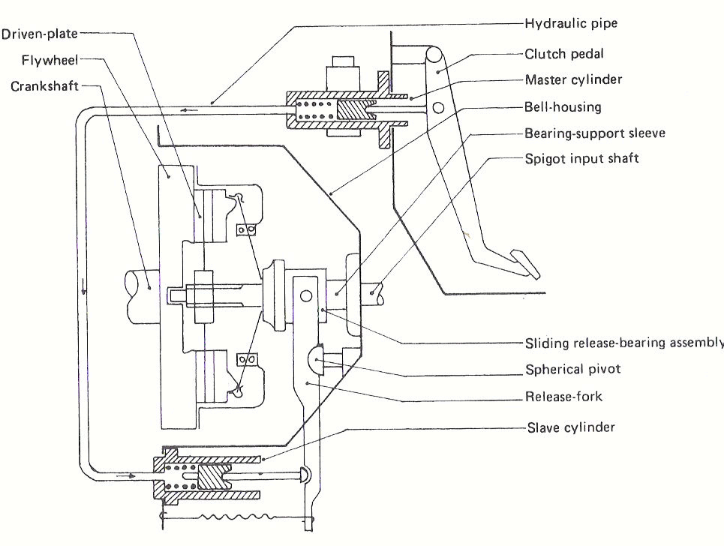
CLUTCH HYDRAULIC ACTUATION SYSTEM
An alternative and convenient method of transmitting force and
movement is by forcing fluid through a flexible plastic pipeline running
between the foot-pedal and the clutch bell housing.
Controlled clutch action is achieved by having a master- cylinder bolted
to the bulk head and a push-rod connecting the clutch-pedal movement to the
sliding piston. A second cylinder and piston-known as the slave-cylinder unit-
are located and supported on an extension formed on the bell-housing flange.
The piston inside this cylinder conveys the slightest movement to the fork-
lever through the slave push rod. The fork-lever has the thrust-bearing
assembly attached to one end, and a spherical pivot is situated slightly in
from this end.
When the clutch pedal is depressed, the master-cylinder piston moves
forwards and pushes a continuous column of fluid through the pipeline.
Consequently, an equal volume of f luid must be displaced into the slave-
cylinder so that the piston moves out and tilts the fork-lever. The net result is
that the trust bearing defects the release-fingers so that the driven-plate will
slip.
Engagement of the clutch occurs when the pedal is released-this allows
the fluid to return to the master-cylinder and its reservoir. The return-spring
in the slave-cylinder will then maintain a slight pressure on the fork-lever, so
that the trust bearing will always be in contact with the release-fingers.
Driven-plate wear will be compensated for by the slave return-spring
and piston automatically moving out to take up the increased fork-lever tilt.
When subjected to large leverage forces, hydraulic actuating mechanisms do
not suffer f rom frictional wear, as do cables. This makes them particularly
suitable for heavy-duty applications on large trucks.
TOYOTA “ECT-i” A NEW AUTOMATIC TRANSMISSION
WITH INTELLIGENT ELECTRONIC CONTROL SYSTEM
In recent years since the oil crisis, technological developments for
automatic transmissions have been aimed mainly at the improvement of fuel
economy, with emphasis placed in increasing the efficiency of the complete
power transmission system, including the engine. The four-speed automatic
transmission, the lock-up clutch and their electronic controls have been
developed and their electronic controls have been developed and put into
practical application. Currently, efforts are being made to increase the
number of transmission speeds for further improvement of drivability and
power performance.
The level of vehicle performance required by drivers is also becoming
higher and higher. In automatic transmissions higher quality levels are
required not only for fuel economy and power performance but also for shift
quality noise reduction, etc... Consequently, smoothness and quietness
including proper controls for the increased number of gear shift operations
required with the increase in transmission speeds are major transmission
developments.
SPECIFICATIONS OF THE TOYOTA ECT- i TRANSMISSION
S.NO. SPECIFICATIONS VALUES
1 Torque Capacity 3.6 kg-m (353 N-m)
3-Element, 2-Phase with Lockup
2 Torque Converter
Clutch Type, Impeller Diameter
272mm.
1
2.531:1
st
Gear Train
2
1.531:1
nd
3
3
1.000:1
rd
Gear Ratio
O.D 0.705:1
Reverse 1.830:1
6 Disc Clutches
4 Friction Element
1 Band Clutches
5 Shift Positions 6 Positions
P-R-N-D-2-3
Electronic Hydraulic Control
19 Valves
6 Control System
2 ON-OFF Solenoids
2 Linear Solenoids
Automatic
7
Capacity 8.3 liters
Transmission Fluid
8 Weight 77 kg (755 N)
Under such circumstances, TOYOTA has developed a new automatic
transmission, called the A341E. This transmission employs a unique engine
and transmission integrated intelligent control system. The main function of
the engine and transmission integrated intelligent control system are engine
torque control and clutch hydraulic pressure control. And the “super Flow”
Torque converter has a modified geometry optimized by the analysis of
internal flow by means of computer simulations, attaining the highest
efficiency in the world. With the use of such systems, this new automatic
transmission has attained very smooth shift changes over system life.
ENGINE AND TRANSMISSION INTEGRATED INTELLIGENT
CONTROL SYSTEM
NEW GENERATION CLUTCH HYDRAULIC ACTUATION SYSTEM
Traditionally manual clutch actuation for automobiles was a spin-off
from hydraulic brake technology namely heavy steel or cast iron cylinders,
steel pipes and rubber hoses. Because of this archaic, inefficient and
expensive approach to providing a mechanical advantage, an alternative
lower cost system of cable operation gained popularity throughout the
industry. However, the 1:1 ratio of a cable plus routing problems, NVH
issues, efficiency losses and the need for complex adjustment mechanisms,
opened up the opportunity for a rebirth of the old hydraulic concept.
The goal was to design a system with a totally new approach that
would meet the following criteria, high efficiency, increased temperature
resistance, increased durability, reduced packages size and weight, cost
competitive with cable systems, and finally to take advantage of the latest
advances in materials and processes.
TWO MARKS QUESTIONS
UNIT I CLUTCH AND GEARBOX
1. What are the requirements of a transmission system?
2. State the principle of friction clutch.
3. What are the various components of a clutch?
4. What are the requirements of a clutch?
5. What is the necessity of providing clutch free pedal play?
6. Why are coil springs installed in a clutch plate? (Or) Indicate the function
of the clutch damper spring.
7. What are the various materials used in the manufacture of clutches?
8. What are the various components of the transmission system?
9. Why are clutch friction plate perforated?
10. List out the various types of clutches used in practice.
11. What are meant by wet and dry clutches?
12. Define clutch grab and clatter.
13. Mention the advantages of diaphragm spring clutch.
14. Write a note on clutch plate materials.
15. Explain the reasons for using cones as engaging surface in a cone clutch.
16. Why are wet-type of multi plate disc clutch preferred in automatic
transmission?
17. What are the various materials in which a gear box is made?
18. What are the various types of lubrication available in practice?
19. State different types of gear boxes used in practice?
20. What are the advantages of gear ratios forming geometrical series? (Or)
Why the gear ratios are arranged in geometrical progression?
21. What is the principle of a synchromesh gear box?
22. What are the advantages of using a spur gear?
23. What is the purpose of gear box in a transmission system? (Or)
State the function of a gear box?
24. What do you mean by the term “speed synchronizing”?
25. What are the different faults found in a gear box?
26. List out the various materials used for the manufacture of gears?
27. Sketch a three speed constant mesh gear box?
28. Mention few materials used for transmission shafts?
29. Discuss the performance curves of a gear box?
30. Sketch 3-speed constant mesh gear box?
31. What is the function of synchronizer?
32. Find out the axial force required to synchronize the speeds. Given
coefficient of friction = 0.04, cone angle is 10 degree, angular
acceleration is 50 rad/sec², moment of inertia 254 kg cm² and the mean
radius of the cone surface 4.13 cm.
UNIT II FLUID COUPLING AND TORQUE CONVENTER
1. What are the advantages of the fluid coupling?
2. Define torque capacity?
3. State the principle of torque conversion?
4. State a few advantages of poly phase torque converters?
5. Diff erentiate clearly between a torque converter and a fluid coupling?
6. Elucidate three main differences between fluid coupling and torque
converter.
7. Define slip in a fluid coupling.
8. What is the function of the reaction member in the torque converter?
9. What do you mean by coupling point in two phase torque converter?
10. Draw the polar diagram illustrating the principle of hydro dynamic
torque conversion.
11. What are the various means used to reduce drag torque in fluid coupling?
12. What are the limitations of fluid coupling?
13. What is the function of a torque converter?
14. What are the advantages of hydraulic transmission drives over other
drives?
15. What are the limitations of hydrodynamic torque converter?
16. What is the effect of slip in coupling?
17. Discuss the performance characteristics of fluid coupling
18. What is a converter- coupling?
19. What is multistage and poly phase torque converters?
20. What is meant by drag torque?
21. A petrol engine develops 10 N-m torque at maximum BHP speed of
4000rpm. Determine the diame ter of the impeller required to transmit the
torque for a slip of 3%.
22. Mention the properties to be satisfied for the working fluid used in hydro
dynamic drive.
UNIT III AUTOMATIC TRANSMISSION
1. What are the disadvantages of Automatic Transmission when
compared to conventional transmission?
2. What are the various parts of an Automatic Transmission System?
3. What are the advantages of overdrive?
4. In a gear system, the front unit having internal gear of 67 teeth and
run gear of 30 teeth. Find the gear ratio.
5. What is the function of an over- running clutch in an over- drive
transmission?
6. Why is locking device necessary for over running clutch in over drive?
7. How are different speeds obtained in a planetary gear box?
8. How is reversing achieved in a planetary gear set?
9. List out any three merits of an automatic transmission.
10. What are the advantages of the epicyclic hear box over the ordinary
gear box?
11. What are the relative merits of Automatic Transmission when
compared to conventional transmission?
12. In epicyclic box to get forward speed and reverse speed normally
which member is fixed?
UNIT IV HYDROSTATIC DRIVE AND ELECTRIC DRIVE
1. What are the advantages and limitations of Electrical drive?
2. What is the various hydraulic transmission drives used in practice?
3. What are the advantages of hydrostatic drives?
4. Differentiate clearly between a hydrodynamic and hydrostatic drive
systems
5. Draw the curves of generator input torque and motor torque versus
armature current
6. What is the principle of electric torque conversion on an electric
drives?
7. What are the differences in early and later ward Leonard systems of
control?
8. What are the disadvantages of hydrostatic drives?
9. Explain the need for providing a foot switch operated additional field
resistance in the generator field of a modern electric drives for buses
10. Sketch the efficiency and torque characteristics for hydrostatic
drives having fixed displacement pump a variable motor.
11. Sketch the efficiency and torque characteristics for hydrostatics
drive having variable displacement pump a fixed displacement
motor.
UNIT V AUTOMATIC TRANSMISSION APPLICATIONS
1.
What are the functions of intelligent electronic control system of Toyota
transmission?
2.
Brief about the controls used in Toyota ECT-i automatic transmission
with intelligent control system.
3.
Write a note on new generation hydraulic actuation system of a clutch?
MODEL QUESTION PAPER
B.E. AUTOMOBILE ENGINEERING
SEMESTER V
AT 335 - AUTOMOTIVE TRANSMISSION
Time: 3 Hours Max. Marks: 100
Answer ALL Questions
PART – A (10 x 2 = 20 Marks)
1. What are the requirements of a transmission system?
2. Explain the reasons for using cone as engaging surface in cone clutch.
3. Describe the procedure for arriving of suitable gear ratios for Tractors.
4. Differentiate Torque Converter and Fluid Coupling.
5. How the torque ratio of a torque converter varies with speed ratio?
6. Compare the performance characteristics of different hydraulic pumps
and hydraulic motors combinations.
7. List out the merits and demerits of Hydrostatic drive.
8. What are the advantages and limitations of electric drive?
9. Explain Automatic and Semi-Automatic transmission.
10. Write a brief note on Automatic Overdrive.
PART – B (5 x 16 = 80 Marks)
11. Sketch the Wilson planetary gearbox. Explain clearly how the third
gear ratio is obtained for this gearbox.
12. a) Explain the construction and operation of diaphragm spring
clutch with a neat sketch.
(OR)
12. b)i) Sketch and explain the variation of Tractive effort with vehicle speed.
ii) Explain the necessity of gearbox for a vehicle using performance curves
analysis.
13.a) Differentiate Multistage and Poly phase torque converter.
Sketch and explain the performance characteristics for the above two
types of torque converters.
(OR)
13.b) Sketch and explain WHITE’s hydro torque drive.
14.a) Explain the Janny hydrostatic transmission with a sketch.
(OR)
14.b) With a circuit diagram explain the operation of Electric drive f or
city buses.
15.a) With a basic hydraulic circuit diagram, explain the functions of
various valves while engaging second gear.
(OR)
15.b) Describe Chevrolet ‘Turbo glide’ automatic transmission system.
* * * * *
E 170
813
B.E./B.Tech. DEGREE EXAMINATION, NOVEMBER/DECEMBER 2003.
Fifth Semester
Automobile Engineering
AT 335 — AUTOMOTIVE TRANSMISSION
Time: Three hours
Maximum : 100 marks
Answer ALL the questions.
PART A — (10 × 2 = 20 marks)
1. What are the requirements for an automotive clutch?
2. With a sketch illustrate the principle of friction clutch.
3. Draw the layout of sliding mesh gear box.
4. What Find out the axial force required to synchronize the speeds. Given
coefficient of friction = 0.04, cone angle is 10 degree, angular acceleration is 50
rad/sec², moment of inertia 254 kg cm² and the mean radius of the cone surface 4.13
cm.
5. A petrol engine develops 10 N-m torque at a maximum BHP speed of 4000rpm.
Determine the diameter of the impeller required to transmit the torque for a slip of
3%.
6. What is meant by drag torque? Explain a method of minimizing it?
7. How the efficiency of a torque converter varies with speed ratio?
8. What are the different types of hydrostatic transmission combination? Specify
the features of them.
9. Write a note on new generation hydraulic actuation system of a clutch?
10. List out the merits and demerits of electric drive.
PART B — (5 × 16 = 80 marks)
11. The b.p of a vehicle is 94.2 kW at 3300 rpm. The total tractive resistance on low
gear including gradient resistance is 5395.5 N and that in the top gear is 1697
N. the diameter of the wheels is 0.9144 m and the efficiency of the
transmission is 75% on low gear and 85% in top gear. Calculate the gear ratio
for a three-speed gear box.
12. (a) Explain the principle of operation of hydrodynamic fluid coupling with
relevant sketch.
Or
(b) Explain the principle of operation of hydrodynamic torque converter with a
polar diagram.
13. (a) Explain how second gear is obtained in Wilson gear box with a neat sketch.
Deduce the second gear ratio.
Or
(b) How shift valves are controlled by throttle and governor valves / with a
hydraulic circuit explain how second gear is engaged?
14. (a) Describe Janny hydrostatic transmission system with a neat sketch.
Or
(b) Explain the principle of modified ward Leonard type of control for electric
drive in vehicles.
15. (a) Explain the construction and operation of single plate diaphragm spring
clutch with a neat sketch.
Or
(b) Explain Chevrolet ‘turbo glide’ automatic transmission system with a
sketch.
_____________________
K 1007
170 813
B.E./B.Tech. DEGREE EXAMINATION, NOVEMBER/DECEMBER 2004.
Fifth Semester
Automobile Engineering
AT 335 — AUTOMOTIVE TRANSMISSION
Time: Three hours
Maximum: 100 marks
Answer ALL the questions.
PART A — (10 × 2 = 20 marks)
1. Enumerate the various requirements t be satisfied by a clutch.
2. What are the main functions to be performed by the vehicle transmission
system?
3. Write the requirements to be satisfied by automatic transmission fluids.
4. Write the advantages of fluid coupling.
5. Write the advantages of epicyclic gear system.
6. What is meant by drag torque and how it can be reduced?
7. Write the advantages of hydrostatic drives.
8. Brief about the advantages of electric drives in a automatic vehicle.
9. Brief about the controls used in Toyota ECT-i automatic transmission with
intelligent control system.
10. write the advantages of diaphragm type of clutch
PART B — (5 × 16 = 80 marks)
11. A truck has a gross vehicle weight of 89026 N. engine displacement is
10m
, power 77.3kW at governed speed, of 2400 r.p.m. maximum torque,
3
345.8 Nm at 1400r.p.m. Rear axle ratio, 6.166: 1. fourth speed reduction
ratio in transmission,1.605 :1, drive line losses amount to 10.7kW at
2400r.p.m and 6.3kW at 1400r.p.m.type size 0.4572 m x1.016m(effective
wheel diameter 0.950m),frontal area of truck 6.95mcalculate the grades
which the vehicle can climb in fourth gear in still air conditions.
(i) At governed engine speed; and
(ii) At speed of maximum torque, in the equation
R = KW +Ka A V²
Ka= 0.0462 where V in km/hr
12. (a) By using the line sketch explain the working of hydrodynamic torque
converter.
(Or)
(b) Draw graph for characteristics of a conventional three element converter
by using this explain the general properties of the hydrodynamic torque
converter.
13. (a) describe the working principle of ford model T planetary transmission
with a suitable sketch.
(Or)
(b) Explain the working principle of Wilson planetary transmission. Draw
neat line sketch of the system.
14. (a) By using simple line sketch explain the working of janney hydrostatic
drive. (Or)
(b) Describe the working of early ward Leonard control system.
15. (a) Describe the working of Chevrolet turboglide transmission.
(Or)
(b) Describe the construction and working of single plate spring clutch.
---------------
S 202
B.E./B.Tech. DEGREE EXAMINATION, APRIL/MAY 2005.
Fifth Semester
Automobile Engineering
AT 335 — AUTOMOTIVE TRANSMISSION
Time: Three hours
Maximum: 100 marks
Answer ALL the questions.
PART A — (10 × 2 = 20 marks)
1. What is meant by double deducting?
2. How clutches are classified?
3. What is the principle of synchronizing?
4. What are the differences between fluid coupling and torque converter?
5. Define slip with respect to torque converter.
6. State some advantages of hydrometric transmission.
7. What are hydrostatic transmission combinations?
8. What is meant by turbo glide?
9. What is meant by intelligent control?
10. Compare a mechanical clutch with fluids coupling.
PART B — (5 × 16 = 80 marks)
11. In a gear box the clutch shaft pinion has 14 teeth and low gear main shaft pinion
32 teeth. The corresponding lay shaft pinions have 36 teeth and 18 teeth. The
axle ratio is 3.7:1 and effective radius of the rear type is 35.5 cm. calculate the
car speed in the above arrangement at an engine speed of 2500rpm.
12. (a) (i)discuss various type of gear boxes used in an automobile. (6)
(ii) What is a synchronizing device? How this device helps smooth gear
engagement.
(10)
Or
(b) (i) What is the functions of a clutch? (3)
(ii) Draw a neat sketch of a centrifugal clutch and explain its
construction and operation. (13)
13. (a) What is a fluid coupling? Explain its constructional details. Draw and
explain its performance curves. (16)
Or
(b) Draw a neat sketch of a multistage torque converter and explain its
construction and working principle. (16)
14. (a) (i) What is meant by automatic drive? (4)
(ii)Draw a schematic diagram of hydraulic control system for automatic
transmission and explain.
(12)
Or
(b) (i) What are the principles involved in hydrostatic drive? What are it
advantages and limitations?
(8)
(ii) Compare hydrostatic and hydrodynamic transmission. (8)
15. (a) Draw a neat sketch of a Chevrolet Turbo glide transmission and explain
its salient features. (16)
Or
(b) (i) Discuss about Toyota ECT-i Transmission. (8)
(ii) Discuss about Hydraulic Actuation system. (8)
——————
J 271
B.E./B.Tech. DEGREE EXAMINATION, APRIL/MAY 2004.
Fifth Semester
Automobile Engineering
AT 335 — AUTOMOTIVE TRANSMISSION
Time: Three hours
Maximum: 100 marks
Answer ALL the questions.
PART A — (10 × 2 = 20 marks)
1. List out the requirements of transmission system.
2. How engagement and disengagement can be affected in an electromagnetic
clutch.
3. What is meant by tractive effort? How is it obtained from engine torque?
4. What is the function of a gear synchronizer?
5. How the torque ratio of a torque converter varies with speed ratio?
6. Compare the performance characteristics of different hydraulic pump and
motor combinations.
7. What are advantages and limitations of electric drive?
8. What is the effect of current on variation of torque of an electric drives?
9. What are the functions of intelligent electronic control system of Toyota
transmission?
10. A petrol engine develops 13 Nm torque at a maximum b.h.p speed of
3500rpm.determine of the impeller required to transmit it the torque for a
slip of 3%.
PART B — (5 × 16 = 80 marks)
11. Explain Chevrolet “turbo glide” automatic transmission system with a
sketch.
12. (a) A motorcar engine develops 5.9 b.k W at2100rpm. Find the suitable size
of clutch plate having friction linings riveted on both sides, to transmit the
power, under the following conditions:
(v) Intensity of pressure on the surface not to exceed 6.87x10 pa.
(vi) Slip torque and losses due to wear etc. is 35% of engine torque.
(vii) Coefficient of friction on contact surface is 0.3.
(viii) Inside diameter of the friction plate is 0.55 times the outside
diameter.
Also calculate the dimensions of pressure plate.
Or
(b) The coefficient of rolling resistance for a truck weighing 62293.5 N is
0.018 and the coefficient of air resistance is 0.0276 in the formula
R=KW+Ka AV², N, where A is m² of frontal area and V the speed in
km/hr. the transmission efficiency in top gear of 6.2:1 is 90% and that in
the second gear of 15:1 is 88%. The frontal area is 5.574 m². If the truck
has to have maximum speed of88km/hr. in top gear calculate.
(i) the engine b.p required;
(ii) the engine speed if the driving wheels have an effective diameter of
0.8125m;
(iii) The maximum grade the truck can negotiate at the above engine
speed in second gear.
13. (a) Explain the principle and operation of fluid coupling with sketches.
Or
(b) Explain the necessary, construction and operation of multi-stage torque
converter with a neat sketch.
14. (a) Explain how second gear is obtained in Wilson gear box with a neat
sketch. Deduce that gear ratio.
Or
(b) Explain the construction and operation of cotal electromagnetic
transmission with a sketch.
15. (a) Describe janny hydrostatic transmission system with a neat sketch.(Or)
(b) Explain the principle of ward Leonard type of control for electric drive.

