Jawaharlal Nehru Engineering College

Laboratory Manual

PROGRAMMING IN OOP WITH C++

For

Second Year Students CSE

Dept: Computer Science & Engineering

Author: JNEC, Aurangabad
FOREWORD

It is my great pleasure to present this laboratory manual for Second year engineering students for the subject of Object Oriented Programming (UsingC++)keeping in view the vast coverage required for visualization of concepts ofOOP with simple language.

As a student, many of you may be wondering with some of the questions in your mind regarding the subject and exactly what has been tried is to answer through this manual.

As you may be aware that MGM has already been awarded with ISO 9000 certification and it is our endure to technically equip our students taking the advantage of the procedural aspects of ISO 9000 Certification.

Faculty members are also advised that covering these aspects in initial stage itself, will greatly relived them in future as much of the load will be taken care by the enthusiasm energies of the students once they are conceptually clear.

Dr. S.D.Deshmukh

Principal

LABORATORY MANUAL CONTENTS

This manual is intended for the Second year students of IT & CSE branches in the subject of OOP. This manual typically contains practical/Lab Sessions related OOP covering various aspects related the subject to enhanced understanding. Main aim of this course is to understand and solve logical & mathematical problems through C++ language. Strengthen knowledge of a procedural programming language. Further develop your skills in software development using a procedural language.

This course will also prepare students with the necessary programming background for Data Structures using C/C++ and Java programming courses.

We have made the efforts to cover various aspects of the subject covering These labs encompass the regular materials as well as some advanced experiments useful in real life applications. programming aspects will be complete in itself to make it meaningful, elaborative understandable concepts and conceptual visualization.

Students are advised to thoroughly go through this manual rather than only topics mentioned in the syllabus, as practical aspects are the key to understanding and conceptual visualization of theoretical aspects covered in the books.
Good Luck for your Enjoyable Laboratory Sessions

Prof. D.S.Deshpande | Ms. P.S.Maniyar
HOD, CSE | Lecturer, CSE Dept.

MGM’s
Jawaharlal Nehru Engineering College, Aurangabad
Department of Computer Science and Engineering

Vision of CSE Department

To develop computer engineers with necessary analytical ability and human values who can creatively design, implement a wide spectrum of computer systems for welfare of the society.

Mission of the CSE Department:
- Preparing graduates to work on multidisciplinary platforms associated with their professional position both independently and in a team environment.
- Preparing graduates for higher education and research in computer science and engineering enabling them to develop systems for society development.

Programme Educational Objectives

Graduates will be able to

- To analyze, design and provide optimal solution for Computer Science & Engineering and multidisciplinary problems.
- To pursue higher studies and research by applying knowledge of mathematics and fundamentals of computer science.
- To exhibit professionalism, communication skills and adapt to current trends by engaging in lifelong learning.

Programme Outcomes (POs):
Engineering Graduates will be able to:

- Engineering knowledge: Apply the knowledge of mathematics, science, engineering fundamentals, and an engineering specialization to the solution of complex engineering problems.
- Problem analysis: Identify, formulate, review research literature, and analyze complex engineering problems reaching substantiated conclusions using first principles of mathematics, natural sciences, and engineering sciences.
- Design/development of solutions: Design solutions for complex engineering problems anddesign system components or processes that meet the specified needs with appropriate consideration for the public health and safety, and the cultural, societal, and environmental considerations.
- Conduct investigations of complex problems: Use research-based knowledge and research methods including design of experiments, analysis and interpretation of data, and synthesis of the information to provide valid conclusions.
- Modern tool usage: Create, select, and apply appropriate techniques, resources, and modern engineering and IT tools including prediction and modeling to complex engineering activities with an understanding of the limitations.
- The engineer and society: Apply reasoning informed by the contextual knowledge to assess societal, health, safety, legal and cultural issues and the consequent responsibilities relevant to the professional engineering practice.
- Environment and sustainability: Understand the impact of the professional engineering solutions in societal and environmental contexts, and demonstrate the knowledge of, and need for sustainable development.
- Ethics: Apply ethical principles and commit to professional ethics and responsibilities and norms ofthe engineering practice.
- Individual and team work: Function effectively as an individual, and as a member or leader in diverse teams, and in multidisciplinary settings.
- Communication: Communicate effectively on complex engineering activities with the engineering community and with society at large, such as, being able to comprehend and write effective reports and design documentation, make effective presentations, and give and receive clear instructions.
- Project management and finance: Demonstrate knowledge and understanding of the engineering and management principles and apply these to one’s own work, as a member and leader in a team, to manage projects and in multidisciplinary environments.
- Life-long learning: Recognize the need for, and have the preparation and ability to engage independent and life-long learning in the broadest context of technological change.

General Guidelines and Rules

Guidelines

- Students must read the lab module and make necessary preparation for each session PRIOR TO coming to the lab.

- Each lab session will last for approximately TWO hours, which is divided into the following time slots:

Item | Time
Demonstration | 40 minutes
▪ Instructor will give a brief demonstration during the allocated time
and students will be given some hands-on exercises. Hence the
students are expected to fully utilize this time to enquire the
instructor/tutors regarding the subject matter.
Lab assignment | 80 minutes
▪ Students must::
o Answer all the given questions
o Report to the lab instructor and demonstrator to submit the
answers before the lab ends
▪ No take-home assignment will be allowed.
▪ Solutions will ONLY be given after the module is covered by all
groups.

DOs and Don’ts in Laboratory:

- Make entry in the Log Book as soon as you enter the Laboratory.

- All the students should sit according to their roll numbers starting from their left to right.

- All the students are supposed to enter the terminal number in the log book.

- Do not change the terminal on which you are working.

- All the students are expected to get at least the algorithm of the program/concept to be implemented.

- Strictly observe the instructions given by the teacher/Lab Instructor.

Instruction for Laboratory Teachers::

- Submission related to whatever lab work has been completed should be done during the next lab session. The immediate arrangements for printouts related to submission on the day of practical assignments.

- Students should be taught for taking the printouts under the observation of lab teacher.

- The promptness of submission should be encouraged by way of marking and evaluation patterns that will benefit the sincere students.

Rules

All students are bound to adhere to the following rules. Failure of complying with any rules will be penalized accordingly.

- Students must be in the lab before the lab activities started. No late coming is tolerated without prior consent from the respective lecturer. Failure to do so may eliminate your mark for that particular lab session.

- During lab session any form of portable data storage and retrieval devices is prohibited. If found, then we reserve the right to confiscate the item and devoid your mark for that particular lab session. Collection of the confiscated item(s) requires approval from Deputy Dean of Academic Affairs.

- Duplicated lab assignment: the source and duplicate will be considered void.

- Submission procedure:

  - Create a folder in the D: \ drive of your workstation. Name the folder with your IDnumber and your name. Example: 04xxxxxx Rahul Joshi

  - Save all your answers and source codes inside the folder. Name the files according to the question, example: question1.cpp/question1.txt.

Report your completed lab assignment to the instructor/demonstrator for inspection and

assessment

Special Instruction Before Each Lab Session

- Create 2 folders in the D: \ drive:

  - 1 folder for lab exercise and hand-on experience:

    - Name the folder with your ID number and your name with (demo). Example: 04xxxxxx Rahul Joshi (demo)

  - 1 folder for submission (refer to Section B)

- This lab is aimed to apply the theories that you have learnt in Object Oriented Programming
in C++, not intended to teach you everything about C++. Hence, you need to do your own homework.

- Lab module is designed as a guideline, not a comprehensive set of notes and exercises. Read your theory notes and books pertaining to the topics to be covered (Refer to „Objective‟ section in each of the lab module).

How to get lab manual

- You can obtain the lab manual from the selected lab representatives

- Please get the materials ready before coming to the lab.

H/w, S/w Requirement:

IBM-compatible 486 System, a hard drive, Min 8Mb memory, Win xpS/w. Turbo C++

SUBJECT INDEX

Lab No. | Index | Week
 |  | involved
1 | Introduction to OOP lab (Simple C++ program) | 1-2
2 | Classes and Objects | 5-6
3 | Constructors and Destructors | 7-8
 | Write a program to demonstrate different types of constructors.
4 | Operator overloading | 9-10
 | Write a program for overloading various unary operators.
5 | Write a program for overloading various binary operators | 10-11
 | Type Conversion
6 | Write a program for type conversion | 11-12
 | (basic to class, class to basic ,class to class)
 | Inheritance
7 | Write a program for multiple inheritance | 13-14
 | Write a program for hybrid inheritance
8 | Polymorphism | 15-16
 | Write a program for polymorphism(virtual function)
9 | Write a program for templates | 17-18
10 | Program using files | 19-20
11 | Program using streams | 21-22
 | Conduction of Viva-Voce Examinations
 | Appendix - A
 | Appendix - B

Experiment No. 1

Title:Introduction to the Fundamentals and history of OOP Concepts

Objective:
At the end of this experiment, students should be able to understand following points:
- Basic concepts of c++ like insertion,extraction operator
- Different operators
- Array,String,Function
- Basic object oriented concepts

Theory:

Introduction

Object oriented language was developed by Bjarne Stroustrup in1979 at Bell Labs. As an enhancement to the C programming language and originally named "C withClasses". It was renamed to C++ in 1983.C++ is designed to be a statically typedgeneral-purpose language that is as efficient and portable as C. C++ is designed to directly and comprehensively support multiple programming styles (procedural programming, data abstraction, object-oriented programming, and generic programming ) C++ avoids features that are platform specific or not general purpose
Class
Multiple Inheritance
Virtual Function

`
Exception Handling
Templates
Function Overloading
C++
C
A LOOK AT PROCEDURE ORIENTED LANGUAGES

C, PASCAL, FORTRAN commonly known as procedure-oriented programming(POP).That is,each statement in the language tells the computer to do something..A program in the procedural language is a list of instuction.The program creates the list of insructions and the computer carries them out.

Object Oriented | Procedural
Methods | Functions
Objects | Modules
Message | Argument
Attribute | Variable

In multi-function program, many important data items are placed as global so that they may be accessed by all the functions .Each function may have its own local data. Fig shows the relationship of data and functions in a procedure

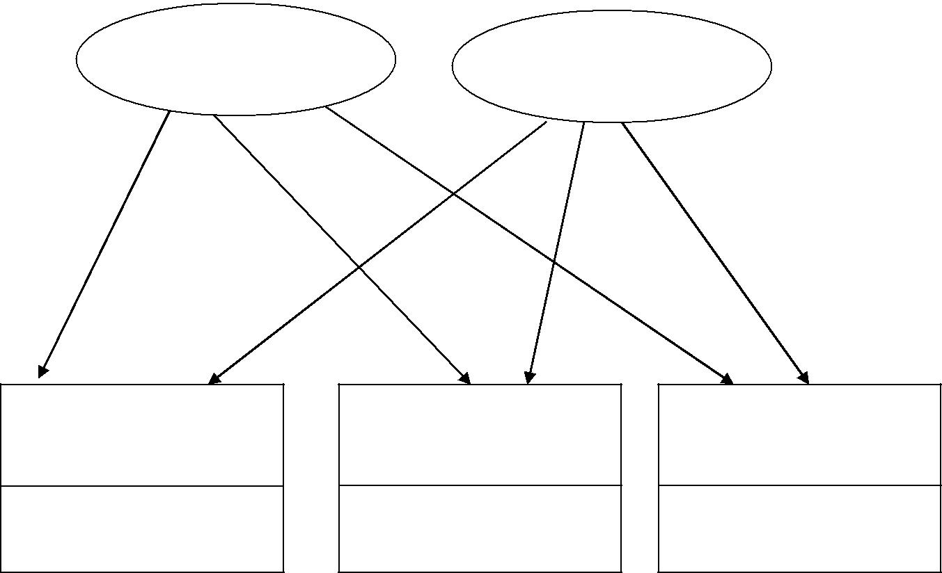
GLOBAL DATA
GLOBAL DATA
LOCAL DATA
LOCAL DATA
LOCAL DATA
FUNCTION-3
FUNCTION-2
FUNCTION-1

Relationship of data and functions in procedural language
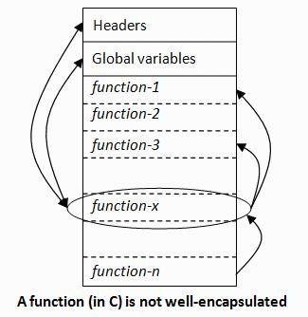

OBJECT ORIENTED LANGUAGE

The fundamental idea behind the object oriented language is to combine into a single unit of data and functions that operate on that data. Such unit is called an object. Object-oriented programming (OOP) is a programming paradigm that uses "objects" – data structures consisting of datafields and methods together with their interactions – to design applications and computer programs. Programming techniques may include features such as information hiding, data abstraction, encapsulation, modularity, polymorphism, and inheritance. It was not commonly used in mainstream software application development until the early 1990s.] Many modern programming languages now support OOP.

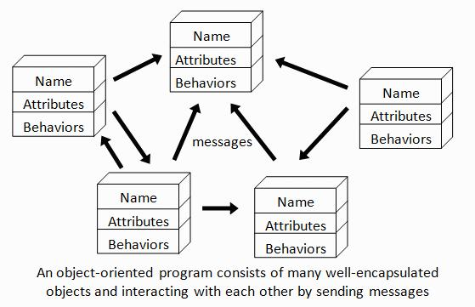

BASIC CONCEPTS OF OBJECT-ORIENTED PROGRAMMING

Object

An object is a basic run time entity. Object represents/resembles a Physical/real entity. An object is simply something you can give a name. All the objects have some characteristics and behavior. The states of an object represent all the information held within it and behavior of an object is the set of action that it can perform to change the state of the object. All real world objects have three characteristics:
- State: How object react?

- Behavior: what we can do with this object?

- Identity: difference between one object to another object?

Object is the basic unit of object-oriented programming. Objects are identified by its unique name. An object represents a particular instance of a class. There can be
more than one instance of an object. Each instance of an object can hold its own relevant data.

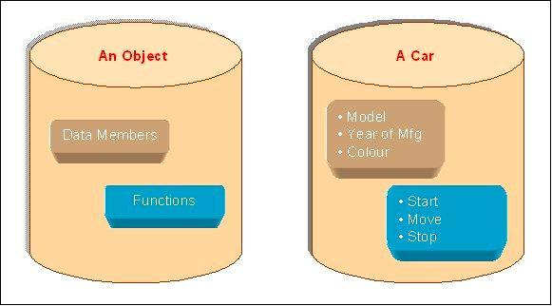

An Object is a collection of data members and associated member functions also known as methods.

Class

Classes are data types based on which objects are created. Objects with similar properties and methods are grouped together to form a Class. Thus a Class represent a set of individual objects. Characteristics of an object are represented in a class as Properties. The actions that can be performed by objects become functions of the class and is referred to as Methods.

For example consider we have a Class of Cars under which Santro Xing, Alto and

WaganR represents individual Objects. In this context each Car Object will haveits own, Model, Year of Manufacture, Color, Top Speed, Engine Power etc., which form Properties of the Car class and the associated actions i.e., object functions like Start, Move, and Stop form the Methods of Car Class.

No memory is allocated when a class is created. Memory is allocated only when an object is created, i.e., when an instance of a class is created.

Data Abstraction:

Data Abstraction increases the power of programming language by creating user defined data types. Data Abstraction also represents the needed information in the program without presenting the details.

Data Encapsulation:

Data Encapsulation combines data and functions into a single unit called Class. When using Data Encapsulation, data is not accessed directly; it is only accessible through the functions present inside the class. Data Encapsulation enables the important concept of data hiding possible.

Instance

One can have an instance of a class or a particular object. The instance is the actual object created at runtime.. The object consists of state and the behaviour that's defined in the object's class.

Data hiding:

This is the property in which some of the members are restricted from Outside access. This is implemented by using private and protected access specifies.

Message passing

"The process by which an object sends data to another object or asks the other object to invoke a method." Also known to some programming languages as interfacing
Inheritance

Inheritance is the process of forming a new class from an existing class or baseclass. The base class is also known as parent class or super class, the new classthat is formed is called derived class. Derived class is also known as a child class or sub class. Inheritance helps in reducing the overall code size of the program, which is an important concept in object-oriented programming.

Polymorphism:

Polymorphism allows routines to use variables of different types at different times. An operator or function can be given different meanings or functions. Polymorphism refers to a single function or multi-functioning operator performing in different ways.

Reusability:

This term refers to the ability for multiple programmers to use the same written and debugged existing class of data. This is a time saving device and adds code efficiency to the language. Additionally, the programmer can incorporate new features to the existing class, further developing the application and allowing users to achieve increased performance. This time saving feature optimizes code, helps in gaining secured applications and facilitates easier maintenance on the application.

Basics of C/C++ Programming

C++ is a high level language with certain low-level features as well. Remember that C++ is a case-sensitive language. A C++ program is actually a collection of statements and data on which various operations can be performed. C++ is a
superset of C. Most of what we already know about C applies to C++ also. Therefore, most all C programs are also C++ programs. However, there are a few minor differences that will prevent a C programs to run under C++ compiler .the object oriented features in C++ allow programmers to build large programs with clarity , extensibility and ease of maintenance incorporating the spirit and efficiency of C. The addition of new features has transformed C from a language that currently facilitates top-down structured design, to one that provides bottom-up, object-oriented design. Kindly refer to listing 1.1 to see what a simple C++ program looks like.

Comments

C++ introduces a new comment symbol //(double slash).A comment may start anywhere in the line. Note that there is no closing symbol

//This is an example of C++ // program

The C comment symbol /* */ are still valid for multi line comments. /* this is an example of C++ */

Output Operator

cout<<”C++ is better than C”;

Causes the string quotation marks to be displayed on the screen. This statement introduces new C++ features, cout and <<. The identifier cout is a predefined object that represents output stream in C++. The standard output stream represents the screen. The operator << is called the insertion operator. It inserts (or sends) the contents of the variable on its right to the object on its left. It is same as printf() in C++.

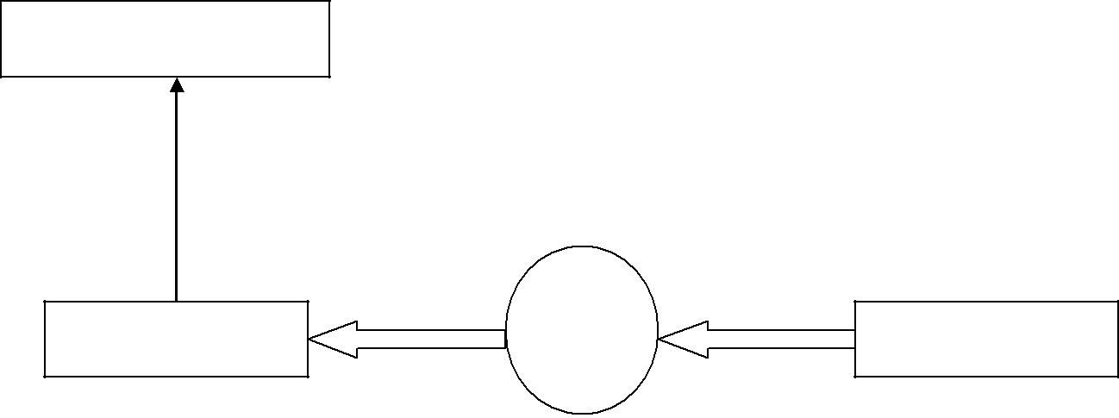
Insertion Operator
C++
<<

Cout

Output using insertion operator

Input Operator

The statement cin<<num1; is an input statement and causes program to wait for the user to type in number. The identifier cin is a predefined object in C++ that corresponds to the standard input stream. Here stream represents the keyboard. The operator >> is known as extraction or get from operator.
Object Variable
>>
40.5
Cin
Input using extraction operator
Keyboard
Data Types

Following are the few basic data types used in C++.

Name | C++ | Describes
Integer | int | numeric data in the range of -32768 to 32768
Floating- | float | floating-point numeric data in the range 8.43x10-37 to
Point |  | 3.37x1038
Double | double | floating-point numeric data in the range 2.225x10-308 to
 |  | 1.7976x10308;
Character | char | character specified by character codes -128 to 127
Boolean | bool | has only two values, either true (1) or false (0)
Void | void | A non existent value

Relational Operators

C++ also uses some relational operators to perform comparison of different values.

Some of these are:

Operation | Operator
Equal to | = =
Not equal to | !=
Less than | <
Less than or equal to | <=
Greater than or equal to | >=
Greater than | >
Type Qualifiers Name C

Name | C++ | Describes
Long Form | long | It requests a long form of an item. Can be used with both int and
 |  | double
Short Form | short | It requests a short form of an item. Can be only used with int and
 |  | not double
Signed | signed | It describes a variable from its maximum negative to its maximum
Number |  | positive value
Unsigned | unsigned | It describes a variable from 0 to a maximum positive value. Valid
Number |  | only with int and char data types
Constant | const | It describes value of a variable to be unchangeable
Value

Operators

C++ has a variety of operators to perform various tasks. You came across a few in the previous lab and a few new operators will be discussed in this lab.
Logical Operators

Logical Operators are used to perform logical operations on data. These operatorsare typically useful to see whether certain conditions are satisfied or not. Logical Operations used in C++ are:
x | y | Ans
1 | 1 | 1
1 | 0 | 0
0 | 1 | 0
0 | 0 | 0
And (&&)

This operator is used to evaluate an expression for logical AND operation. The truth table on the right explains what a logical And (&&) really means.

Example:

If (a>b && a>c)

{

cout<<”a is greater than both b & c”;

}

x | y | Ans
1 | 1 | 1
1 | 0 | 1
0 | 1 | 1
0 | 0 | 0
Or (||)

This operator is used to evaluate an expression for logical OR operation. The truth table on the right explains what a logical and (&&) really means

.Example:
If (a>b || c>b)

{

cout<<”Either a or c or both are greater than b”;

}

Negation (!)
This operator is used to evaluate an expression for logical negation operation. Also, there is an operator for the condition “Not equal to” (!=). An example can be:
If (!(a>b) && c!=b)

{

cout<<”here a is not greater than b, and c is not equal to b”;

}

Increment & Decrement (++ and --)

These operators are used to increment or decrement value of a variable. For Example:
a++; //This is same as a=a+1;

a - -; //This is same as a=a -1;

Assignment (=) and Compound Assignemnts (operator=)

A = 1; //Simple assignment operator

If a mathematical operator is used in conjunction with the assignment operator we can make the

code better.

A += 1; //Same as A=A+1;

ARRAYS

An array is like a list or table of any data type. We use arrays for a variety of programming tasks especially when we have to make a list of the same type of data.

UNIDIMENSIONAL ARRAYS

An array with a single dimension is like a list. That is how we define such arrays:

int list[10]; //Defining a list of 10 integers

This statement actually means that we are declaring a list of arrays from 0 to 9. This means that the starting array element will be referred to as list[0] and the last element will be referred to as

list[9].

Elements of this array can be referenced as: list[2]=20;

list[5]=30; cout<<list[2]<<”\n”; cout<<list[5];

Elements of an array can be initialized at the time of its declaration.

int list[] = { 1, 2, 3, 4, 5, 6, 7, 8, 9, 10 }; //Defining an array of ten integers

MULTIDIMENSIONAL ARRAYS

An array can also be multidimensional. To define a multidimensional array, we follow a similar approach:

int list[3][3]; //Define a 3x3 matrix or table

To reference various elements of this array, similar approach is used. For example: list[1][2] = 34; //Assigning 34 to row 1 and column 2

list[0][2] = 20; //Assigning 20 to row 0 and column 2

Like the one-dimensional array, we can also initialize a multidimensional array like:

int list[3 ] [3 ] = { { 1, 2, 3} , {4, 5, 6} , {7, 8, 9} }; //Initializing a 3x3 matrix You can write the same thing more elegantly as:

int list[3][3] = { { 1, 2, 3 },{ 4, 5, 6 },{ 7, 8, 9 } }; 1 2 3 4 5 6 7 8 9

The initialized matrix will be like this

A text string in C++ is nothing but a one-dimensional array of characters terminated by a

special character „\0‟. Let‟s see what we can do with string in C++; DEFINING A STRING

A string can be defined in a similar fashion as an array. That‟s how we define a

string:

char str[30]; //Defining a string of 30 characters.

Similarly to access individual characters of a string, we use the following syntax:

str[0] = „U‟;

str[1] = „m‟; str[2] = „a‟; cin>>str[3]; cout<<str[3];

We can also initialize a string while declaring it. This is how we do it: char str[] = { „a‟, „b‟, „c‟, „\0‟ }; //Defining a string initialized to “abc” making it more simple by:

char str[] = “abc”; //Defining a string initialized to “abc”

To help us in string manipulation, we include two more header files:

string.h

stdio.h

SOME INTERESTING OPERATIONS ON STRINGS

Following are a few interesting string manipulation functions defined in string.h. These functions make the life of a C++ programmer a lot easier and are a part of the standard C++ library. To assign some text to a string, we can use the following function:

strcpy ( char dest[ ], char source[ ] )

Similarly, to concatenate two strings we use the following function:

strcat ( char str1[], char str2[] )

To compare two strings, we use the function:

strcmp ( char str1[], char str2[] )

If this function returns 0, that means both strings are same.find the length of the string, we use the function:

strlen(str[]);

FUNCTIONS

Basic format of a function prototype:

return_type function_name(argument_list)

Similar to the concept of a black box, function can be treated like a black box where you give some input to that box and request it to perform something in order to obtain the desired output. Hence, as the creator of the function, one should be careful of what you are creating. Avoid from making careless mistakes in providing the return and the arguments lists.

Common mistakes done by students that can cause syntax and execution errors are:

- Not passing the correct values for the parameter list. For example: when a function requires a pointer as argument, then you have to place „&‟ operator before the variable name, which means you are passing the address of the variable in calling the function. So be sure of writing the correct syntax for such a purpose.

- Providing a return type in function header/prototype but not defining it inside function definition.

- Forgetting to place semicolon at the end of function header/prototype.

- The function call and function prototype do not match to each other.

Some important terminologies

These are some terminologies that you normally encounter in class, books or website. By referring to the function given below, Table 3 gives the associated example with its corresponding terminology.

Example function:

- double square (double side)

- {

3 return side*side;

4 }

Terminologies | Example
Function header/signature | Line 1
Function prototype | double square (double)
Function definition | Line 1 to 4
Function call | double a=square(5.6);
Function parameter | double side

Simple C++ Program

#include<iostream.h> int main()

{

float num1,num2,sum,avg; clrscr();

cout<<"Enter two numbers\n\n"; //output statement

cin>>num1; //input statement cin>>num2;

sum=num1+num2;

avg=sum/2;

cout<<"SUM="<<sum<<"\n\n";

cout<<"AVERAGE="<<avg<<"\n";

getch();
return 0;

}

Output
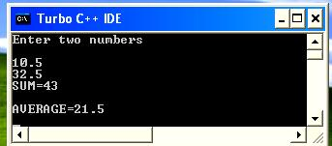

Conclusion:

OOP provides a clear modular structure for programs which makes it good for defining abstract data types where implementation details are hidden and the unit has a clearly defined interface. C++ is a versatile language for handling very large programs

Experiment No.2
Title:Write a program which demonstrates Classes and objects.

Objective:
At the end of this experiment, students should be able to understand following points:
- Class and object.
- Crating class and object.
- Defining function in different ways.
- Concept of Access Specifier like private, public etc.

Theory:

An Overview about Objects and Classes

In object-oriented programming language C++, the data and functions (procedures to manipulate the data) are bundled together as a self-contained unit called an object. A class is an extended concept similar to that of structure in Cprogramming language, this class describes the data properties alone. In C++ programming language, class describes both the properties (data) and behaviors (functions) of objects. Classes are not objects, but they are used to instantiate objects.

A typical C++ program would contain four sections as shown in the Fig. 2.1. These sections may be placed in separate code files and then complied independently.
Include Header Files
Class Declaration
Member Function Defination
Main Function Program

Features of Class:

Classes contain data known as members and member functions. As a unit, the collection of members and member functions is an object. Therefore, these units of objects make up a class

How to write a Class:

In Structure in C programming language, a structure is specified with a name. The C++ programming language extends this concept. A class is specified with a name after the keyword class.

The starting flower brace symbol {is placed at the beginning of the code. Following the flower brace symbol, the body of the class is defined with the member functions data. Then the class is closed with a flower brace symbol} and concluded with a colon;.
class class_name
{

data;
member functions;
……………
};

There are different access specifiers for defining the data and functions present inside a class.

Access specifiers:

Access specifiers are used to identify access rights for the data and member functions of the class. There are three main types of access specifiers in C++ programming language:

- private :Aprivatemember within a class denotes that only members of thesame class have accessibility. The private member is inaccessible from outside the class.

- public : Publicmembers are accessible from outside the class.

- protected: A protected access specifier is a stage betweenprivateandpublic access. If member functions defined in a class are protected, theycannot be accessed from outside the class but can be accessed from the derived class. .

When defining access specifiers, the programmer must use the keywords: private, public or protected when needed, followed by a semicolon and then define thedata and member functions under it.
class NewClass
{
private:

int data; float cost;

public:
void | getData(int a,float b);//function to initialize data
void | putData(void); | //function to return data
};

In the code above, the member x and y are defined as private access specifiers. The member function sum is defined as a public access specifier.

General Template of a class:

General structure for defining a class is:
class classname
{
Access specifier:
Data members;
Member Functions

Access specifier:
Data members;
Member Functions

};

Comparison between a Class and a Structure

class Bird
{ | struct Bird
char name[10]; | {
int age; | char name[10];
say(); | int age;
move(); | say();
}; | move();
 | };

If you compare the two declarations, you will not notice any difference accept the keyword “struct” or “class”.The difference between them is in their implementation. A Structure‟s components are defined public by default while that of a class are defined private by default. Here private and public are called access specifiers.

Creating Objects

Once class has been declared, we can create variables of that type by using the class name (like other built-in variables)

Juts as we declare a variable of data type int as: int x;

Objects are also declared as:
class name followed by object name;

NewClass N; //memory for N is created

This declares e1 to be an object of class NewClass

The object can also be declared immediately after the class definition. In other words the object name can also be placed immediately before the closing flower brace symbol } of the class declaration. For example
class NewClass
{

--------
--------

}N1,N2,N3;

would create the objects N1,N2and N3 of type NewClass

Accessing Class members

The private data of class can be accessed only through the member function of that class. The following is the format for calling a member function.

Object-name.function-name (actual-arguments);

For example, the function call statement

N.getcdata(100,75.5);

is valid and assigns the value 100 to data and 75.5 to cost of the object N by implementing getdata() function. Similarly the statement

N.putdata();

Would display the values of the data members.

Defining Member Function

Member function can be defined in two places

- Outside the class definition

- Inside the class definition

Outside the class definition:

An important difference between a member function and normal function is that a member function incorporates a membership „identity label„ in the header. This label tells the complier which class the function belongs to. The general form of a member function definition is:

Return-type class-name :: function-name (argument declaration)

{

Function body

}

class-name:: tells the compiler that the functionfunction-namebelongs to the

class-name

:: Is called scope resolution operator.

For example

void NewClass :: getdata(int a, float b)

{

data = a; cost = b;

}

void NewClass :: purdata(void)

{

cout<<”Data :”<<data<<”\n”; cout<<”Cost :”<<cost<<”\n”;

}
Inside the Class Definition

Another method of defining the member function is to replace the function declaration by the actual function definition inside the class. For instance

class NewClass

{

int data; float cost;

public:

void getdata(int a,float b); //inline function

void putdata(void ) { //display data }

};

when function is defined inside a class, it is treated as an inline function.

friend function

Friend function is a special function which can access the private and protected Members of a class through the object of the same class. Friend functions are not the member functions of a class and they can be declared under any access specify. To make an outside function “friendly” to the class we have to declare this function as friend of the class as shown

class ABC

{

……

public:

……

……

friend void xyz(void);// Declaration

};

Algorithm:

- Create any class(NewClass) , define class variables, member functions of class.

- In main function create object of the class(N,N1)

- Access members of above class in main class.

- Call the methods of the class with the respective class with obj_name.method_name(N.getdata(actual arguments))

Output

Practice No1.

Design, develop, and execute a program in C++ based on the following requirements:

An EMPLOYEE class is to contain the following data members and member functions: Data members: EmployeeNumber (an integer), EmployeeName (a string of characters), BasicSalary (an integer), All Allowances (an integer), IT (an integer), NetSalary (aninteger).

Member functions: to read the data of an employee, to calculate Net Salary and to print the values of all the data members. (AllAllowances = 123% of Basic; Income Tax (IT) = 30% of the gross salary (= basic Salary _ AllAllowance); Net Salary = Basic Salary + All Allowances – IT)

Algorithm:

- Create Class Employee.
- Class Employee Contains following data members
  - Employee_Number as integer
  - Employee_Name as String
  - Basic_Salary as integer
  - All_Allowances as integer
  - IT as integer
  - Net_Salary as integer
  - Gross_Salary as integer

- Class Employee Contains following members functions
  - Create function as getdata for accepting information of employee. Like employee name,employee number and basic salary etc.
  - Create function Net_salary_Calculation to calculate gross salary.
  - Create function displayInformation to display information about employee.
- Create main function to call this function of class Employee.

Program:

#include<conio.h>
#include<iostream.h>
Class Employee
{
Private: //Access Specifier
Int Employee_Number;
Char Employee_Name[50];
Int Basic_Salary,Net_Salary,IT,All_Allowances,Gross_Salary;

Public:
Void getdata()
{
Cout<<”Enter Employee Name:”;
Cin>>Employee_Name;
Cout<<”Enter Employee Number:”;
Cin>>Employee_Number;
Cout<<”Enter Employee Basic Salary:”;
Cin>>Employee_Salary;
}

Void Net_salary_Calculation()
{
All_Allowances=123/100*Basic_Salary;
Gross_Salary=Basic_Salary+All_Allowances;
IT=30/100*Gross_Salary;
Net_Salary=Basic_Salary+All_Allowances-IT;
}

Void displayInformation()
{
Cout<<”\n-----------------Information About Employee---------“;
Cout<<”\nEmployee Name:”<<Employee_Name;
Cout<<”\nEmployee Number:”<<Employee_Number;
Cout<<”\nEmployee Basic Salary:”<<Basic_Salary;
Cout<<”\nEmployee Net Salary:”<<Net_Salary;

}
};

Void main()
{
Employee e; //creating object of employee
Clrscr(); //clear the screen

e.getdata(); // calling function
e. Net_salary_Calculation()
e.displayInformation();

getch();

}

Output:
Enter Employee Name: ABC
Enter Employee Number:123
Enter Employee Basic Salary:10000

-----------------Information About Employee---------“;
Employee Name:ABC
Employee Number:123
Employee Basic Salary:10000
Employee Net Salary:15610

Conclusion

A class is an extension to the structure data type. Data member should be grouped in private access specifier and member functions are normally clustered together in public section. Attempting to access private members from outside the class will cause syntax error.

Experiment No.3

Title:Write a program to demonstrate different types of constructors

Objective:
At the end of this experiment, students should be able to understand following points:
- Concept of Constructor and Destructor.
- Use of constructor and Destructor.

Theory:

Constructors:

What is the use of Constructor

The main use of constructors is to initialize objects. The function of initialization is automatically carried out by the use of a special member function called a constructor.

General Syntax of Constructor

Constructor is a special member function that takes the same name as the class name. The syntax generally is as given below:

<class name> { arguments};

The default constructor for a class X has the form

X::X()

In the above example the arguments is optional. The constructor is automatically named when an object is created. A constructor is named whenever an object is defined or dynamically allocated using the "new" operator.

The constructor is invoke whenever an object of its class is created. It is called constructor because it constructs the values of data member of the class

A constructor is declared and defined as follows

class integer
{
int m, n;

public:

integer(void); //constructor declared

----------

----------

};

integer :: integer(void) // constructor defined

{

m=0;

n=0;

}

The Constructor functions have some special characteristics:

- They should be declared in the public section.

- They are invoked automatically when the objects are created.

- They do not have return types, not even void and therefore they cannot return values.

- Cannot be inherited, through a derived class can call the base class constructor.

- Like other C++ function, they can have default arguments.
- Constructor cannot be virtual.

- We cannot refer to their address.

- An object with a constructor (or destructor) cannot be use as a member of union.
- They make implicit calls to the operators new and delete when memory allocation is required.

PARAMETERIZED CONSTRUCTOR

The constructors that can take arguments are called as parameterized constructors.

The constructor integer( ) may be modified to take arguments as shown below

class integer

{

int m, n; public:

integer(int x , int y)

---------------

---------------

};

integer :: integer(int x, int y) //parameterized constructor

{

m = x; n = y;

}

when constructor has been parameterized, the object declaration statement

integer int1;

may not work. We must pass initial values as a arguments to the constructor function when an object is declared. This can be done in two ways.

- By calling the constructor explicitly

integer int1 = integer(0,150); //explicit call

this function creates an integer object int1 and passes the value 0 and 150 to it.

- By calling the constructor implicitly

integer int1 = integer(0,150); //implicit call

CONSTRUCTOR WITH DEFAULT ARGUMENTS

Its possible to defined constructor with default arguments. For e.g. complex( ) can be declared as

complex(float real, float imag=0 );

the default value of the argument imag is zero. Then, the statement complex C(5.6);

assigns the value 5.6 to the real variable and 0.0 to imag (by default). COPY CONSTRUCTOR

A copy constructor is used to declare and initialize an object from another object. For e.g. the statement

integer I2(I1);

Would define the object I2 and at the same time initialize it to I1. Another form of this statement is integer I2 = I1;

The process of initializing through a copy constructor is known as copyinitialization. A copy constructor takes a reference to an object of the same classas itself as an argument.

MULTIPLE CONSTRUCTORS IN A CLASS

class integer
{
int m, n;
public:
integer( ) { m = 0 ; n = 0; } | //constructor 1
integer( int a, int b) | //constructor 2
{ m = a; n = b; }
integer(integer & i) //constructor 3

{m = i.m; n = i.n;}

};

This declares three constructors for an integer object .

- integer I1;

the declaration would invoke the first constructor an set both m and n of I1 to zero.

(Receives no argument )

- integer I2(10,20);

initializes the data members m and n of I2 to 10 and 20 respectively.

- integer I3(I2);

invokes the third constructor which copies the value of I2 to I3.such a constructor is called as copy constructor

Algorithm

- Declare class(complex).Declare data members(x, y) and methods (constructor with no argument ,with one and two argument) also declare friend function if required.( friend complex sum(complex, complex);)

- Define the declared methods with help of scope resolution operator if it is defined outside the class.

- Create an object of the respective class (complex c;) and call the constructor or pass the value to the constructor.

Output

DESTRUCTORS

A destructor as name implies, is used to destroy the objects that have been created by a constructor. Like constructor, the destructor is a member function whose name is the same as the class name but is preceded by tilde. For Example, the destructor for the class integer can be defined as shown below

~integer( ) { }

A destructor never takes any argument nor does it returns any value. It will be invoked implicitly by the compiler upon exit from the program to clean up storage that is no longer accessible. It is good practice to declare the destructors in a program since it releases memory space for future use.

What is the use of Destructors

Destructors are also special member functions used in C++ programming language. Destructors have the opposite function of a constructor. The main use of destructors is to release dynamic allocated memory. Destructors are used to free memory, release resources and to perform other clean up. Destructors are automatically named when an object is destroyed. Like constructors, destructors also take the same name as that of the class name.

General Syntax of Destructors

~ classname();

The above is the general syntax of a destructor. In the above, the symbol tilde ~ represents a destructor which precedes the name of the class.

Some important points about destructors:

- Destructors take the same name as the class name.

- Like the constructor, the destructor must also be defined in the public. The destructor must be a public member.

- The Destructor does not take any argument which means that destructors cannot be overloaded.
- No return type is specified for destructors.

For example

class alpha

{

public:

alpha()

{

count++;

cout<<”\nNumber of object created”<<count;

}

~alpha()

{

cout<<”\nNumber of object destroyed”<<count;

}

};

Algorithm

- Declare constructor in any class(alpha)

- In constructor declare one variable for keeping the record of created objects

- For releasing the memory of declared constructor define the destructor with

„~‟ sign, above variable will show the destroyed object.

- Create object of class (alpha)
Output
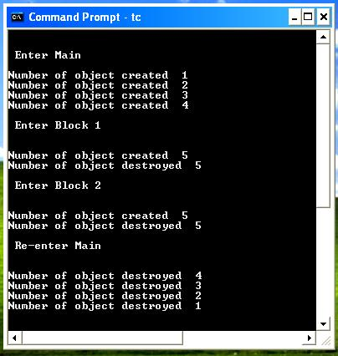

Conclusion

With help of constructors we have fulfilled one of our requirements of implementation of abstract data types. Initialization at definition time. Providing a constructor to ensure every object is initialized with meaningful values can help eliminate logic errors. We still need a mechanism which automatically destroy same object when it gets invalid. (For e.g. because of leaving its scope.) Therefore classes can define destructors

Experiment No.4

Title:Write a program using static data member as well as member function, create function using default argument concept.

Objective:
At the end of this experiment, students should be able to understand following points:
- Static Data Member and Static Member Function.
- Concept of Defalut argument.

Theory:

Static Data Member:

We can define class members static using static keyword. When we declare a member of a class as static it means no matter how many objects of the class are created, there is only one copy of the static member.

A static member is shared by all objects of the class. All static data is initialized to zero when the first object is created, if no other initialization is present. We can't put it in the class definition but it can be initialized outside the class as done in the following example by redeclaring the static variable, using the scope resolution operator :: to identify which class it belongs to.
Declarion Syntax:
Static static_variable_name;

Initaliztion of static variable:
Static variable initlize outside the class.
Syntax:
Data_type class_name:: static_variable_name=value;

Data_type class_name:: static_variable_name=value;

Access Static data member outside the class Syntax:
class_name:: static_variable_name;

Algorithm:
- Create Class name Box.
- Declare class member objectCountas static,length,breadth,height.
- Define member function
  - Define constructor.
  - Member function Volume for calculate Volume.
- Create main function to call functions of Box class.

Let us try the following example to understand the concept of static data members:

#include<iostream.h>

classBox
{
public:
staticint objectCount; //static variable
// Constructor definition with default argument
Box(double l=2.0,double b=2.0,double h=2.0)
{
cout <<"Constructor called."<< endl;
length = l;
breadth = b;
height = h;
// Increase every time object is created
objectCount++;
}
doubleVolume()
{
return length * breadth * height;
}
private:
double length;// Length of a box
double breadth;// Breadth of a box
double height;// Height of a box
};

// Initialize static member of class Box
intBox::objectCount =0;

int main(void)
{
BoxBox1(3.3,1.2,1.5);// Declare box1
BoxBox2(8.5,6.0,2.0);// Declare box2

// Print total number of objects.
cout <<"Total objects: "<<Box::objectCount << endl;

return0;
}
When the above code is compiled and executed, it produces the following result:
Output:
Constructor called.
Constructor called.
Total objects:2

Static Member Function:

By declaring a function member as static, you make it independent of any particular object of the class. A static member function can be called even if no objects of the class exist and the static functions are accessed using only the class name and the scope resolution operator ::.
A static member function can only access static data member, other static member functions and any other functions from outside the class.
Static member functions have a class scope and they do not have access to the this pointer of the class. You could use a static member function to determine whether some objects of the class have been created or not.

Declaration of Static Function
Static data_type function_name(Argument1,argument2,….,argument)
{
//Access only static data member and static member functions.
Static_variable=value;
}

Calling Static function outside the class
Class_name::static_function_name();

Algorithm:
- Create Class name Box.
- Declare class member objectCount as static,length,breadth,height.
- Define member function
  - Define constructor.
  - Member function Volume for calculate Volume.
  - getCount Member function as static
- Create main function to call functions of Box class.

Let us try the following example to understand the concept of static function members:
#include<iostream>

usingnamespace std;

classBox
{
public:
staticint objectCount;
// Constructor definition with default argument
Box(double l=2.0,double b=2.0,double h=2.0)
{
cout <<"Constructor called."<< endl;
length = l;
breadth = b;
height = h;
// Increase every time object is created
objectCount++;
}
doubleVolume()
{
return length * breadth * height;
}
staticint getCount()
{
return objectCount;
}
private:
double length;// Length of a box
double breadth;// Breadth of a box
double height;// Height of a box
};

// Initialize static member of class Box
intBox::objectCount =0;

int main(void)
{

// Print total number of objects before creating object.
cout <<"Inital Stage Count: "<<Box::getCount()<< endl;

BoxBox1(3.3,1.2,1.5);// Declare box1
BoxBox2(8.5,6.0,2.0);// Declare box2

// Print total number of objects after creating object.
cout <<"Final Stage Count: "<<Box::getCount()<< endl;

return0;
}
When the above code is compiled and executed, it produces the following result:
Output:
InitalStageCount:0
Constructor called.
Constructor called.
FinalStageCount:2

