MGM’s

JAWAHARLAL NEHRU ENGINEERING

COLLEGE

LAB MANUAL

YEAR: 2015-16

CLASS: ME EPS

SUBJECT: DIGITAL PROTECTION OF POWER SYSTEM

SUBJECT TEACHER: S. D. JAWALE

**SUBJECT: DIGITAL PROTECTION OF POWER SYSTEM**

**LIST OF PRACTICALS**

1. Simulation of Differential protection of Alternator with relay.

2. Simulation of Differential protection of Transformer with relay.

3. Simulation of Distance protection of Transmission Lines.

4. To Perform the operation of electro mechanical over current relay.

5. To Perform the operation of electro mechanical over voltage relay.

6. Modeling of Single‐Phase Instantaneous Over‐Current Relay using MATLAB.

7. To model a transformer using fundamental magnetic library blocks.

8. CT/PT Modeling.

Expt No. 1

Aim: Simulation of Differential protection of Alternator with relay.

Apparatus:

3 phase, 1A, CT operated % biased differential solid state Relay, CT’s 10/1

« Alternator : 5kVA, 3 Phase, 415V, 1500 rpm, Star connected alternator, seperately exited.

« Prime Mover : 7.5 HP 1500rpm 220V DC Shunt Motor.

« Field Exication : 220V DC, 1A

« Aux. Supply for Control Panel : 1 Phase, 230V AC

« Aux. Supply for DC Motor : 220V DC 15A source to be connected externally with 4 point starter.

Theory: The demonstration of differential protection scheme using AC circulating relay in the 3 phase alternator. The incoming & outgoing currents from the star connected stator winding of 3 phase alternators are sensed with the help of CT’s and given to AC circulating current relay. Under the fault conditions, incoming current & outgoing current will change magnitude & phase angle. The change in current depends upon the fault impedance. The CT secondary currents are different in magnitude and phase, as a result this current is circulated through the differential relay & relay operates after specific time period.

Circuit Diagram:

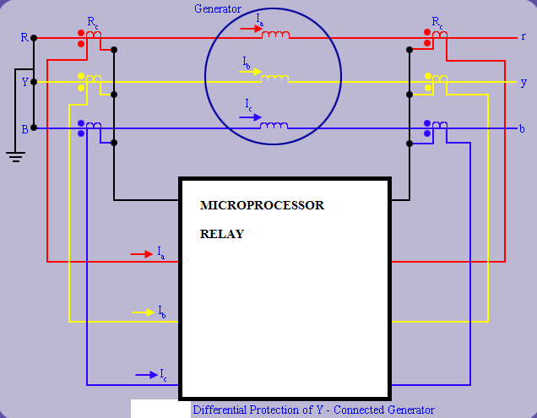

Procedure:

1. Connect as per interconnection diagram

2. Set the relay for fault level.

3. Ensure MCB switch is in OFF position.

4. Bring dimmerstats to zero position.

5. Put on the mains using MAINS ON switch.

6. Adjust the voltage level above the threshold level (Using dimmer).

7. Create fault by changing the Knob position.

8. Don’t disturb the dimmerstats.

9. Bring the Toggle switch to TEST mode.

10. Push TEST START BUTTON, Note down the voltage just before tripping. (Circuit breaker ON, CB ON indicator will glow, time interval meter starts up counting. relay trip occurs ‘TRIP’ indicator will glow).

11. Note down the Time Interval Meter reading. (Drop off time)

12. Press the RESET button.

13. Repeat operation by adjusting different voltage & TMS.

**TABULAR COLUMNS**

**% of Closing Voltage = Set Voltage**

|  |  |  |  |
| --- | --- | --- | --- |
| Sr. No. | Fault Type | % Trip | Trip Time |
|  |  |  |  |

Conclusion: For phase to phase fault, interturn fault and phase to ground fault the alternator is tripped because of relay operation and trip time suggested its fast and accurate operation.

Expt No. 2

Aim: Simulation of Differential protection of Transformer with relay.

Apparatus:

« Transformer specifications : 3-Phase, 5KVA, 415/240V, delta/star connected transformer

« Protection CT's : Primary side CT's 10/1A, 5 VA

« Fault Simulating Switches : 32A, 2-pole, On/Off rotary switches are provided for creating  
a) Line to Ground fault, b) Line to Line fault, c) Inter-turn fault  
« Protective Relay : Solid state % Differential Relay-with 20%, 30%, 40% & 50%  
setting for Current. CT rated 1A

Theory: The transformer protection demo panel is designed to give the demonstration of differential protection scheme used for power transformers. The power transformers, generally rated more than 1 MVA, are provided with differential protection scheme, to protect the transformer from internal faults. The internal faults may be created due to ageing effect, excessive heating, insufficient cooling system, failure of insulation etc.

Circuit Diagram:

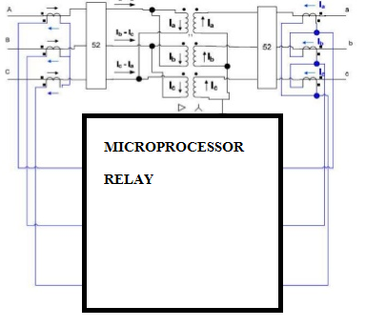

Procedure:

1. Connect as per interconnection diagram

2. Set the relay for fault level.

3. Ensure MCB switch is in OFF position.

4. Put on the mains using MAINS ON switch.

5. Observe the voltage and currrent.

6. Create fault by changing the Knob position.

7. Note down the time just before tripping. (Circuit breaker ON, CB ON indicator will glow, time interval meter starts up counting. relay trip occurs ‘TRIP’ indicator will glow).

8. Note down the Time Interval Meter reading. (Drop off time)

9. Press the RESET button.

10. Repeat operation by adjusting different fault location & TMS.

**TABULAR COLUMNS**

**% of Closing Voltage = Set Voltage**

|  |  |  |  |
| --- | --- | --- | --- |
| Sr. No. | Fault Type | % Trip | Trip Time |
|  |  |  |  |

Conclusion: For phase to phase fault, interturn fault and phase to ground fault the transformer CB is tripped because of relay operation and trip time suggested its fast and accurate operation.

Expt No. 3

Aim: Simulation of Distance protection of Transmission Lines.

Apparatus: Transmission line model for 400 km, 220 KV, transmission

Line with four pie models cascaded for 100 km length.

Solid state impedance relay with PT volt= 220V, CT of 1A

Theory:

The transmission line simulation is designed to demonstrate the fault clearing process on transmission line using distance relay. The principle of operation of these relays depends on the ratio of voltage to current changes & is depends on the fault current and its power factor under the fault conditions. As the fault impedance is proportional to distance of line, relay indicates the distance over which the fault has been occurred.

A transmission line model having the length 400 KM & voltage of 220KV is designed for demonstration purposes. The lumped parameter line model with four cascaded networks each of them is designed for 100 KM parameters. Fault simulating switches are provided to create the fault condition. The switches are used to short live part of line to ground through some fault impedance at different locations. The impedance relay senses the fault current, voltage and gives trip signal to the C. B., which isolates the transmission lines from the supply.

Circuit Diagram:

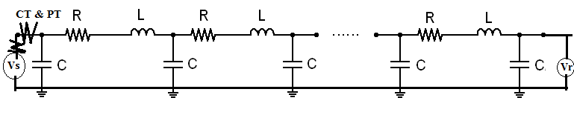

Procedure:

1. Connect as per interconnection diagram

2. Set the relay for fault level.

3. Ensure START switch is in OFF position.

4. Put on the mains using MAINS ON switch.

5. Observe the voltage and currrent.

6. Create fault by changing the Knob position.

7. Note down the time just before tripping. (Circuit breaker ON, CB ON indicator will glow, time interval meter starts up counting. relay trip occurs ‘TRIP’ indicator will glow).

8. Note down the Time Interval Meter reading. (Drop off time)

9. Press the RESET button.

10. Repeat operation by adjusting different fault location & TMS.

**TABULAR COLUMNS**

**% of Closing Voltage = Set Voltage**

|  |  |  |  |
| --- | --- | --- | --- |
| Sr. No. | Fault Location | % Trip | Trip Time |
|  |  |  |  |

Conclusion: For short, medium and long transmission network, three faults created using thee knob and different relay setting suggested accurate and correct operation.

Expt No. 4

**ELECTRO MECHANICAL OVER CURRENT RELAY**

**AIM:** To Perform the operation of electro mechanical over current relay.

**APPARATUS REQUIRED**

1. Electro-Mechanical Over current rely unit

2. Resistive Load.

3. Connecting probes

**PROCEDURE**

1. Set the relay current using plug setting.

2. Connect the power cord& load.

3. Bring dimmer to zero position.

4. Put on the mains using MAINS ON switch then Mains on indicator, ammeter display.

5. Adjust the dimmerstat and load , set the approximate current.

6. Vary the load and observe load current.

7. When current incresed beyond plug setting, relay will pick up and count the time.

10. Push TEST STOP/RESET BUTTON.

11. Don’t disturb the dimmerstat.

12. Repeat operation by adjusting different fault current & TMS.

**TABULAR COLUMNS**

**PSM= Fault Current / Plug setting**

|  |  |  |  |
| --- | --- | --- | --- |
| Sr. No. | Fault Current | Fault Time | PSM |
|  |  |  |  |

Conclusion:

Expt No. 5

**ELECTRO MECHANICAL OVER VOLTAGE RELAY**

**AIM:** To study the operation of electro mechanical over voltage relay.

**APPARATUS REQUIRED**

1. Electro-Mechanical Over voltage rely unit

2. Resistive Load.

3. Connecting probes

**PROCEDURE**

1. Set the relay voltage using plug setting.

2. Connect the power cord & load.

3. Bring dimmer to zero position.

4. Put on the mains using MAINS ON switch then Mains on indicator, voltmeter display.

5. Adjust the dimmerstat and load , set the approximate voltage.

6. Vary the load and observe load current and voltage.

7. When voltage incresed beyond plug setting, relay will pick up and count the time.

10. Push TEST STOP/RESET BUTTON.

11. Don’t disturb the dimmerstat.

12. Repeat operation by adjusting different fault voltage & TMS.

**TABULAR COLUMNS**

**PSM= Fault Current / Plug setting**

|  |  |  |  |
| --- | --- | --- | --- |
| Sr. No. | Fault Voltage | Fault Time | PSM |
|  |  |  |  |

Conclusion:

Expt No. 6

Aim: Modeling of Single‐Phase Instantaneous Over‐Current Relay using MATLAB.

Thoery: Instantaneous Time over Current Relay: It operates in a definite time when current exceeds its pick‐up value. It has operating time is constant. In it, there is no intentional time delay. It operates in 0.1s or less.

Waveform Results in MATLAB for Single Phase Instantaneous Time Over‐Current Relay:



Conclusion: Single phase over current relay modeled for single phase load and as load current increased relay instantly operated the breaker.

Expt No. 7

Aim: to model a transformer using fundamental magnetic library blocks.

Theory: The transformer is rated 50W, 60 Hz, 120V/12V and assumed to have an efficiency of 94%, no-load magnetizing current of 1% and a leakage reactance of 2.3%. Core losses are not modeled and the core material B-H characteristic is assumed to be linear.

The transformer initially operates under no-load conditions. At time t=0.5s, the rated load is turned on. Because of the winding resistances and leakage inductances, the secondary voltage drops from 12 Vrms to 11.3 Vrms and the transformer supplies a full load current of 3.9 A rms on its secondary. The flux and mmf scopes show the operating conditions during no-load and full-load. Compare the leakage flux with the core flux, and observe the primary and secondary-side mmfs.

**Model**

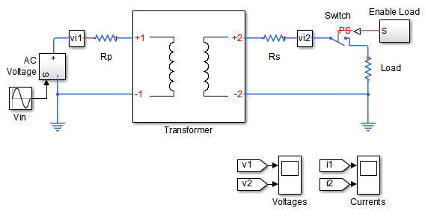

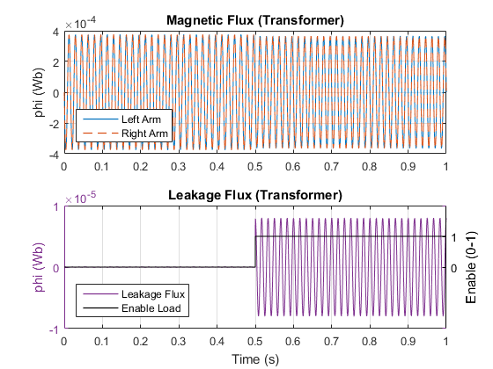

Conclusion: Modeling of transformer shows drop in secondary voltage and presence of leakage flux giving result of conventional transformer.

**Expt No. 8**

**Aim : CT/PT modeling.**

1. **Modeling Transformer Hysteresis**

Modeling the core of the transformer is an involved process because of the nonlinear behavior of the flux in the core. To model the hysteresis, an approximate process with linear elements, resistance and inductance was implemented in MATLAB. Flux can be expressed as in Equation 1 using Faraday’s law.

Equation 1



Hence, the flux density is;



Equation 2

Equation 1shows that the flux is directly proportional to the integral of the voltage across the winding. The magnetic field intensity in the transformer is also directly proportional to the current. Hence, the flux density, B, versus the magnetic field intensity, H, can be approximated by the voltage integral versus current.



**Figure 1:** Voltage Integral versus Current of Resistive Element

Figure 1 shows that the integral of voltage and resistive current are phase-shifted by 90. Due to the phase shift, the relationship has an elliptical shape with two radii that are functions of the resistance and the angular frequency .



**Figure 2:** Voltage Integral versus Current of Inductive Element

Voltage Integral

-1500

-1000

-500

0

500

1000

1500

-1500

-1000

-500

0

500

1000

1500

Inductance Current

Voltage Integral versus current of the inductive element

When the integral of voltage and inductive current are in phase, they form a straight line relationship as shown in Figure 2.

When the two elements are added together in parallel as shown in Figure 3.3, the total currents are given by Equation 3



Equation 3



**Figure 3:** Approximate representation of Transformer Hysteresis

Transformer excitation is shown in Figure 4. This is used in this study as an approximate representation of the transformer core.

-0.02

-0.015

-0.01

-0.005

0

0.005

0.01

0.015

0.02

-1.5

-1

-0.5

0

0.5

1

1.5

excitation current (pu)

excitation flux (pu)

**Figure 4** Typical transformer excitation curve

**2 Transformer Equivalent Circuit**

The transformer equivalent circuit as shown in Figure 3.5 consists of an ideal transformer with ratio N1:N2 and various other elements. The model takes into account the winding resistances R1 and R2, and the leakage inductances L1 and L2. Io is the excitation current representing the magnetic field intensity. Ro and Xo are the equivalent core resistance and the core inductive reactance respectively. The parameters of the core model are referred to the primary side of the transformer.

**2.1 Analysis of the Equivalent Model**

The primary current of the transformer is given by Equation 4



**Equation 4**

The current I2 is equal to the load current as seen from the primary side. This is also known as the reflected load current. The relationship between I2 and I′2 is the turns ratio of the transformer as given by Ampere-Turns Equation .

I′2N1 = I2N2



**Equation 5**

The voltage equations of the primary and secondary circuits are:



**Equation 6**

**Equation 7**



Equation 6 can be re-written by substituting Equation 7 into Equation 6



**Equation 8**

**Equation 9**



V′2 is the reflected voltage of the secondary winding

R′2 is the reflected resistance of the secondary winding

X′2 is the reflected inductive reactance of the secondary winding

**Equation 10**



The transformer equivalent circuit is redrawn as per equation 10 and is shown in Figure 6.



**Figure 6**: Transformer Equivalent Circuit with values refered to the primary

**2.2 Matlab/Simulink Model of the Transformer**

The transformer equivalent circuit was modeled using Equation 10.The model was designed to simulate the current inrush phenomenon upon transformer energisation. The transformer was modeled as a series resistance and leakage inductance and by a nonlinear magnetizing inductance. The core loss was represented by a shunt resistive branch R0



**Figure 7** The Matlab/Simulink circuit for the equivalent transformer.

Figures 8 to 10 show the transformer magnetizing curves for various incident angles

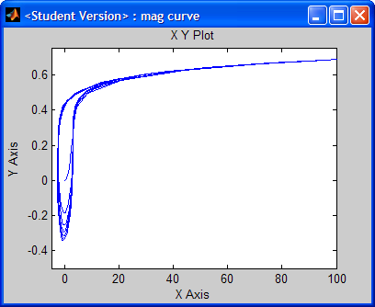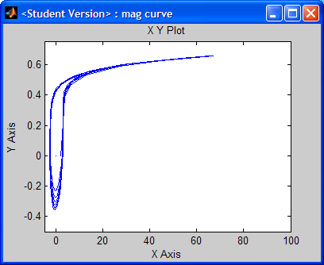

**Figure 8:**Magnetizing Curve at 0° Phase Angle **Figure 9:Magnetizing Curve at 45° Phase Angle**

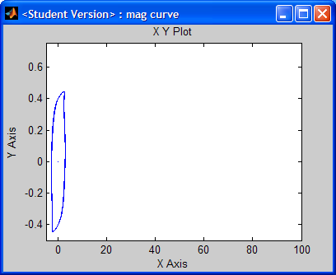

**Figure 10:** Magnetizing Curve at 90° Phase Angle

|  |  |  |
| --- | --- | --- |
| Power,KVA | Primary Voltage | Secondary Voltage |
| 50 | 2400 V | 240 V |

1. **Short Circuit Tests**

The short-circuit test was conducted by short-circuiting the secondary terminal of the transformer, and applying a reduced voltage to the primary side, as shown in Figure 3.12, such that the rated current flowed through the windings.



**Figure 3.12:** Experimental Setup of the Short-Circuit Tests



**Figure 13** Transformer short circuit test simulation

Conclusion: Modeling of Current & Potential transformer shows drop in secondary voltage and presence of leakage flux giving result of conventional transformer.