Jawaharlal Nehru Engineering College

Laboratory Manual

Power System Operation and Control

For

Final Year Bachelor Of Engineering (EEP) Students

Manual made by

Prof. Avinash S. Welankiwar

© Author JNEC, Aurangabad.

FOREWORD

It is my great pleasure to present this laboratory manual for First Year Master of Engineering ELECTRICAL POWER SYSTEMS engineering students for the subject of Computer Aided Power System Analysis. Keeping in view the vast coverage required for visualization of concepts of Computer Aided Power System Analysis with simple language.

As a student, many of you may be wondering with some of the questions in your mind regarding the subject and exactly what has been tried is to answer through this manual.

Faculty members are also advised that covering these aspects in initial stage itself, will greatly relive them in future as much of the load will be taken care by the enthusiasm energies of the students once they are conceptually clear.

H.O.D. (EEP)

LABORATORY MANUAL CONTENTS

This manual is intended for the First year students of ELECTRICAL POWER SYSTEM master of engineering branch in the subject of Computer Aided Power System Analysis. This manual typically contains practical/Lab Sessions related Computer Aided Power System Analysis covering various aspects related to the subject to enhance understanding.

Although, as per the syllabus, only descriptive treatment is prescribed, we have made the efforts to cover various aspects of Computer Aided Power System Analysis subject covering types of different power system analysis tools, their operating principals, their characteristics and Applications will be complete in itself to make it meaningful, elaborative understandable concepts and conceptual visualization.

Students are advised to thoroughly go through this manual rather than only topics mentioned in the syllabus as practical aspects are the key to understanding and conceptual visualization of theoretical aspects covered in the books.

Good Luck for your Enjoyable Laboratory Sessions

Prof. Avinash S. Welankiwar

SUBJECT INDEX

1. Do’s and Don’ts

2. Lab exercise:

1) Measurement of ABCD parameters of transmission line.

2) Formation of admittance matrices for given networks.

3) Programming of power flow using NewtonRaphson Method.

4) Programming of power flow using Gauss Seidel Method.

5) Programming of power flow using Fast Decoupled Method.

6) Modeling of single area and multi line Load frequency control in MATLAB SIMULINK.

7) Modeling AVR in MATLAB SIMULINK .

8) Modeling IEEE excitation systems in MATLAB SIMULINK.

9) Study of effect of Faults (LG, LL, LLG, 3 phase) on a single machine connected to infinite Bus.

10) Representation of Sequence Networks.
11) Modeling of Turbine and Governor System
12) Solution of Swing Equation by any one method.

3. Quiz on the subject

4. Conduction of Viva-Voce Examination

5. Evaluation and Marking Systems

1. DO’s and DON’Ts:

DO’s in Laboratory:

1. Use this software by using license key provided at the main server.
2. Any crash, invalid debugs may hang the software. In such cases, please wait for that program to respond otherwise this will directly delete the files if not saved properly.
DONT’s in Laboratory:

1. Don’t disturb the standard layout of the software.
2. Don’t disturb the license settings.

Instructions for Laboratory Teachers:

1. Submission related to whatever lab work has been completed should be done during the next lab session. The immediate arrangements for printouts related to submission on the day of practical assignments.

2. Students should be taught for taking the observations /readings of different measuring instruments under the able observation of lab teacher.

3. The promptness of submission should be encouraged by way of marking and evaluation patterns that will benefit the sincere students.

Exercise No : ( 2 Hours)
Practical 1 : (2 Hours):
AIM: Measurement of ABCD parameter of transmission line.

APPARATUS:
1 ) Input supply voltage= 1- phase,230V,50Hz.,AC supply.
2) Current capacity= 1 amp.
3 ) Line voltage assumed as 220 KV.
4) Line length assumed as,
a )Short length=100Km
b)Medium length=200Km.
c)Long length=400Km

THEORY:
1)For open circuit test
Vs=A.Vr+BIr
A=Vs/Vr-B.Ir
As Ir=-0
A=Vs/Vr
Now, Is=C.Vr+D.Ir
Is=C.Vr (as Ir=0)
C=Is/Vr

2)calculation for short circuit test
Vs=A.Vr+B.Ir
B=(Vs-A.Vr)/Ir
As, Vr=0 B=Vs/Ir

PROCEDURE:

1. Connect input supply to the sending end of transmission line.
2. Adjust sending end voltage at 220V by autotransformer.
3.
4. Increase load in steps and gradually take the readings of voltmeters and Ammeters.
5. Find Voltage and Current ratio.
6. Plot the graph of a) I1 v/s I2. b) V1 v/s V2

OBSERVATION TABLE:

Sr. No. | Primary  Voltage  (V1) | Primary  Current  ( I1) | Secondary  Voltage  (V2) | Secondary  Current  (I2) | V2 / V1 | I1 / I2
1.
2.
3.

CONCLUSION:
From Graph, Voltage and Current ratio we conclude that transformation ratio K= slope of the graph as well as Voltage and Current ratio is constant for 1-Φ transformer.

Practical 2 : (2 Hours):
Formation of Y bus and Z Bus matrices for given networks.

AIM: Formulate Y bus and Z Bus matrices for given networks.

APPARATUS:

1) MATLAB Software
2) Sim Power System Toolbox

THEORY:
1) What is admittance and how it is represented?
2) what is admittance matrix and Impedance matrix and how the self and mutual elements of this matrices are calculated?

MATAB CODE:

Y BUS MATRIX FORMATION:

% Program to form Admittance And Impedance Bus Formation....

function ybus = ybus(); % Returns ybus

linedata = linedata6(); % Calling "linedata6.m" for Line Data...
fb = linedata(:,1); % From bus number...
tb = linedata(:,2); % To bus number...
r = linedata(:,3); % Resistance, R...
x = linedata(:,4); % Reactance, X...
b = linedata(:,5); % Ground Admittance, B/2...
z = r + i*x; % Z matrix...
y = 1./z; % To get inverse of each element...
b = i*b; % Make B imaginary...

nbus = max(max(fb),max(tb)); % no. of buses...
nbranch = length(fb); % no. of branches...
ybus = zeros(nbus,nbus); % Initialise YBus...

% Formation of the Off Diagonal Elements...
for k=1:nbranch
ybus(fb(k),tb(k)) = -y(k);
ybus(tb(k),fb(k)) = ybus(fb(k),tb(k));
end

% Formation of Diagonal Elements....
for m=1:nbus
for n=1:nbranch
if fb(n) == m | tb(n) == m
ybus(m,m) = ybus(m,m) + y(n) + b(n);
end
end
end
ybus; % Bus Admittance Matrix
zbus = inv(ybus); % Bus Impedance Matrix

Z-Bus matrix formation:

Zbus = [0];
Quit = 0;
i = 0;
while Quit== 0

Case = input('Which case is to be implemented = ');
if Case == 1
if i == 0
Zb = input('Enter the value of impedance = ');
Zbus = [Zb]
end
if i>0
Zb = input('Enter the value of impedance = ');
ord = length(Zb1);
for d = 1:ord+1
for e = i:ord+1
if d<=ord && e<=ord
Zbus1(d,e) = Zb1(d,e);
end
if d==ord+1 && e==ord+1
Zbus1(d,e)=Zb;
end
if d==ord+1 && d~=e || e==ord+1 && d~=e
Zbus1(d,e)= 0;
end

end
end

Zbus = [Zbus1]
end
end
if Case == 2
Z_new = input('Enter the value of impedance for new bus = ');
m = length(Zbus);
for a=1:m
for b=1:m
Z_temp(a,b) = Zbus(a,b);
end
end
for c = 1:m
Z_temp(c,m+1) = Zbus(c,m);
Z_temp(m+1,c) = Zbus(c,m);
Z_temp(m+1,m+1) = Zbus(m,m)+Z_new;
end
Zbus = [Z_temp]
i = i+1;
end
if Case == 3
Z_new = input('Enter the value of impedance for new bus = ');
m = length(Zbus);
for a=1:m
for b=1:m
Z_temp(a,b) = Zbus(a,b);
end
end
for c = 1:m
Z_temp(c,m+1) = Zbus(c,m);
Z_temp(m+1,c) = Zbus(c,m);
Z_temp(m+1,m+1) = Zbus(m,m)+Z_new;
end
fprintf('Zbus before Kron Reduction:\n')
Zbus = [Z_temp]
m = length(Zbus);
for i=1:m-1
for k = 1:m-1
Z(i,k) = Zbus(i,k) - ((Zbus(i,m)*Zbus(m,k))/Zbus(m,m));
end
end
fprintf('Zbus after Kron Reduction:\n')
Zbus = [Z]
end
if Case == 4
Z1 = input('Enter the value of impedance = ');
j = input('Enter the value of bus j = ');
k = input('Enter the value of bus k = ');
m = length(Zbus);
for a=1:m
for b=1:m
Z_temp(a,b) = Zbus(a,b);
end
end
for c = 1:m
Z_temp(c,m+1) = Zbus(c,j)-Zbus(c,k);
Z_temp(m+1,c) = Z_temp(c,m+1);
end
Z_temp(m+1,m+1) = Z1+Zbus(j,j)+Zbus(k,k)-2*Zbus(j,k);
fprintf('Zbus before Kron Reduction:\n')
Zbus = [Z_temp]
m = length(Zbus);
for i=1:m-1
for k = 1:m-1
Z(i,k) = Zbus(i,k) - ((Zbus(i,m)*Zbus(m,k))/Zbus(m,m));
end
end
fprintf('Zbus after Kron Reduction:\n')
Zbus = [Z]
end
Quit = input('Do u want to quit = ');
Zb1 = [Zbus];
end

CONCLUSION:

We conclude that Y bus and Z bus are the characteristic matrices of an electrical network which helps in fault analysis and impedance characterization of that network.

Practical 3 : (2 Hours):

PROGRAMMING OF POWER FLOW USING NEWTONRAPHSON METHOD.

AIM: To simulate power flow using NewtonRaphson Method.

APPARATUS:
1) MATLAB Software
2) Sim Power System Toolbox

THEORY:
1. What is Load Flow.?
2. What is Newton Raphson method for load flow?
3. What is the accuracy for this method ?

MATLAB PROGRAM FOR NEWTON RAPHSON METHOD:

function Y = ybusppg(num) % Returns Y

linedata = linedatas(num); % Calling Linedatas...
fb = linedata(:,1); % From bus number...
tb = linedata(:,2); % To bus number...
r = linedata(:,3); % Resistance, R...
x = linedata(:,4); % Reactance, X...
b = linedata(:,5); % Ground Admittance, B/2...
a = linedata(:,6); % Tap setting value..
z = r + i*x; % z matrix...
y = 1./z; % To get inverse of each element...
b = i*b; % Make B imaginary...

nb = max(max(fb),max(tb)); % No. of buses...
nl = length(fb); % No. of branches...
Y = zeros(nb,nb); % Initialise YBus...

% Formation of the Off Diagonal Elements...
for k = 1:nl
Y(fb(k),tb(k)) = Y(fb(k),tb(k)) - y(k)/a(k);
Y(tb(k),fb(k)) = Y(fb(k),tb(k));
end

% Formation of Diagonal Elements....
for m = 1:nb
for n = 1:nl
if fb(n) == m
Y(m,m) = Y(m,m) + y(n)/(a(n)^2) + b(n);
elseif tb(n) == m
Y(m,m) = Y(m,m) + y(n) + b(n);
end
end
end
%Y; % Bus Admittance Matrix
%Z = inv(Y); % Bus Impedance Matrix

**** This program necessitates the LINE DATA and BUS DATA of a given Network. So, specify these matrices before debugging this program.

OBSERVATION :

This will consists of the output of MATLAB program giving different values of bus voltages, bus angles, and Power flow.

CONCLUSION:

From this Experiment we can conclude that using Newton Raphson method different values of bus voltages, bus angles, and Power flow can be calculated with less no. of iterations.
.

Practical 4 : (2 Hours):

Programming of power flow using Gauss Seidel Method.
Aim :- To simulate Programming of power flow using Gauss Seidel Method.

APPARATUS:

1) MATLAB Software
2) Sim Power System Toolbox

Theory:-
1. What is Load Flow.?
2. What is Gauss Seidel method for load flow?
3. What is the accuracy for this method ?

MATLAB PROGRAM FOR GAUSS SEIDEL METHOD:

function ybus = ybusppg(); % Returns ybus

linedata = linedata6(); % Calling "linedata6.m" for Line Data...
fb = linedata(:,1); % From bus number...
tb = linedata(:,2); % To bus number...
r = linedata(:,3); % Resistance, R...
x = linedata(:,4); % Reactance, X...
b = linedata(:,5); % Ground Admittance, B/2...
z = r + i*x; % Z matrix...
y = 1./z; % To get inverse of each element...
b = i*b; % Make B imaginary...

nbus = max(max(fb),max(tb)); % no. of buses...
nbranch = length(fb); % no. of branches...
ybus = zeros(nbus,nbus); % Initialise YBus...

% Formation of the Off Diagonal Elements...
for k=1:nbranch
ybus(fb(k),tb(k)) = -y(k);
ybus(tb(k),fb(k)) = ybus(fb(k),tb(k));
end

% Formation of Diagonal Elements....
for m=1:nbus
for n=1:nbranch
if fb(n) == m | tb(n) == m
ybus(m,m) = ybus(m,m) + y(n) + b(n);
end
end
end
ybus; % Bus Admittance Matrix
zbus = inv(ybus); % Bus Impedance Matrix

**** This program necessitates the LINE DATA and BUS DATA of a given Network. So, specify these matrices before debugging this program.

OBSERVATION :

This will consists of the output of MATLAB program giving different values of bus voltages, bus angles, and Power flow.

CONCLUSION:

From this Experiment we can conclude that using Gauss seidel method different values of bus voltages, bus angles, and Power flow can be calculated.
Practical 5 : (2 Hours):

PROGRAMMING OF POWER FLOW USING FAST DECOUPLED METHOD.

Aim:- To simulate Programming of power flow using Fast Decoupled Method

APPARATUS:
1) MATLAB Software
2) Sim Power System Toolbox

Theory:-
1. What is Load Flow.?
2. What is Gauss Seidel method for load flow?
3. What is the accuracy for this method?

MATLAB PROGRAM FOR Fast Decoupled METHOD:

clc
clear
%-------------v-----del-----Pg-----Qg----Pd----Qd-------------
bus = [ 1 1.04 0.00 0.00 0.00 0.00 0.00 0.00 0.00 1;
2 1.02533 0.00 1.63 0.00 0.00 0.00 0.00 0.00 2;
3 1.02536 0.00 0.85 0.00 0.00 0.00 0.00 0.00 2;
4 1.00 0.00 0.00 0.00 0.00 0.00 0.00 0.00 3;
5 1.00 0.00 0.00 0.00 0.90 0.30 0.00 0.00 3;
6 1.00 0.00 0.00 0.00 0.00 0.00 0.00 0.00 3;
7 1.00 0.00 0.00 0.00 1.00 0.35 0.00 0.00 3;
8 1.00 0.00 0.00 0.00 0.00 0.00 0.00 0.00 3;
9 1.00 0.00 0.00 0.00 1.25 0.50 0.00 0.00 3];

% formation of y bus for nominal tap ratio i.e. a=1
%----------------r-------x------------b------------
line = [1 4 0.0 0.0576 0. 1. 0. ;
4 5 0.017 0.092 0.158 1. 0. ;
5 6 0.039 0.17 0.358 1. 0. ;
3 6 0.0 0.0586 0. 1. 0. ;
6 7 0.0119 0.1008 0.209 1. 0. ;
7 8 0.0085 0.072 0.149 1. 0. ;
8 2 0.0 0.0625 0. 1. 0. ;
8 9 0.032 0.161 0.306 1. 0. ;
9 4 0.01 0.085 0.176 1. 0. ];

r = size(line);
p = r(1);
w = line(:,2 );
buses = max(w);

% b=zeros(1,buses);
ybus = zeros(buses,buses);
y = zeros(buses,buses);

for k= 1:p % finding the elements of ybus
l= line(k,1);
m= line(k,2);

y(l,m) = 1/(line(k,3)+ 1i*line(k,4));
y(m,l) = y(l,m);
% b(l) = b(l)+(i*line(k,5))/2;
% b(m) = b(m)+(i*line(k,5))/2;

end

for i = 1:buses
for j = 1:buses

if i==j
ybus(i,j) = ybus(i,j)+sum(y(i,:)); %+ b(i);
end

if i~=j
ybus(i,j) = -1*y(i,j);
end
end
end
ybus;
b = -imag(ybus);

%formation of b' matrtix
b1=zeros(buses-1,buses-1);
for i = 1:buses-1
for j = 1:buses-1
b1(i,j) =b(i+1,j+1);
end
end
b1;

%formation of b" matrtix
%assuming all the load buses are at last
b2=zeros(buses-3,buses-3);
for i = 1:buses-3
for j = 1:buses-3
b2(i,j) =b(i+3,j+3);
end
end
b2

v = bus(:,2);
del = bus(:,3);
Pg = bus(:,4);
Qg = bus(:,5);
Pd = bus(:,6);
Qd = bus(:,7);

Pspec = Pg-Pd;
Qspec = Qg-Qd;
iter = 1;
slack = 1;
tolerance = .01;
flag=1

while flag==1;

m = real(ybus);
n = imag(ybus);
P = zeros(buses,1);
Q = zeros(buses,1);
iter= iter+1;

for i=1:buses %finding bus real and reactive power
for j=1:buses
P(i) = P(i)+ (v(i)*v(j)*(m(i,j)*cos(del(i)-del(j))+n(i,j)*sin(del(i)-del(j))));
Q(i) = Q(i)+ (v(i)*v(j)*(m(i,j)*sin(del(i)-del(j))-n(i,j)*cos(del(i)-del(j))));
end
end

P
Q
%finding del P by v
for i=1:(buses-1)
if(i<slack)
delP(i,1)= Pspec(i)-P(i);
else
delP(i,1)=(Pspec(i+1)-P(i+1));

end
delPbyv(i,1)=delP(i,1)/v(i,1);
end

%finding del Q by v
c=0;
for i=1:buses
if bus(i,10)==3
c=c+1;
delQ(c,1)= (Qspec(i)-Q(i));
delQbyv(c,1)= delQ(c,1)/v(i,1);
end
end

if max(abs(delP))>tolerance | max(abs(delQ))>tolerance
flag=1; % tolerance check
else
flag=0;
end

%calc correction vector
deldel = inv(b1)*delPbyv;
delv = inv(b2)*delQbyv;

%updating values
for i=1:(buses-1)
del(i+1,1)= del(i+1,1)+deldel(i,1);
end

c=0;
for i=1:buses
if bus(i,10)==3
c=c+1;
v(i,1)=v(i,1)+delv(c,1);
end
end

iter
v
del
end

**** This program necessitates the LINE DATA and BUS DATA of a given Network. So, specify these matrices before debugging this program.

OBSERVATION :

This will consists of the output of MATLAB program giving different values of bus voltages, bus angles, and Power flow.

CONCLUSION:

From this Experiment we can conclude that using Gauss seidel method different values of bus voltages, bus angles, and Power flow can be calculated.

Practical 6 : (2 Hours):

Modeling single area and multi line Load frequency control in MATLAB SIMULINK.

AIM: Modeling single area and multi line Load frequency control in MATLAB SIMULINK.

APPARATUS:

1) MATLAB Software
2) Sim Power System Toolbox

THEORY:

1. What is Single area and multi area LFC?
2. What is controlled area?

PROCEDURE:

- Make a new model file in MATLAB.
- Use Sims Power System Toolbox and Mathematical Operations Toolbox for inserting the models of different mathematical operations such as add, subtract, limiters etc. and different electrical displays such as scope and Displays.
- Insert the blocks from respective toolboxes into new model by dragging it and connect that blocks.
- Give proper input to the model and check the output of Delta f at the output port/display/scope.
- Just by interconnecting two single area, two area load frequency control can be achieved.

MATLAB SIMULATION:

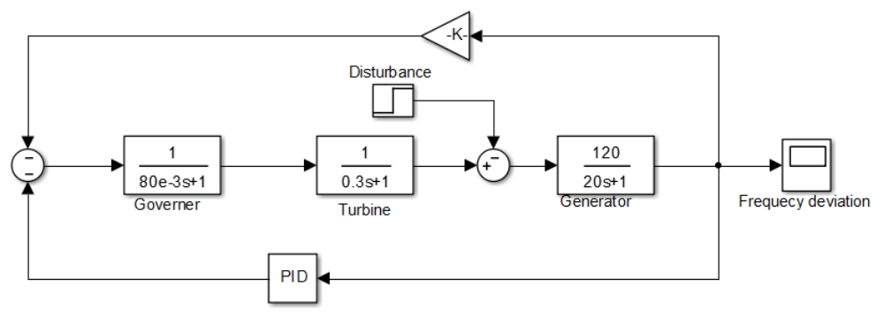

Single Area System
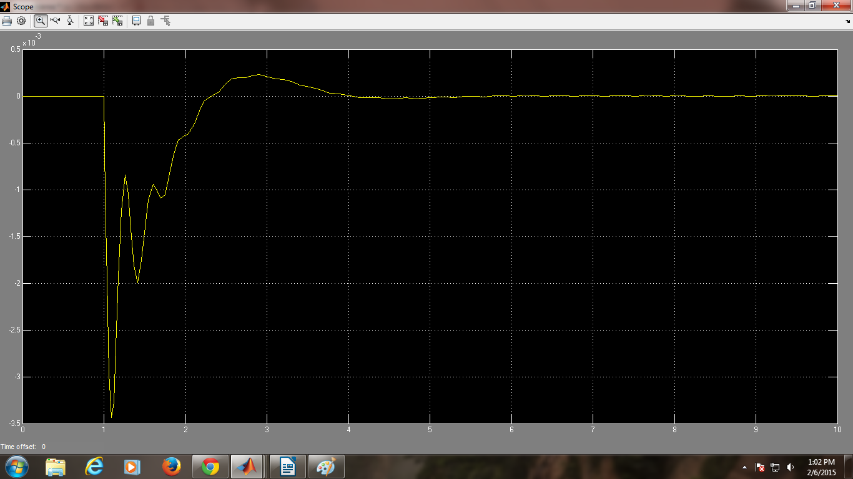
Frequency Deviation Response

OBSERVATIONS: Observe the frequency deviation at the alternator output.

CONCLUSION:

Single and multi area load frequency control involves the reduction of frequency deviation to zero.

Practical 7 : (2 Hours):
Modeling AVR in MATLAB SIMULINK

AIM: Modeling AVR in MATLAB SIMULINK

APPARATUS:

1) MATLAB Software
2) Sim Power System Toolbox

THEORY:
- what is AVR and state its operation?

PROCEDURE:

- Make a new model file in MATLAB.
- Use Sim Power System Toolbox and Mathematical Operations Toolbox for inserting the models of different mathematical operations such as add, subtract, limiters etc. and different electrical displays such as scope and Displays .
- Insert the blocks from respective toolboxes into new model by dragging it and connect that blocks.
- Give proper input to the model and check the output at the output port/display/scope.
- In this simulation, Step load change is given to the alternator system with AVR. By selecting suitable parameters of Error amplifier, SCR power Amplifier and Stabilizer, Vt deviations can be reduced to zero.
MATLAB MODEL

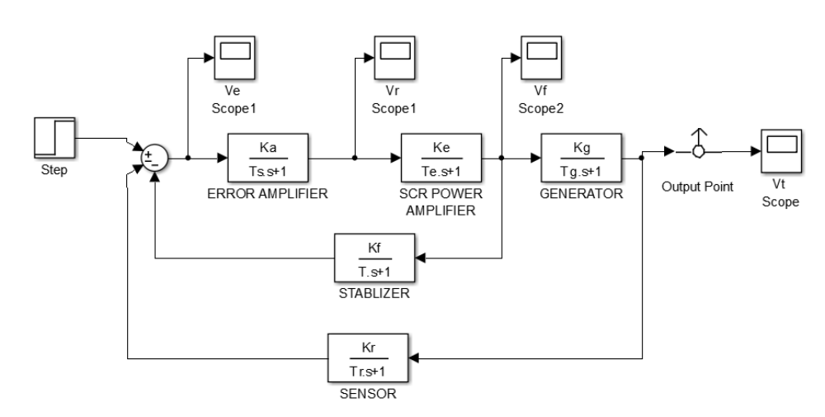
CONCLUSION:

Hence, Automatic voltage regulator controls the terminal voltage of the alternator by controlling excitation voltage.

Practical 8 : (2 Hours):
Small signal stability analysis of single machine connected to infinite bus in MATLAB SIMULINK.

AIM: - To Small signal stability analysis of single machine connected to infinite bus in MATLAB SIMULINK.

APPARATUS:

1) MATLAB Software
2) SIM POWER SYSTEM Toolbox

THEORY:-
1. What is small signal stability?
2. explain Small signal stability analysis of single machine connected to infinite bus.

Simulation model:
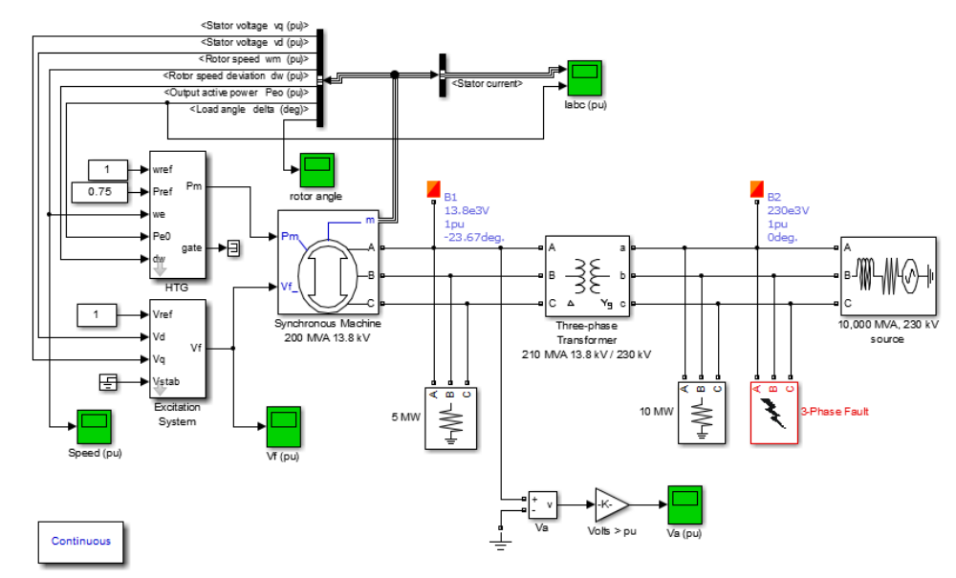

RESULTS:

A three-phase generator rated 200 MVA, 13.8 kV, 112.5 rpm is connected to a 230 kV, 10,000 MVA network through a Delta-Wye 210 MVA transformer. At t = 0.1 s, a three-phase to ground fault occurs on the 230 kV bus. The fault is cleared after 6 cycles (t = 0.2 s)

In case of fault, accelaration of the rotor results into oscillationsin rotor angle delta.

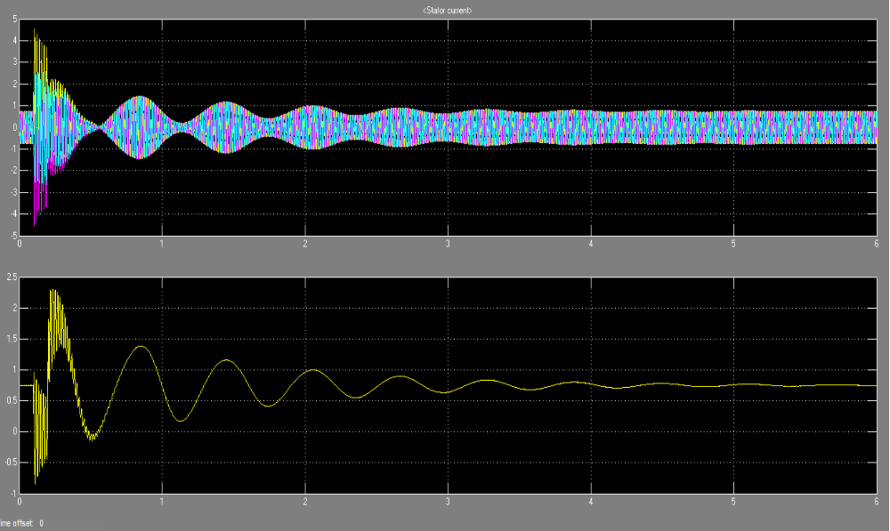
Line current and rotor angle variation.

CONCLUSION :- Small signal stability is characterized by means of underdamped oscillations in rotor angle of single machine connected to infinite bus.

Practical 9 : (2 Hours):

Modeling IEEE excitation systems in MATLAB SIMULINK

AIM: Modeling IEEE excitation systems in MATLAB SIMULINK

APPARATUS:
1) MATLAB Software
2) Sim Power System Toolbox

THEORY:
1. What is Excitation system?
2. What are types of excitation systems?

AC EXCITATION SYSTEMS:

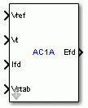
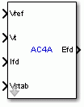
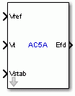

Vref
The reference value of the stator terminal voltage, in p.u.
Vt
The measured value in p.u. of the stator terminal voltage of the controlled Synchronous Machine block.
Ifd
The measured value in p.u. of the stator field current of the controlled Synchronous Machine block.
Vstab
Connect this input to a power system stabilizer to provide additional stabilization of power system oscillations. When you do not use this option, connect to a Simulink ground block. The input is in p.u.
Efd
The field voltage to apply to the Vf input of the controlled Synchronous Machine block. The output is in p.u.

DC EXCITATION SYSTEMS:
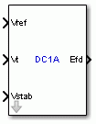
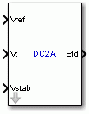

Vref
The reference value of the stator terminal voltage, in p.u.
Vt
The measured value in p.u. of the stator terminal voltage of the controlled Synchronous Machine block.
Vstab
Connect this input to a power system stabilizer to provide additional stabilization of power system oscillations. When you do not use this option, connect to a Simulink ground block. The input is in p.u.
Efd
The field voltage to apply to the Vf input of the controlled Synchronous Machine block. The output is in p.u.

STATIC EXCITATION SYSTEMS

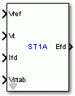
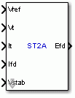

Vref
The reference value of the stator terminal voltage, in p.u.
Vt
The measured value in p.u. of the stator terminal voltage of the controlled Synchronous Machine block.
It
It The measured value in p.u. of the stator terminal current of the controlled Synchronous Machine block.
Ifd
The measured value in p.u. of the stator field current of the controlled Synchronous Machine block.
Vstab
Connect this input to a power system stabilizer to provide additional stabilization of power system oscillations. When you do not use this option, connect to a Simulink ground block. The input is in p.u.
Efd
The field voltage to apply to the Vf input of the controlled Synchronous Machine block. The output is in p.u.

CONCLUSION:

“IEEE Recommended Practice for Excitation System Models for Power System Stability Studies” gives the model ing of different excitation systems.
.

Practical 10 : (2 Hours):
REPRESENTATION OF SEQUENCE NETWORKS.

AIM: - To simulate Sequence Networks using basic mathematical relationships of it.

APPARATUS:

1) MATLAB Software
2) SIM POWER SYSTEM Toolbox

THEORY:-

The theory of symmetrical components resolves any set of unbalanced voltages or currents into three sets of symmetrical balanced phasors. These are known as positive, negative and zero-sequence components. Fig. shows balanced and unbalanced systems.

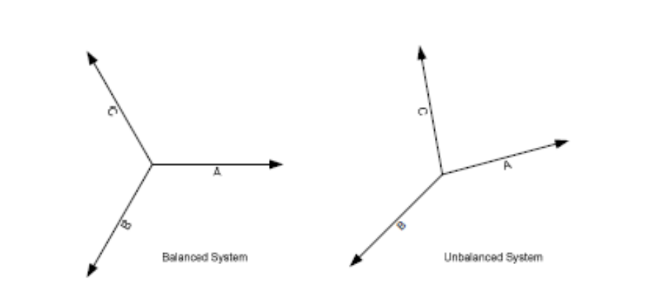

Consider the symmetrical system of phasors in Fig. 7.2. Being balanced, the phasors have equal amplitudes and are displaced 120 relative to each other. By the definition of symmetrical components, V b1 always lags V a1 by a fixed angle of 120 deg .and always has the same magnitude as V a1 . Similarly V c1 leads V a1 by 120 deg. It follows then that,

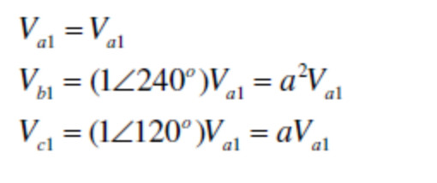
Negative sequence components are given by,
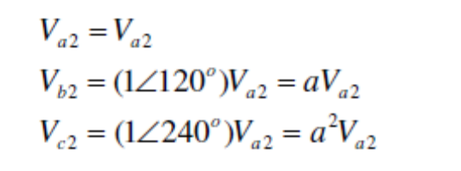
Zero Sequence components are given by,
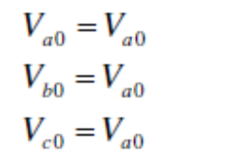
Where the subscript (2) designates the negative-sequence component and subscript (0) designates zero-sequence components. For the negative-sequence phasors the order of sequence of the maxima occur cba, which is opposite to that of the positive-sequence. The maxima of the instantaneous values for zero-sequence occur simultaneously.

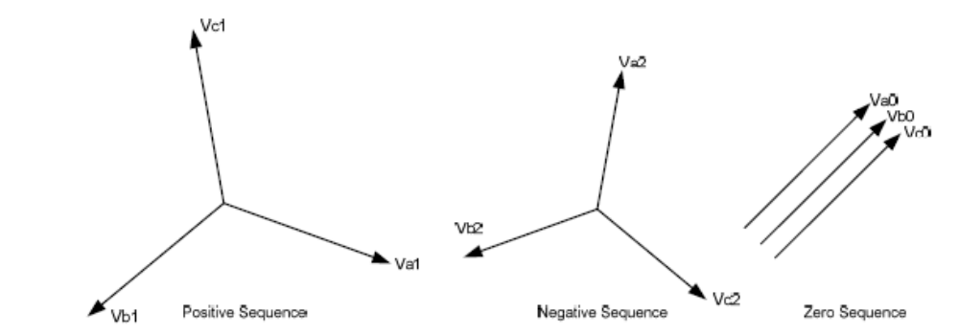

In all three systems of the symmetrical components, the subscripts denote the
components in the different phases. The total voltage of any phase is then equal to the
sum of the corresponding components of the different sequences in that phase. It is nowpossible to write our symmetrical components in terms of three, namely, those referred to the a phase

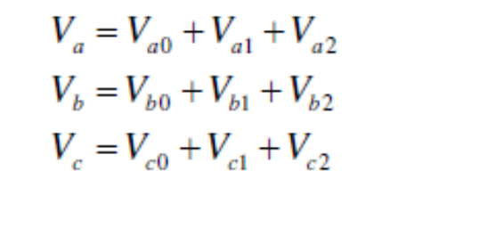
These components can be resolved by using ‘a’ operator,

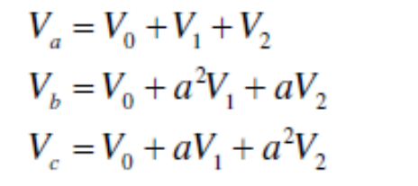

Symmetrical components of voltage can be derived from phase voltage components by the relationship given below,
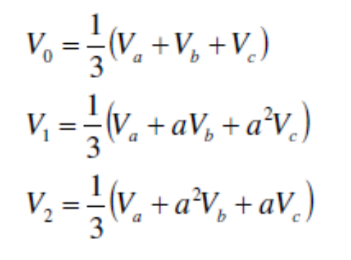
Similarly phase currents can be derived from symmetrical components of currents bys using relation ship
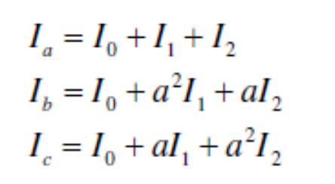

Sequence currents can be obtained by,
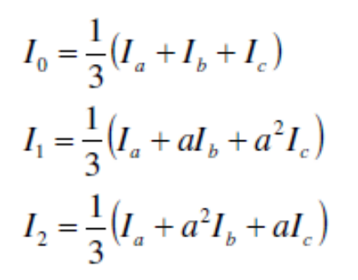

MATLAB PROGRAM FOR CALCULATION OF SYMETRICAL COMPONENTS:

RESULTS:

CONCLUSION: Symmetrical components of voltages or currents resolves that quantity into a set of three balanced vectors using ‘a’ operator. This helps in understanding the behavior of the unbalanced quantity and used in fault analysis

Practical 11 : (2 Hours):

Modeling of Turbine and Governor System
Aim :- Modeling of Turbine and Governor System

APPARATUS:

1) MATLAB Software
2) Sim Power System Toolbox

Theory:-
1.Explain in detail the turbine and governor

MATLAB SIMULATION:

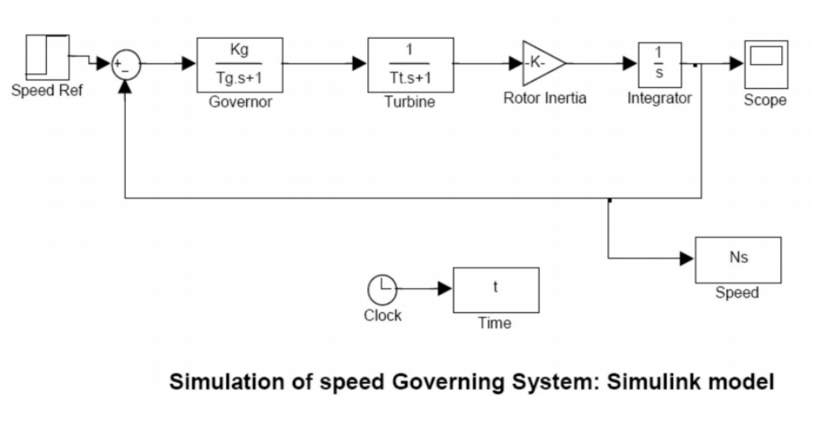

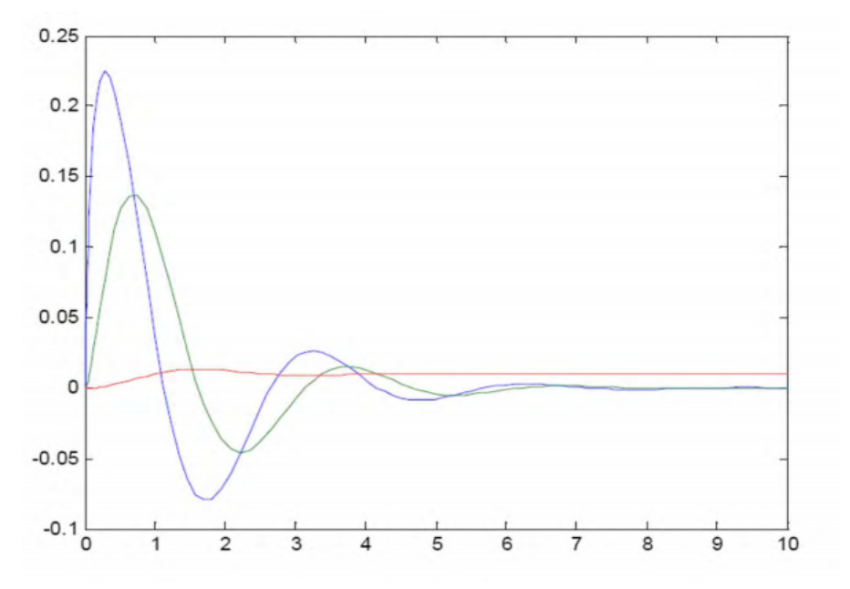

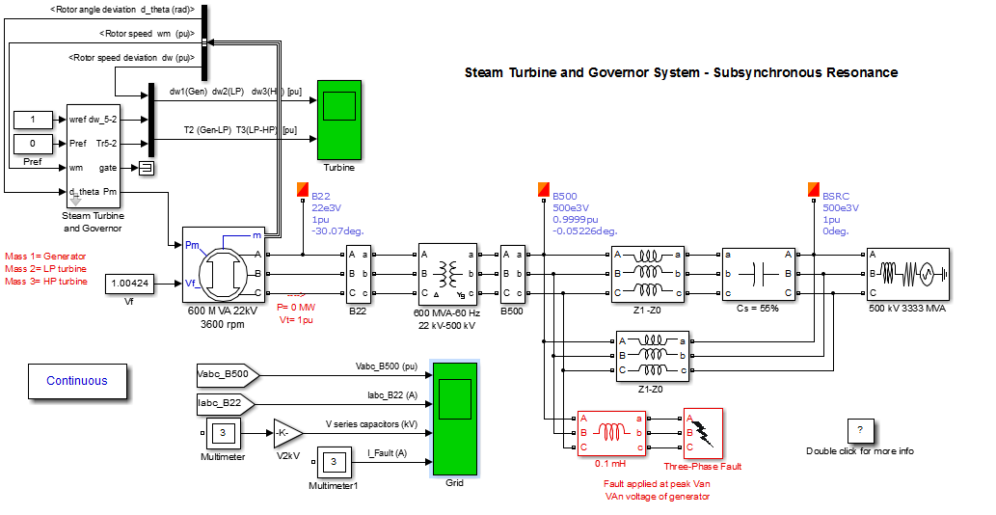
OBSERVATION :

Observe the speed regulation waveform in which speed regulations are reduced to zero.

CONCLUSION:

From this Experiment, we have studied turbine and governor modeling.

Practical 12 : (2 Hours):

Solution of Swing Equation by any one method.

AIM:-To solve swing equation by Point by Point method

(a) plot swing curve for a sustained fault up to a time of 5 secs.

(b) plot swing curve if fault is cleared by isolating line in 0.1 seconds.

(c) Find the critical clearing angle

THEORY:-
Swing equation being a non linear equation, numerical methods are use to solve it.

Point by Point method is one of the classical solutions to solve swing equation. Below is a solution of swing equation for a machine connected to infinite bus through two parallel lines. Swing equation is drawn for a persisting fault in one of the parallel line and also after fault is cleared. Stability of system is concluded after analyzing the swing curve. clearing angle is calculated for system stability.

Solve the following problem.

Problem: - f = 50Hz generator 50 MVA supplying 50 MW with inertia constant 'H' = 2.7

MJ/MVA at rated speed. E = 1.05 pu ,V = 1 pu, X1 = X2 = 0.4 pu. three phase fault at line 2.

(a) plot swing curve for a sustained fault up to a time of 5 secs.

(b) plot swing curve if fault is cleared by isolating line in 0.1 seconds.

(c) Find the critical clearing angle.

MATLAB PROGRAM:-

MVA base = 50

GIVEN:-

E = 50; V =1; Xd = 0.2; X1 =0.4; X2 = 0.4;H = 2.7;

prefault condition

del = 0:pi/10:pi;

del1 =del;

del2 = del;

M = 2.7/(180*50); % angular momentum = H/180*f

Peo = (1.05/0.4)*sin(del); % Initial power curve

Po = 1 ; % power output in pu = 50 MW/50 MVA

delo = asind(0.4/1.05); % initial load angle in degrees //Pe = (E*V/X) sin(delo)

During fault

Pe2 = 1.05*sin(del1); % Power curve during fault

Post fault condition

Pe3 = (1.05/0.6)*sin(del2); % Power curve after clearing fault

plot(del,Peo);

set(gca,'XTick',0:pi/10:pi);

set(gca,'XTickLabel',{'0','','','','','pi/2','','','','','pi'});

title('Power Curve');

xlabel('Load angle');

ylabel('Genpower');

text((2/3)*pi,(1.05/0.4)*sin((2/3)*pi),'\leftarrow intial curve','HorizontalAlignment','left');

text(pi/2,2.75,'2.625*sin\delta','HorizontalAlignment','center');

hold all

plot(del1,Pe2);

text((2/3)*pi,1.05*sin((2/3)*pi),'\leftarrow during fault','HorizontalAlignment','left');

text(pi/2,1.80,'1.05*sin\delta','HorizontalAlignment','center');

plot(del2,Pe3);

text((2/3)*pi,(1.05/0.6)*sin((2/3)*pi),'\leftarrow fault cleared','HorizontalAlignment','left');

text(pi/2,1.1,'1.75*sin\delta','HorizontalAlignment','center');

hold off

t = 0.05; % time step preferably 0.05 seconds

t1 = 0:t:0.5;

Similarly develop for

(a) sustained fault at t = 0

for discontinuity at t = 0 , we take the average of accelerating power

before and after the fault

at t = 0-, Pa1 = 0

at t = 0+. Pa2 = Pi - Pe2

at t = 0 ,Pa =Pa1+Pa2/2

(b) Fault cleared in 0.10 seconds ,2nd step ---- 3rd element [1]0 [2] 0.05,[3]0.10

(c) critical clearing angle

delo = degtorad(delo); % initial load angle in rad

delm = pi - asin(1/1.75); % angle of max swing

c1 = ((delm-delo)-(1.05*cos(delo))+(1.75*cos(delm)))/(1.75-1.05);

cclang = acos(c1); % critical clearing angle in rad

cclang = radtodeg(cclang); % critical clearing angle in degree

cclang = int16(cclang); % converting to integer

fprintf('\n\n\t\t Critical Clearing angle is %d degree ',cclang);

PROGRAM RESULTS:-

CONCLUSION:-
4. Conduction of Viva Voce Examination:

Teacher should take oral exams of the students with full preparation. Normally, the objective questions with guess are to be avoided. To make it meaningful, the questions should be such that depth of the students in the subject is tested Oral examinations are to be conducted in cocordial environment amongst the teachers taking the examination. Teachers taking such examinations should not have ill thoughts about each other and courtesies should be offered to each other in case of difference of opinion, which should be critically suppressed in front of the students.

5. Evaluation and marking system:

Basic honesty in the evaluation and marking system is absolutely essential and in the process impartial nature of the evaluator is required in the examination system to become popular amongst the students. It is a primary responsibility of the teacher that right students who are really putting up lot of hard work with right kind of intelligence are correctly awarded.

The marking patterns should be justifiable to the students without any ambiguity and teacher should see that students are faced with unjust circumstances.

