Jawaharlal Nehru Engineering College

Network Theory

For
Second Year Students

Manual made by
Prof. B.V. Pahade

LABORATORY MANNUAL CONTENTS

This manual is intended for the second year students of engineering branches in the subject of network theory. This manual typically contains practical/Lab Sessions related to Network Theory covering various aspects related the subject to enhance understanding.

In this manual we have made the efforts to cover various experiments on network theory with detailed circuit diagrams, detailed procedure and graphs wherever required.

Students are advised to thoroughly go through this manual rather than only topics mentioned in the syllabus as practical aspects are the key to understanding and conceptual visualization of theoretical aspects covered in the books.

Good Luck for your Enjoyable Laboratory Sessions

Prof. B.V.Pahade

FOREWORD

It is my great pleasure to present this laboratory manual for second year engineering students for the subject of Network Theory, keeping in view the vast coverage required to visualize the basic concepts of various networks using basic components. NT covers designing a network for specific input/output requirements.

This being a core subject, it becomes very essential to have clear theoretical and practical designing aspects.

This lab manual provides a platform to the students for understanding the basic concepts of network theory. This practical background will help students to gain confidence in qualitative and quantitative approach to electronic networks.

Good Luck for your Enjoyable Laboratory Sessions.

Prof. Dr. S.D.Deshmukh
Principal

SUBJECT INDEX
1. Do’s and Don’ts
2. Lab exercise:
1) To perform mesh analysis.
2) To perform nodal analysis.
3) To verify superposition theorem
4) To verify Thevnins theorem
5) To verify Nortans theorem.
6) To Study maximum Power transfer theorem.
7) To verify reciprocity theorem
8) Verification of Millmans equivalent circuit.
9) To Study analysis of RL circuit
10) To Study analysis of RC circuit
3. Conduction of Viva-Voce Examination
4. Evaluation and Marking Systems

1. DOs and DON’T DOs in Laboratory :
1. Do not handle kits without reading the instructions from manual.
2. Go through the procedures given in the lab manual for performing practical’s.
3. Strictly observe the instructions given by teacher/lab instructor.

Instruction for Laboratory Teachers:

1. Submission related to whatever lab work has been completed should be done during the next lab session.
2. Students should be guided and helped whenever they face difficulties.
3. The promptness of submission should be encouraged by way of marking and evaluation patterns that will benefit the sincere students.

2. Lab Exercises:
Exercise No1: (2 Hours) – 1 Practical
To perform mesh analysis.
Aim: To perform mesh analysis.
Theory:
- Explain how the circuit can be solved using mesh analysis?

Circuit to be solved.

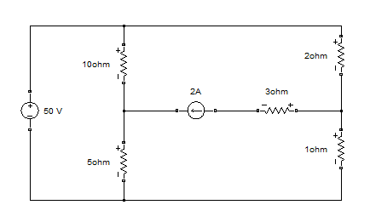

Matlab Simulation

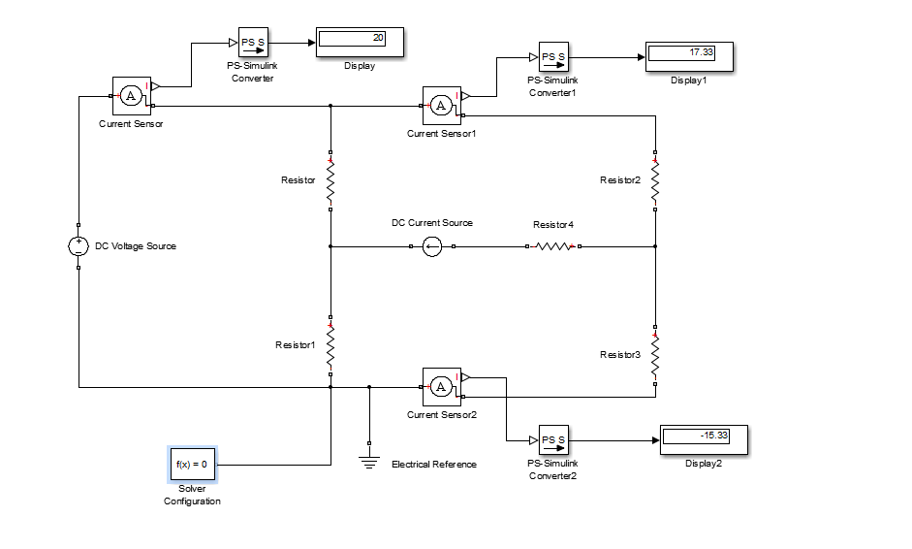

Conclusion:
Hence we have studied and analyzed the circuit for mesh anaylysis and also verification is done in matlab.

Exercise No 2: (2 Hours) – 1 Practical
To perform nodal analysis.
Aim: To perform nodal analysis.
Theory:
- Explain how the circuit can be solved using nodal analysis.

Circuit to be solved:
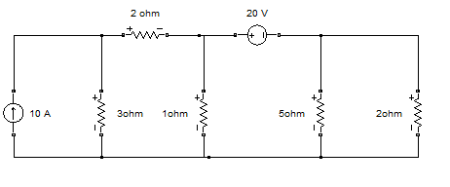
Matlab Simulation
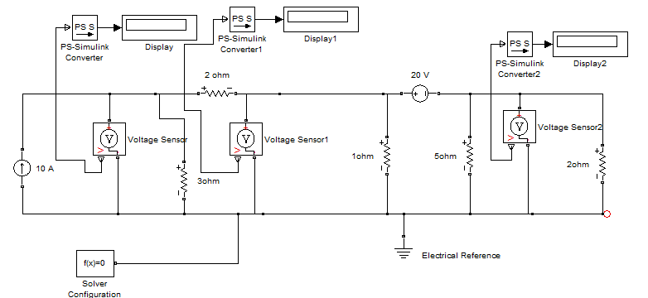

Conclusion:
Hence we have studied and analyzed the circuit for nodal analysis and also verification is done in matlab

Exercise No 3 : ( 2 Hours) – 1 Practical

To verify superposition theorem.
Aim: To verify superposition theorem.
Theory: State superposition theorem and explain how the circuit can be simplified by using superposition theorem.
Circuit to be solved:
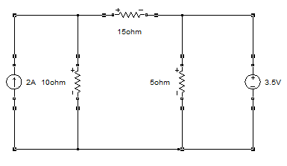
Matlab Simulation
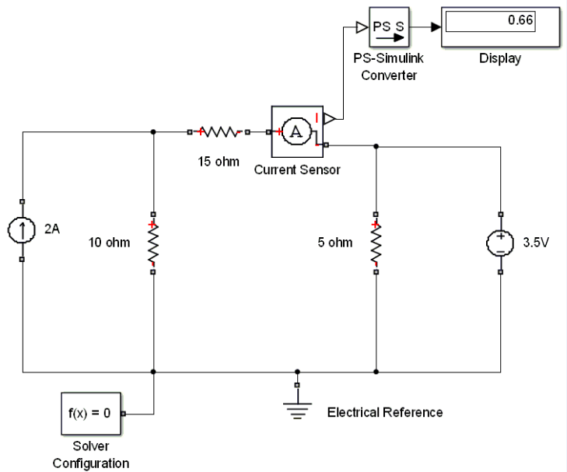
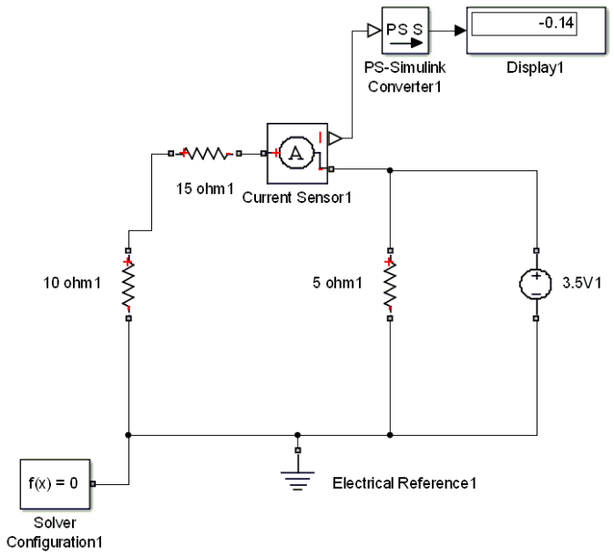

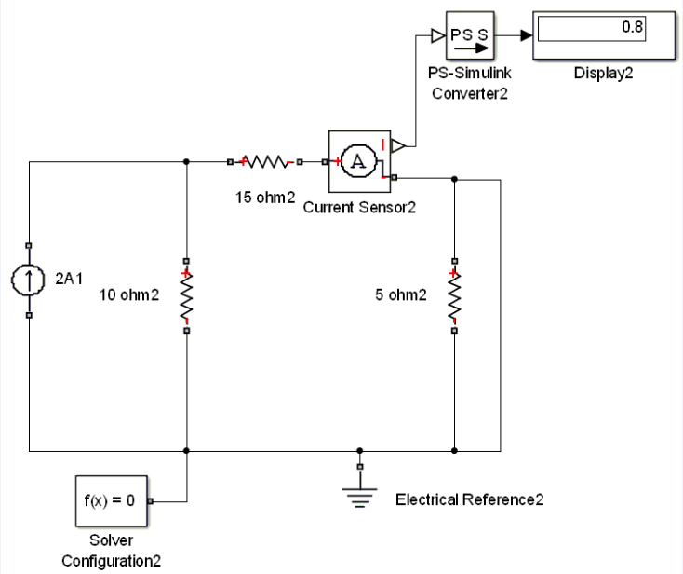

Conclusion: Hence superposition theorem is used to solve linear network containing more than one independent source and dependent source and also the same is verified in matlab.

Exercise No 4 : ( 2 Hours) – 1 Practical
To verify Thevnins theorem
Aim: To verify Thevnins theorem
Theory : State thevenins theorem and explain how the circuit can be simplified by using thevnins theorem.

Circuit to be solved:
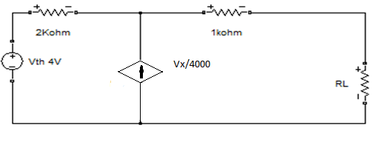

Matlab Simulation

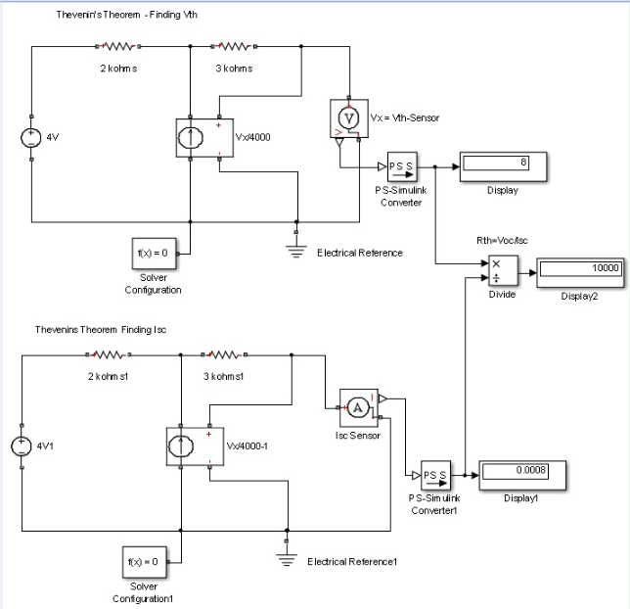

Conclusion : Hence we have studied and analyzed thevnins theorem to find its equivalent circuit. We can conclude that thevnins theorem convert complex network in to simple equivalent network having one voltage source and verified in matlab.

Exercise No 5: (2 Hours) – 1 Practical
To verify Nortans theorem
Aim: To verify Nortans theorem
Theory : State Nortans theorem and explain how the circuit can be simplified by using Nortans theorem
Circuit to be solved:
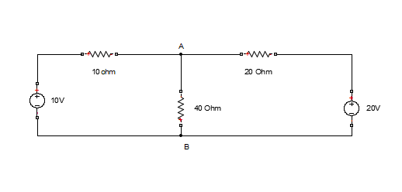

Matlab Simulation
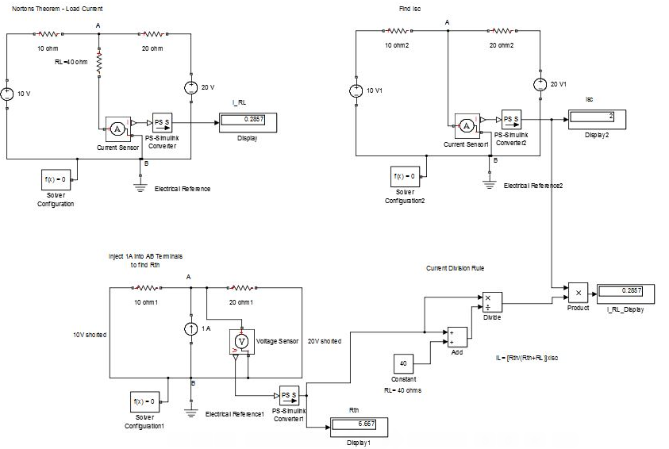
Conclusion:-Hence we have studied and analyzed nortans theorem to find nortan equivalent circuit for complex network and verified in matlab.

Exercise No 6: (2 Hours) – 1 Practical
To Study maximum Power transfer theorem
Aim: To Study maximum Power transfer theorem.
Theory : State maximum Power transfer theorem and explain how the circuit can be simplified by using maximum Power transfer theorem
Plot the graph of power against RL for maximum power transfer theorem.

Circuit to be solved:
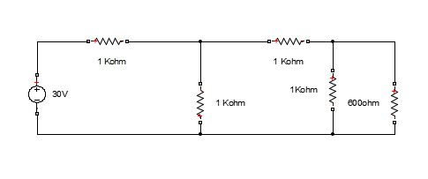

Matlab Simulation
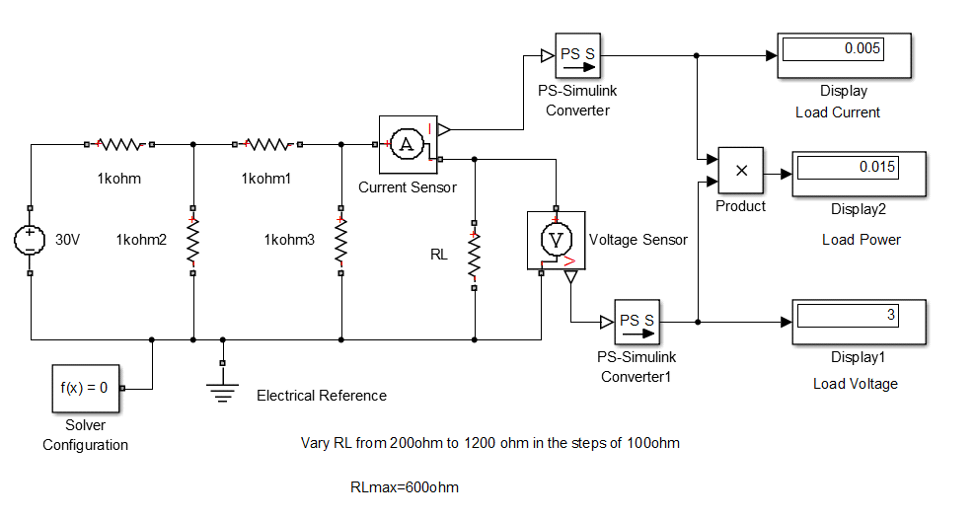
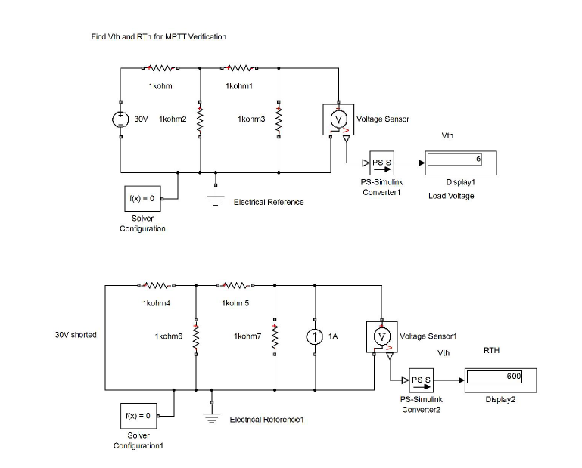
Conclusion:
Maximum power transfer theorem when load resistance RL is equal to source resistance is verified in matlab.

Exercise No 7: (2 Hours) – 1 Practical
To verify reciprocity theorem
Aim: To verify reciprocity theorem
Theory : State reciprocity theorem and explain how the circuit can be simplified by using reciprocity theorem.
Circuit to be solved
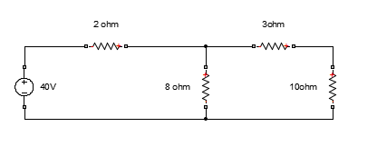
Matlab Simulation
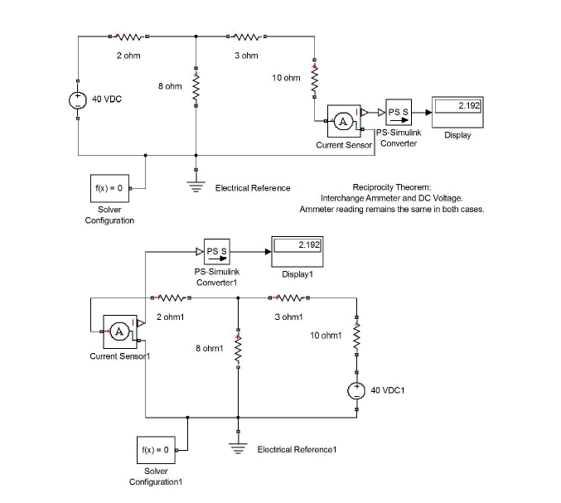
Conclusion: -
Thus we have studied reciprocity theorem and verified that ration of output and input is constant even though voltage source position is interchanged and the same is verified in matlab.

Exercise No 8: (2 Hours) – 1 Practical
Verification of Millmans equivalent circuit.
Aim: To verify Millmans equivalent circuit.
Theory: State Millmans theorem and explain how the circuit can be simplified by using Millmans theorem.
Circuit to be solved
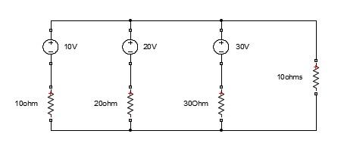
Matlab Simulation
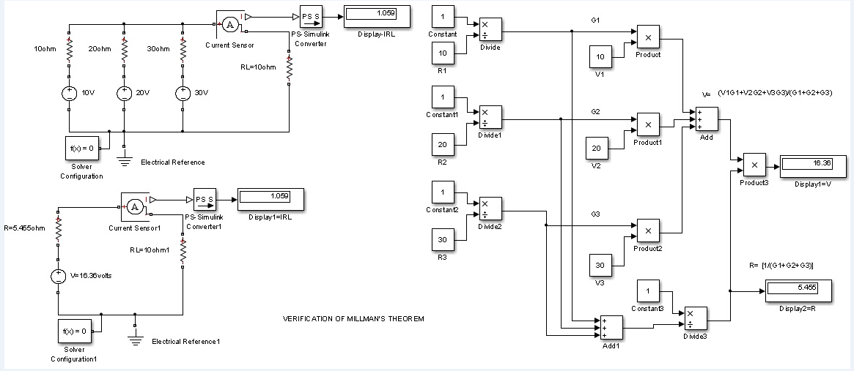

Conclusion: Hence we have studied millmans theorem and verified in matlab.

Exercise No 9: (2 Hours) – 1 Practical
To Study analysis of RL circuit
Aim: To Study and analyse RL circuit
Theory:
Explain series RL circuit.
Derive the expression for voltage and current in a series RL circuit.
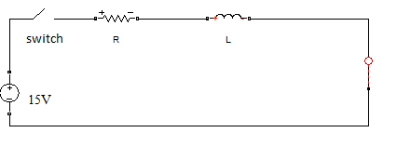
Matlab simulation
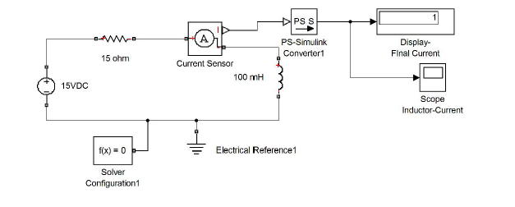
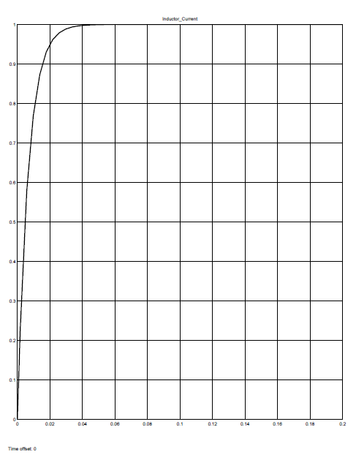
Conclusion:
Hence we have studied and analyzed the response of RL circuit using matlab.

Exercise No 10: (2 Hours) – 1 Practical
To Study analysis of RC circuit
Aim: To Study and analyse RC circuit
Theory:
Explain series RC circuit.
Derive the expression for voltage and current in a series RC circuit.
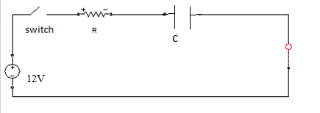
Matlab simulation.
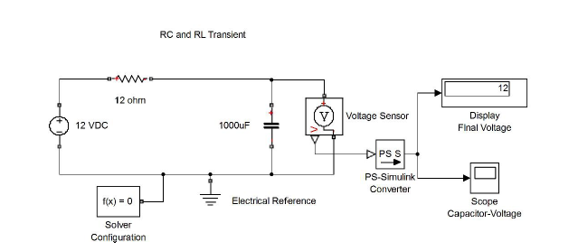
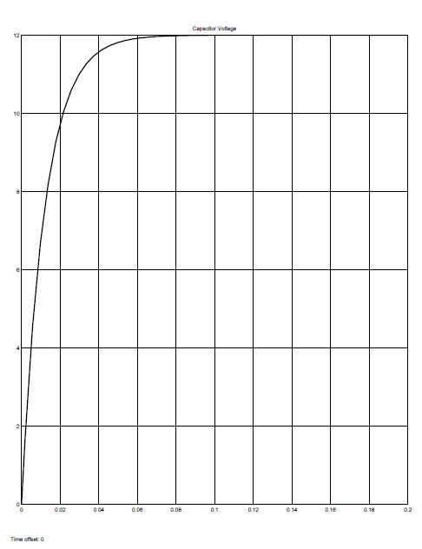
Conclusion:
Hence we have studied and analyzed the response of RC circuit using matlab.

3.Conduction of Viva-Voce Examinations:

Teacher should take oral exams of the students with full preparation. Normally, the objective questions with guess are to be avoided. To make it meaningful, the questions should be such that depth of the students in the subject is tested Oral examinations are to be conducted in co-cordial environment amongst the teachers taking the examination. Teachers taking such examinations should not have ill thoughts about each other and courtesies should be offered to each other in case of difference of opinion, which should be critically suppressed in front of the students.
4.Evaluation and marking system:
Basic honesty in the evaluation and marking system is absolutely essential and in the process impartial nature of the evaluator is required in the examination system to become popular amongst the students. It is a wrong approach or concept to award the students by way of easy marking to get cheap popularity among the students to which they do not deserve. It is a primary responsibility of the teacher that right students who are really putting up lot of hard work with right kind of intelligence are correctly awarded.

